

Builder Acceptance Package
Last Updated: 02/12/2025

Builder Acceptance Profile
Builder and Company Information
Primary Contact Name
Company Legal Name
DBA(s) If Applicable
Has your business operated under a different name in the last 5 years? If yes, provide name(s)
Business Address
City, State, Zip
Email Address
Contact Number | Office # |  |  |  |  |  | Cell #
Preferred Method of Communication |  |  |  |  | ☐ Text |  | ☐ Call |  |  |  |  | ☐ Email
Date Established |  |  |  |  |  | Is the company incorporated ☐ Y ☐ N |  |  |  |  |  | If so, year?
State Builder/Contractor License |  |  |  |  |  |  |  |  | Fed. Tax ID #
Manufactured/Modular/DOT licenses

List of all Individuals Who Own 25% or More of the Company, including yourself.
Name | Title | DOB and/or SSN | Percentage of Company

Please Answer the Following Questions
- Have you, the company, or any of the principles declared bankruptcy within the last 10 years?
If yes, please provide an explanation in detail.
☐ Y ☐ N
- Are you, the company, or any of the principles currently a defendant in any suits or legal actions?
If yes, please provide an explanation in detail.
☐ Y ☐ N
- Do you, the company, or any of the principles have any outstanding judgements against them?
If yes, please provide an explanation in detail.
☐ Y ☐ N
- Have you, the company, or any of the principles ever had your general contractors license revoked?
If yes, please provide an explanation in detail.
☐ Y ☐ N

Builder Acceptance Profile
Project and Loan Closing Experience
Does your company have experience completing “ground up” residential construction projects that utilized construction loan financing (using “draw disbursements”)? ☐ Y ☐ N
What type of residential home construction does your company offer? (Check all that apply)
☐ Stick/Site Built ☐ Modular/Manufactured/Specialty Manufacturer
☐ Modular/Manufactured/Specialty Installer ☐ Modular/Manufactured/Specialty Dealer (Supplier)
MH Only: Homes meet FNMA MH Advantage/Freddie Mac CHOICEHome requirements: ☐ Y ☐ N
Number of residential “ground up” construction projects completed in (please complete all sections):
YTD |  | 2025 |  | 2024

Number of residential “ground up” projects currently under construction:

Number of “other” (reno/remodel) projects currently under construction:

Current average construction time: ☐ <6 Months ☐ 6-9 Months ☐ 10-12 Months ☐ > 12 Months
Do you currently have a Builder/Supplier Line of Credit? |  | ☐ Y ☐ N
If yes, please complete Line of Credit Amount: | $
References
Supplier |  |  |  |  |  | Contact Person
Phone # |  |  |  |  |  | Fax #
Address
Subcontractor |  |  |  |  |  | Contact Person
Phone # |  |  |  |  |  | Fax #
Address
Financial Institution |  |  |  |  |  | Contact Person
Phone # |  |  |  |  |  | Fax #
Address

Provide the documents listed below. All items are required to complete the review and acceptance process:

☐ Completed and signed Builder Profile (attached - please complete and return all sections)
☐ Copy of State Builder/Contractor License (as applicable by state or municipality)
☐ Certificate of General Liability insurance aggregate $1M minimum coverage
☐ List of authorized signors for the company (attached)
☐ Completed Statement of Workers Comp Coverage disclosure (attached)
☐ Evidence of Workers Compensation insurance or evidence company is exempt (aka State Waiver)
☐ Completed Draw Schedule Form (attached) or copy of your preferred draw schedule
☐ Completed 24 Month Project Details sheet (attached – complete if less than 10 ground-up projects)

☐ Completed W-9 form (attached)
☐ Copy of (5) most recent Permits/Certificate of Occupancy for residential new builds
☐ **CCM reserves the right to request additional financial documentation as needed**

CrossCountry Representative you are working with:

Client you are working with/Property address (if applicable):

Email all documentation and completed builder acceptance package to:
constructionteam@ccm.com

Builder Acceptance Profile
Authorization and Release

By signing below, the undersigned ("I" or "me" or "my") hereby declares the statements contained herein are accurate, complete, and truthful. I expressly authorize and give permission to Lender and/or it’s assigns to obtain business credit information for the company or business identified within this profile ("Company") for purposes of completing an investigative review to the extent deemed necessary by Lender. I understand the investigative review may be used to determine credit worthiness, credit standing, credit capacity, character, general reputation, work experience and personal characteristics as authorized by the Fair Credit Reporting Act. In this regard, I give full authority and permission for Lender to obtain information concerning my and the Company's past employment, past performance, placement and/or construction contracts, work history, trade references, business credit information, criminal background and any other matters deemed relevant by Lender. I authorize, but do not require Lender to disclose information obtained in the investigative review to the Lender's borrower(s) or other necessary persons for which the Company or I will be providing services. I understand and agree that for so long as Lender acts in good faith, the Company and I will hold Lender harmless and will indemnify each of them from and against any and all claims, demands, suits, actions or the like which relate in any way to the investigative review performed by Lender.
I understand Lender may not provide a copy of my consumer report to me and will not reveal specific contents contained in the consumer report to me. I understand it is my responsibility for contacting one or more consumer reporting agencies directly to obtain a copy of my credit report. A facsimile, electronic, or copy of my signature below shall be valid as the original for me and the Company. In addition, I have thoroughly read and reviewed the additional information about the general requirements, draw process, and special requirements attached herein.

Printed Name |  | Date

Double Click to e-Sign

Date

Authorized Signors for Company

Builders Company Name

NOTE: Include Owner(s) and ALL parties authorized to sign on behalf of the company, including yourself, for official loan documents or draw disbursements (if you already have a company list, include with your submission in lieu of this page).

Name | Title | Phone | Email

Statement of Worker's Compensation Coverage
I certify the below to be accurate and true, and that I have the authority designated by the organization
to execute this form.
(Business Name)

Please check one and attach necessary documentation:

○ I have exercised the State option to an exemption from carrying Worker's Compensation Insurance and have attached a copy of the state issued exemption.

○ I am a Sole Proprietor, Owner, or Partner and have no “employees" as defined under the law, and therefore, am not required to carry Worker's Compensation.

○ I operate in a State where coverage is mandatory on my company and have attached a copy of the Worker's Compensation coverage that I carry.

Double Click to e-Sign

Date

Document is valid one year from date of signature

Approved Draw Schedule
(Select Only One)

☐ “Line-Item / Budget” (attach your line-item budget template)
A detailed line-item budget will be provided by the Builder on each transaction. The draws will be disbursed based on items identified as completed at the time of inspection and the amounts identified on the approved budget.
NOTE: CrossCountry Mortgage has a 10% Final Draw Holdback.

☐ “Staged / Percentage Completed” (attach your percentage completed template)
The draws will be disbursed based on the pre-defined percentages and stages of completion identified below. The stage must be 100% complete at time of inspection or funds will not be disbursed, with the exception of any closing draw (CCM does not issue “partial” draws).
NOTE: CrossCountry Mortgage has a 10% Final Draw Holdback.

NOTE: CrossCountry Mortgage Budget Templates (below are the files to download):
[Double Click to Open]

24 Month Project Details (for All Projects)

(Only Required if you have not completed 5 “New Residential Ground Up” Construction projects in 24 months) *If you build in Texas, must list last 5 projects
Project Address | Type of Job  (Ground Up, Addition, ADU, Remodel, MH Install) | Approximate Start Date | Approximate Completion Date | Approximate Sq Footage | Approximate Gross Project Cost

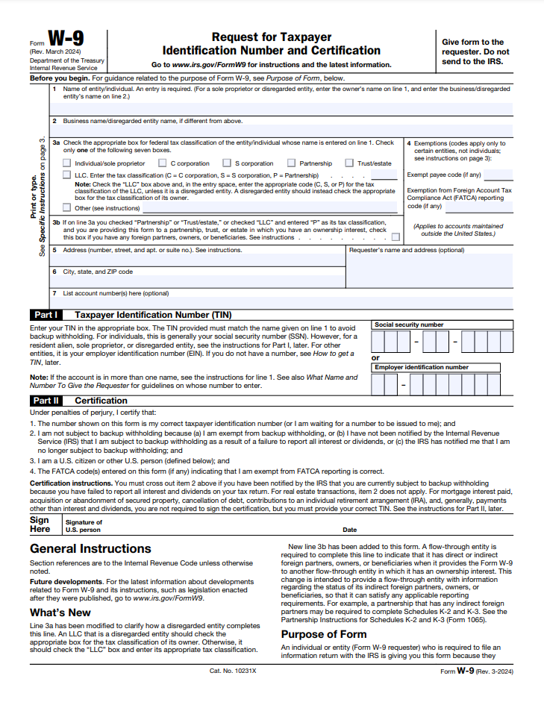

Draw Information, General, and Special Requirements

Special Requirements to Note:

- Any information you can provide to CrossCountry Mortgage regarding your experience will help in the review and acceptance process. If your company is less than 2 years old, a detailed resume that includes licenses, education, general contractor experience, etc. is required.
- CrossCountry Mortgage requires the Builder to act as the general contractor. The Borrower(s) may recommend some of the “subcontractors” to the “general contractor”.
- Borrower(s) cannot be compensated for any "sweat equity" credit.
- All costs required to provide a “substantially completed” project must be included in the contract and cost to build. Responsibility for completion of the home and improvements will be upon the Builder.
- Contracts must be either Fixed Cost or Fixed Price. “Cost Plus” contracts will convert to a Fixed Cost, plus builder margin/profit, and contingency to cover the estimated changes made during construction.
- IMPORTANT: Absolutely NO structural prestart work can be started, or materials delivered to the property prior to the initial loan closing. Site Prep and Lot Clearing are allowed.

CCM Builder Welcome Letter (below is a file to download): This will go over everything you need to know regarding the Draw Process, Change Order Requests, and Final Draw Request.

[Double Click to Open]

W-9 Form Fillable PDF (below is a link)

[CTRL-Click to Open]


W-9

