
THANK YOU….
For choosing a GBC Granite Benchtop

With product care and maintenance it will look as good in ten years as the day it was installed! We are sure it will give you years of enjoyment as well as adding value to your home.

BASIC CARE
Marble, Granite, Limestone & Travertine should be washed with a clean, soft cloth and fresh warm water. Then as an additional safeguard, wash your natural stone surfaces periodically with warm water and a mild neutral detergent. This should remove any residue which may have become ingrained.

- GBC have included a spray bottle of Lithofin MN Easy-Clean for regular, everyday cleaning of all natural stone and quartz surfaces such as kitchen work tops, table tops and in sanitary areas. Specifically formulated for use on marble and limestone.
- Do not use sandpaper or cleaners containing grit or abrasives on natural stone surfaces.
- Use a coaster under all glasses, particularly those containing alcohol or citrus juices. Many common foods and drinks contain acids that will etch or dull the stone surface.
- Do not place hot items directly on the stone surface. Use trivets or mats under hot dishes and placemats under china, ceramics, silver or other objects that can scratch the surface.
- All natural stone should be sealed to protect the finish. Please consult a qualified applicator for advice on the correct sealer to use on your stone.
- Avoid standing on your bench top especially around weak points such as sink and hob areas.

SPILLS
Blot the spill with a paper towel immediately. Don’t wipe the area, it will spread the spill. Flush the area with water and neutral cleaner or stone safe cleaner and rinse several times. Dry the area thoroughly with a soft cloth. Repeat as necessary.

FLOOR SURFACES
Dust mop interior floors frequently using a clean non-treated dry dust mop. Sand, dirt & grit do the most damage to natural stone surfaces due to their abrasiveness. Mats or area rugs inside and outside an entrance will help to minimize the sand, dirt and grit that will scratch the stone floor. Be sure that the underside of the mat or rug is a non-slip surface. Do not use vacuum cleaners that are worn, as the metal and plastic attachments may scratch the surface.

OTHER SURFACES
Clean the stone surface with a neutral cleaner, (Lithofin MN Easy Clean available from GBC). Use a clean rag mop on floors and a soft cloth for other surfaces for best results.

- Do not use products that contain lemon, vinegar or other acids on natural stone surfaces. Rinse the surface thoroughly after washing with the soap solution and dry with a soft cloth. Change the rinse water frequently.
- Do not use scouring powders or creams; these products contain abrasives that may scratch the surface
VANITY TOP SURFACES
Vanity tops may need to have a penetrating sealer applied. Check with your installer for recommendations. A good quality marble wax can be applied to minimize water spotting.

Clean your vanity regularly with a neutral cleaner / stone safe cleaner. Dilute product 1:1 with tap water and follow the manufacturer’s instructions.

FOOD PREPARATIONS AREAS
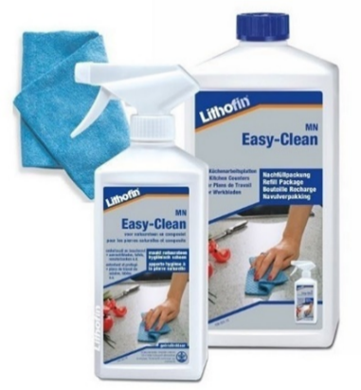
In food preparation areas, the stone may need to have penetrating sealer applied. Sealing does not make the stone stain proof; rather it makes the stone more stain resistant. If a sealer is applied, be sure it is non-toxic and safe for use on food preparation surfaces.

Consult with your supplier to specify the type of sealer and frequency of use recommended.

Prolonged exposure to oils or acids may compromise the sealers.

Kitchen bench tops should be cleaned regularly with Easy-Clean. A few squirts of this product will help remove grease, oil and general dirt from the countertop. We recommend cleaning the surface immediately after cooking in order to minimize the time food remains on the stone.

DO & DON’TS

- Do dust mop floor frequently
- Do clean surfaces with mild detergent or stone soap
- Do thoroughly rinse and dry the surface after washing
- Do blot up spills immediately
- Do protect floor surfaces with non-slip mats or area rugs & countertop surfaces with coaster, trivets or placemats
- Don’t use vinegar, lemon juice or other cleaners containing acids on natural stone surfaces
- Don’t use cleaners that contain acid such as bathroom cleaners, grout cleaners or tub & tile cleaners
- Don’t use abrasive cleaners such as dry cleaners or soft cleaners
- Don’t cut on surfaces always using chopping boards

From the team at GBC South Island Ltd, thanks again for your support.
May you get as much enjoyment from your new benchtop as we did making it.



www.gbcsouth.co.nz
info@gbcsouth.co.nz
Ph 03 338 4848
132 Wrights Road,
Christchurch

