

Introduction

Welcome to Your Family Council Starter Kit
A simple way to turn everyday family life into practice for adulthood.
The ReadiKids® Family Council Parent Guide explains the purpose of the Family Council and how regular family meetings can help children gradually develop responsibility, confidence, problem-solving skills, and respect for others.
This Starter Kit helps your family put those ideas into practice.
It begins with guidance for holding your first Family Council and includes practical tools your family can continue using as the meetings become part of your routine:
- Family Council Agenda Cards provide a simple structure built around the four anchors of every meeting: Celebrate, Acknowledge, Solve, and Act.
- The Family Council Responsibility Log helps family members clearly identify what each person has agreed to do and provides a way to follow through together.
- Readiness Pack Badges help parents recognize the life skills children are gradually learning to understand, practice, and own.
You do not need to use every tool at once, and your first meeting does not need to be perfect. Begin simply. Give everyone time to understand the rhythm, find their voice, and become comfortable participating.
Every family is different. Adapt these materials to fit your children, your schedule, and the way your family communicates. Over time, the Family Council should not feel like a program your family is following. It should become something that belongs to your family.
The goal is not simply to hold meetings. The goal is to use ordinary family life to help children practice the skills, habits, and values they will need long after they leave home.

Table of Contents
Introduction 2
Your First Family Council 4
A Different Kind of Support at Every Stage 5
Family Council Agenda Cards 6
Family Council Responsibility Log 7
Readiness Pack Badges 11
Give the Family Council Time to Become Yours 17

Your First Family Council

A simple 20-minute guide for your first meeting.
Keep the first meeting warm, short, and simple. Your purpose is to begin the rhythm—not to make everything perfect.
The words below are suggestions, not a script you must follow. Use language that feels natural to you. You know your family best.
Step | Suggested Length | Suggested Action
Before | 2 min. | Set the scene. Place the four Agenda Cards and the Responsibility Log where everyone can see them. Turn off screens and remove other distractions. A parent should lead the first meeting.
Open | 2 min. | You might say: “Tonight, we are starting something new as a family—a place where everyone has a chance to speak, everyone is expected to listen, and we learn how to handle family life together.”
Celebrate | 4 min. | Ask: “What went well this week?” Go around the table and invite each person to share one win—large or small.
Acknowledge | 4 min. | Ask: “Who would you like to recognize or thank?” Encourage family members to notice a specific effort, kindness, responsibility, or improvement.
Solve | 4 min. | Ask: “What is one challenge we can work on together?” Describe the challenge without blame. Invite the children to offer ideas first, then agree on one reasonable next step.
Act | 3 min. | Introduce Responsibility Week. Invite each child to choose one responsibility to own before the next meeting. A parent may choose one as well. Record each responsibility, its owner, and when it should be completed on the Responsibility Log.
Close | 1 min. | Confirm the plan. Read the responsibilities aloud and set the date for the next Family Council. End with encouragement: “That was a good start. We’ll meet again next week.”

A Different Kind of Support at Every Stage
- Little Explorer — Guide: Provide structure, offer choices, and practice together.
- Pathfinder — Coach: Ask questions, listen, and give them room to think.
- Trailblazer — Advisor: Respect their growing independence and let them own both the decision and the follow-through.

Your First Meeting Probably Won’t Be Perfect
Your first Family Council may go very well—or it may feel awkward, disorganized, or even discouraging. Every family will respond differently. Younger children may be curious and eager to participate. Older children may be skeptical, quiet, or resistant because the meeting feels like an interruption to their routine rather than something valuable to them.
None of these reactions determines whether the Family Council will work for your family.
The value of the Family Council is rarely revealed in one meeting. It develops through repetition. As family members become familiar with the rhythm, learn that their voices will be heard, and see that the meetings lead to real improvements, participation usually becomes more natural and meaningful. What feels unfamiliar today can gradually become a trusted part of family life.
Avoid turning the meeting into a correction or a lecture, or expecting enthusiasm right away. Stay calm, keep the meeting moving, and end when you said you would. Over time, consistency will accomplish far more than pressure.
For this first meeting, success can be simple:
- Everyone was given an opportunity to participate.
- One manageable responsibility was chosen.
- The next Family Council was placed on the calendar.
That is enough for a good beginning. The goal of the first meeting is not to prove that the Family Council works. It is to give it the opportunity to begin working.

Family Council Agenda Cards
Cut out each card separately and place the four cards where everyone can easily see them during the meeting. As you move through the Family Council, the cards provide a clear structure, help everyone follow the conversation, and keep the meeting focused.
Their presence also adds a sense of preparation and professionalism. They quietly communicate that the Family Council is not simply another family conversation that happened by chance. It is a purposeful time set aside for everyone to participate, listen, solve problems, and take meaningful action together. Over time, the familiar cards will help create a rhythm your family recognizes and understands.
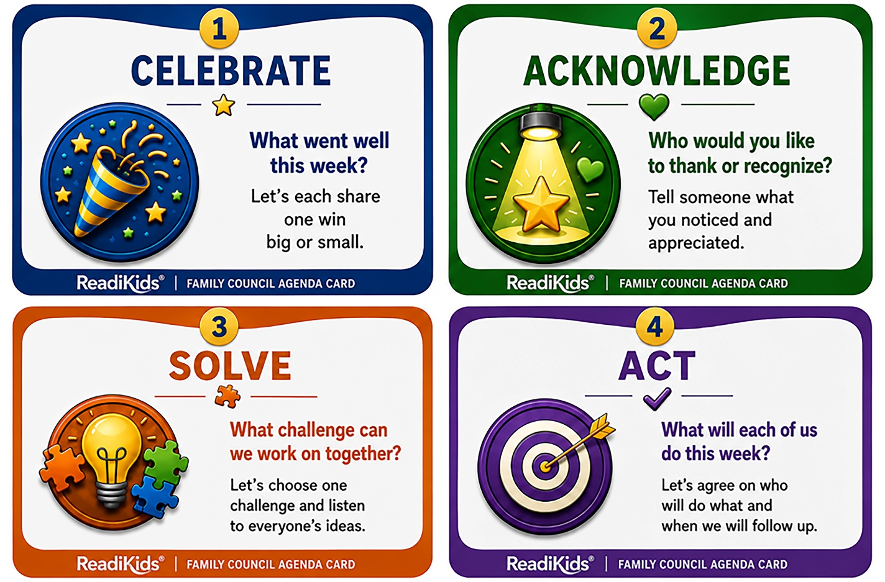

Family Council Responsibility Log
Turning Family Responsibilities Into Practice for Life.
The Responsibility Log gives each family member a clear record of what they have agreed to own before the next Family Council. It is more than a list of chores. It helps children practice making a commitment, remembering what they agreed to do, following through, and reporting honestly on the result.
Use a new log at each Family Council. Begin with one manageable responsibility for each child. Whenever possible, let children suggest or choose what they will own. A parent may also add a responsibility, demonstrating that ownership and accountability belong to everyone in the family.
A responsibility should be:
- Clearly understood by the person accepting it.
- Appropriate for the child’s age and ability.
- Specific enough that everyone will know what completion means.
- Realistic to complete before the next Family Council.

Note: Print several copies of the next page for next meetings

Family Council Responsibility Log
Next
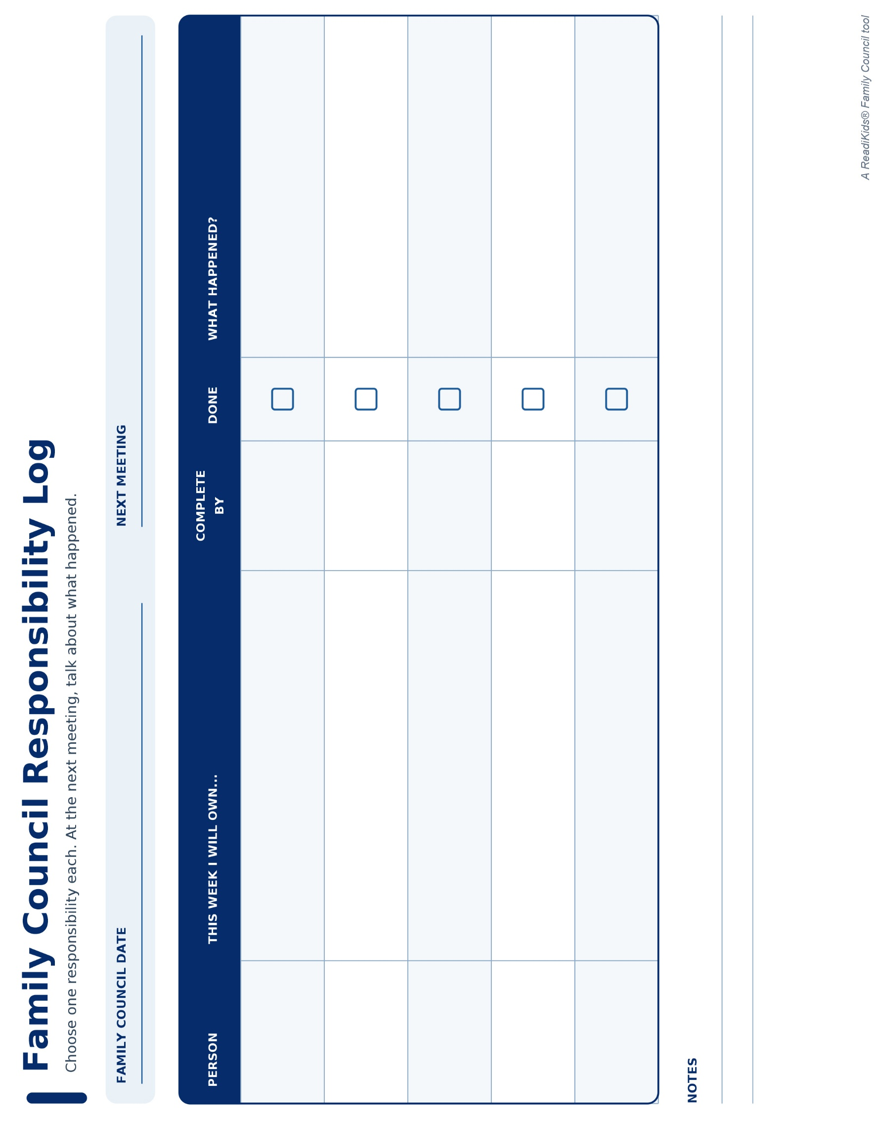

At the Next Family Council
Review the log together during the Act portion of the meeting. Invite each person to report on their own responsibility before anyone else comments.
The purpose is not simply to check whether a task was completed. It is to help each person recognize what worked, speak honestly about what did not, and decide what should happen next.
You might ask:
- “What happened with the responsibility you accepted?”
- “What helped you follow through?”
- “If it was not completed, what got in the way?”
- “What did you learn?”
- “Should you continue this responsibility, adjust it, or choose something new?”
Write a brief note in the What Happened? column. A few words are enough: completed independently, needed a reminder, underestimated the time, or will try again next week.

Match Your Support to the Child
Little Explorer | Pathfinder | Trailblazer
Parent as Guide | Parent as Coach | Parent as Advisor
Show what the responsibility involves. Practice it together, then let the child complete an appropriate part. | Ask questions before offering answers. Let the child make a plan, try it, make adjustments, and report back. | Agree on the expected outcome, then step back. Allow the young person to manage the details and offer perspective when it is useful.

When a Responsibility Is Not Completed
An unfinished responsibility is not a reason for embarrassment or punishment. It is an opportunity to understand what happened and strengthen the plan. The responsibility may have been unclear, too large, easily forgotten, or beyond the child’s present ability. Sometimes the child simply did not follow through—and learning to acknowledge that honestly is also part of becoming responsible.
Avoid immediately taking over or delivering a lecture. Ask what happened, listen to the answer, and help the child identify a better next step. Accountability should remain real, but it can be taught without shame.
Remember: Responsibility transfers gradually. The parent does not disappear from the process; the parent changes roles as the child becomes increasingly capable of owning the decision, the work, and the result.

Readiness Pack Badges

Recognizing Growth That Lasts
The Readiness Pack Badges recognize growth in five important areas: Responsibility, Problem-Solving, Courage, Moneywise, and Team Player. Each represents a capability that will help prepare a child for life.
A badge is not earned merely because a child completes one task or demonstrates a quality on one occasion. Those moments may be important first steps, but the badge represents something more. It recognizes that the child understands what the capability means and is beginning to put that understanding into repeatable action.
Perfection is not required. Children are still learning, and they will sometimes forget, struggle, or make poor choices. Look instead for a developing pattern: the child accepts responsibility with fewer reminders, works through problems more thoughtfully, acts with courage when something is difficult, makes wiser decisions about money, or contributes more consistently as a member of a team.
There is no required timetable, and children should not be compared with one another. You know your child. Present a badge when you believe the growth is genuine and the capability is becoming part of how your child approaches life.
When awarding a badge, explain specifically what you have observed and why it matters. This helps the child understand that the badge is more than a reward—it recognizes a strength they have worked to develop and can continue building.
The pages that follow contain six copies of each badge. Cut them out and keep them available until the appropriate moment arrives.
A badge celebrates more than something a child did. It recognizes something the child is learning to become.

Responsibility Badges
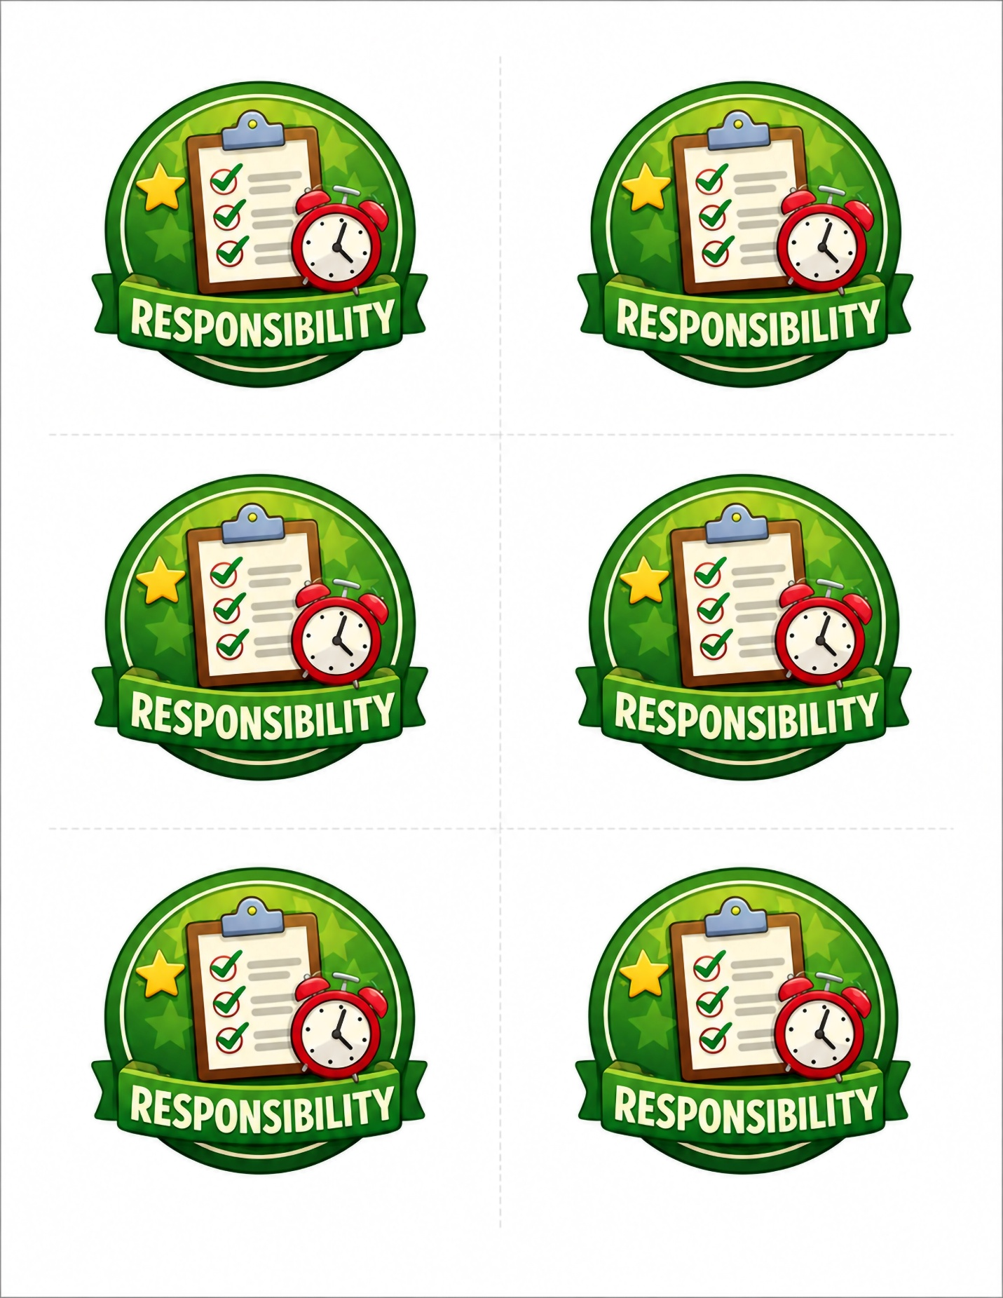

Problem-Solving Badges
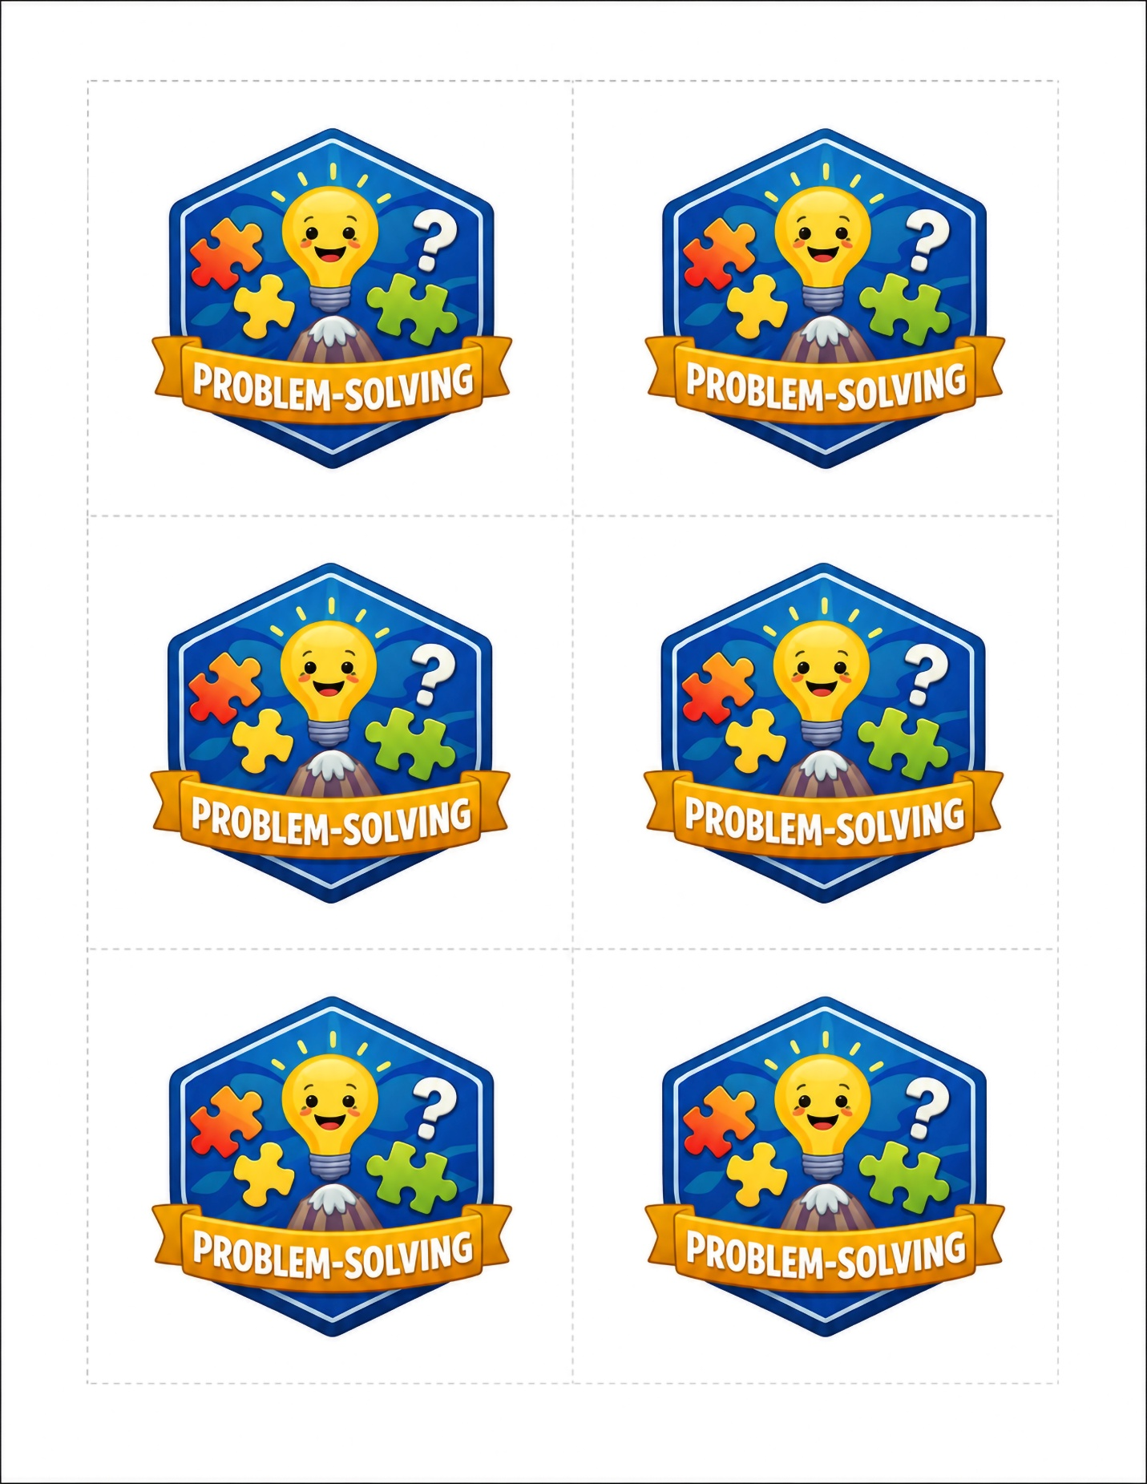

Courage Badges



Moneywise Badges


Team Player Badges


Give the Family Council Time to Become Yours
What Feels Unfamiliar Today Can Become Part of Family Life
Your first few Family Councils may not look or feel the way you imagined. Younger children may be excited simply because the meeting is something new. Older children may be skeptical, distracted, or convinced that this is one more activity being added to their lives. Some family members may talk too much. Others may say almost nothing.
That does not mean the Family Council is failing. It means your family is learning a new way of being together.
The Family Council becomes valuable through experience. Family members need time to learn the four-part rhythm, to discover that their voices will be heard, and to see that the conversation leads to meaningful action.

What Progress May Look Like
Do not expect every meeting to be better than the one before it. Progress is rarely that orderly. One meeting may feel encouraging and the next may feel awkward. A difficult week may produce a difficult meeting. What matters is the direction you see over time.
You may begin to notice that:
- Family members understand what comes next without being reminded.
- Children arrive with something they want to celebrate or discuss.
- Recognition becomes more specific and sincere.
- Problems are discussed with less blaming and more listening.
- Children begin suggesting solutions instead of waiting for the parent to provide them.
- Responsibilities become clearer and require fewer reminders.
- Family members speak more honestly about what worked and what did not.
- The meeting begins to feel less like the parent’s idea and more like the family’s time together.
These changes may appear gradually, and they will not happen at the same pace in every family. Even one small sign of growing participation or trust is meaningful.

Your Role During the Early Weeks
Keep the meeting short, warm, and predictable. Continue using the four Agenda Cards so everyone knows the rhythm: Celebrate, Acknowledge, Solve, and Act.
Resist the temptation to make each meeting accomplish too much. Celebrate what is going well. Listen without immediately correcting. Work on one manageable challenge. End with clear responsibilities and a date for the next meeting.
Most importantly, keep showing up.
You are helping your family build a place where everyone learns to listen, contribute, solve problems, accept responsibility, and grow together. Those habits require repetition before they begin to feel natural.

Let the Family Council Grow With Your Family
Over time, invite children to take a larger role. Let them ask one of the questions, read an Agenda Card, record the responsibilities, keep track of time, or eventually lead the meeting. Shared ownership often grows when children experience the Family Council as something they help shape—not something being done to them.
Your Family Council does not have to resemble anyone else’s. The four-part rhythm provides the structure, but your family will give it its own language, personality, traditions, and even humor.
The Family Council takes hold not when every meeting goes smoothly, but when the family learns that this is a place where everyone can return, participate, and begin again.

