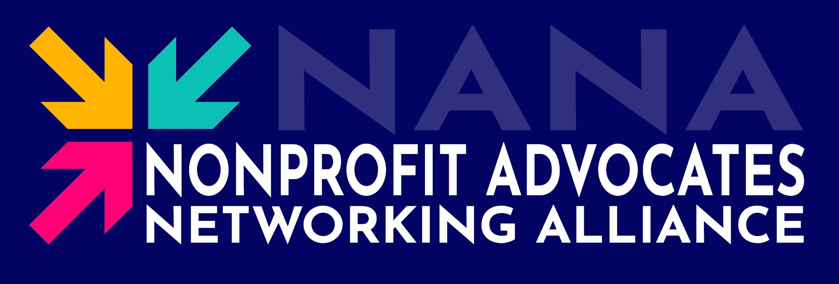

You’re invited to join NANA!

What if your professional network did more than generate referrals? What if it gave you a real reason to show up — every single month — that actually meant something?
Introducing NANA …

The Nonprofit Advocates Networking Alliance (NANA) is a mission-driven community engagement program that connects nonprofits with the local business community through ongoing relationship-building and advisory support.
The first NANA Chapter is NANA Susquehanna, serving nonprofits in Harford and Cecil County, MD.
In addition to functioning as a traditional networking group, each NANA group within the Chapter serves as a standing business advisory and advocacy panel, providing nonprofits with consistent access to professional insight, community connections, and mission-aligned supporters.
Furthermore, as more and more nonprofits come on board, a wide network of organizations is formed – where group members can visit other groups, widening the exposure of both the organization and the individual member!

$25  per month to join | 1 hr  per month, that’s it | 20%  of dues go directly to your nonprofit

HOW IT WORKS
One Hour. One Nonprofit. Real Impact.

Each NANA Group is built around a single host nonprofit. Every month, 15–30 business professionals gather for a structured one-hour meeting at the nonprofit’s location. A trained NANA facilitator guides the session — so the nonprofit can focus entirely on sharing their work and getting value from the room.

15 min | Mingle & Connect  Arrive, meet fellow members, and welcome guests. The relationships you build here are the ones that outlast the meeting. *

5 min | Introductions  Quick roundtable — name and business only. The nonprofit representative closes the introductions and sets up the advisory session.

30 min | Advisory Session  The nonprofit shares a brief update and one focused strategic challenge. Members contribute ideas, connections, and expertise from their professional experience.

10 min | Wrap-Up & Commitments  The facilitator synthesizes key takeaways. Members offer follow-up commitments. *
* Groups might add optional, informal conversation periods before or after the meeting.
After Every Meeting
NANA automatically sends every member an Attendance List — so you can follow up, schedule one-on-ones, and build the professional relationships that started in the room. This eliminates taking the time to circulate business cards or make repetitive elevator pitches.

WHY JOIN NANA
Better Networking. Real Purpose. Lasting Relationships.

Most networking groups make a promise they can’t keep: show up, shake hands, grow your business.

NANA is different — not because it abandons professional relationship-building, but because it gives those relationships something real to grow from. When people meet around a shared mission, the connections tend to last.

What You Get  ✓ A room full of professionals who share your values  ✓ Monthly advisory discussions that sharpen your thinking  ✓ Genuine civic impact — your expertise helps a nonprofit thrive  ✓ Post-meeting contact list to keep relationships going  ✓ Access to all groups in your NANA Chapter  ✓ Recognition as a community leader and civic contributor | What You Give  ✓ One hour per month — not a board commitment  ✓ $25 / month — 20% goes directly to the nonprofit  ✓ Your professional perspective and connections  ✓ A willingness to show up, engage, and follow through

NANA does not eliminate networking – it elevates it. Members still build professional relationships, exchange contacts, and create business opportunities. But they do it in a room full of people who share a common purpose, which makes every connection more authentic and more durable.

WHO JOINS NANA?
This Community Is Built for You …

NANA groups bring together three kinds of professionals — and the mix is what makes every room unique, dynamic and valuable.

~ 35%  Traditional Networkers  Business professionals who want something more meaningful than a standard networking group. | ~ 40%  Nonprofit-Connected Pros  Donors, volunteers, board members, and supporters of the host nonprofit who join because of the mission. | ~ 25%  Mission-Driven Advocates  People personally invested in the cause who want to contribute their professional skills to help their community.

YOUR NONPROFIT
More Than a Meeting Location.

Your host nonprofit is the heart of your NANA Group. In most cases, each meeting is held at their location — which means you get to see their work, understand their mission firsthand, and build a real connection to the cause your group supports.

The nonprofit brings a genuine strategic challenge to each meeting. Not a rehearsed pitch — a real question they are wrestling with right now. Your professional experience, your network, and your perspective become the raw material for every advisory session.

What Your Support Looks Like
- Strategic advice on marketing, fundraising, operations, board development, etc.
- Introductions to businesses, donors, volunteers, or community partners
- Professional expertise in HR, legal, finance, technology, communications, and more
- Hands-on involvement volunteering for a project, event, or initiative
- Deeper engagement becoming a meaningful part of the nonprofit’s community over time

THE BIGGER PICTURE
You’re Joining More Than a Group.

Your NANA Group is your home base — so it’s called your “Home NANA Group”. But your membership extends across the entire NANA Chapter. You’re welcome to visit any other group within your chapter two times per year — which means your professional network grows with every meeting you attend. (Premium Memberships and Chapter & Group Sponsors have unlimited visits to other groups).
1  group you call home | Any  group you can visit | All  members you can connect with
NANA members tend to do business together, refer each other, and maintain relationships long after they would have faded in a transactional setting because the foundation of every NANA relationship isn’t a business card exchange — it’s a shared commitment to something that matters.
CHAPTER EVENTS
Come Together Beyond the Monthly Meeting.

In addition to the monthly NANA Group meetings, NANA offers other ways to connect with your community!

The Nonprofit Advisory Group (Annual)  Our annual daytime conference brings together 150+ nonprofit professionals and business leaders for a day of peer learning, community connection, networking and strategic conversation. As a NANA member, this event is part of your community. | NANA Chapter Gala (Annual)  Our annual evening reception brings together all active members, host nonprofits, alumni, and prospective members from across the chapter — celebrating the relationships and outcomes built throughout the year.

Downtime Networking (Monthly)  NANA groups will join with Downtime Networking on the 2nd Thursday of the Month to host a Happy Hour that is open to the entire community. Join us at Downtime Networking to further expand your relationships in a social environment! | .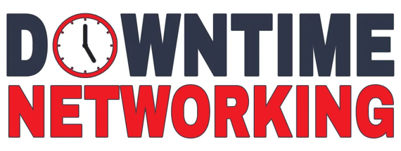

MEMBERSHIP
Simple Pricing. Real Value.

Starting at $25 per month, NANA membership is priced to be accessible to any professional who wants to participate — not just those with a corporate expense account or a generous employer. The low barrier is intentional. A NANA Group is most valuable when the room reflects the full breadth of the business community: the solo consultant alongside the regional bank VP, the independent contractor alongside the marketing director. Diverse professional perspectives make for better advisory conversations — and more interesting relationships.
Both membership tiers are described in the Table on the next page.
- Standard Membership - $25/Month ($300/Year)
- Premium Membership - $50/Month ($600/Year)
And, by the way, 20% of your Membership dues are donated to your host nonprofit.
S P O N S O R S H I P O P P O R T U N I T I E S
Put Your Brand Behind a Mission That Matters.

For businesses that want to be known as community leaders — not just community donors — NANA sponsorships offer something most sponsorship opportunities can't: sustained, repeated visibility with a highly engaged, professionally relevant audience. Every month, your brand is in the room with business professionals and nonprofit leaders who are actively investing their time and expertise in the community. That's not a one-time impression. It's a relationship built over 12 months of consistent presence. Unlike a gala table or an event banner that disappears after one evening, a NANA sponsorship puts your name and logo in front of the same motivated audience month after month — in meeting materials, in digital communications, on the NANA website, and at the Annual Events that bring the full chapter together.
NANA offers two levels of sponsorship — Chapter Sponsorships and Group Sponsorships — each designed for a different scope of visibility and community engagement. A Chapter Sponsorship puts your brand across the entire chapter, reaching every group, every member, and every event. A Group Sponsorship gives you deep, focused visibility within a single advisory group — ideal for businesses that have a close connection to a specific nonprofit's mission or community. Both are described in the Table on the next page.
- Group Sponsorship - $1,000 / Year
- Premium Membership - $3,000 / Year

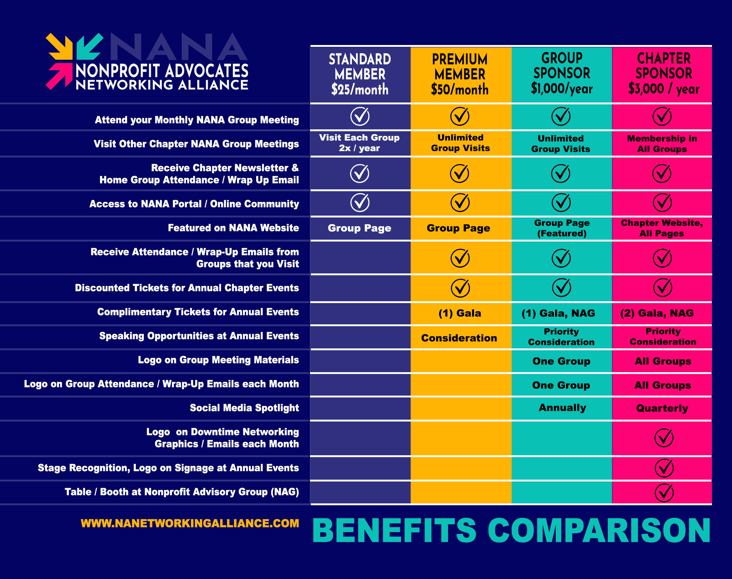

Ready to Join?
$25 / month · One hour per month · Real impact
Sign up at nanetworkingalliance.com
Questions? Reach out — we’d love to tell you more.


Scan for more information or to join a NANA Group!

