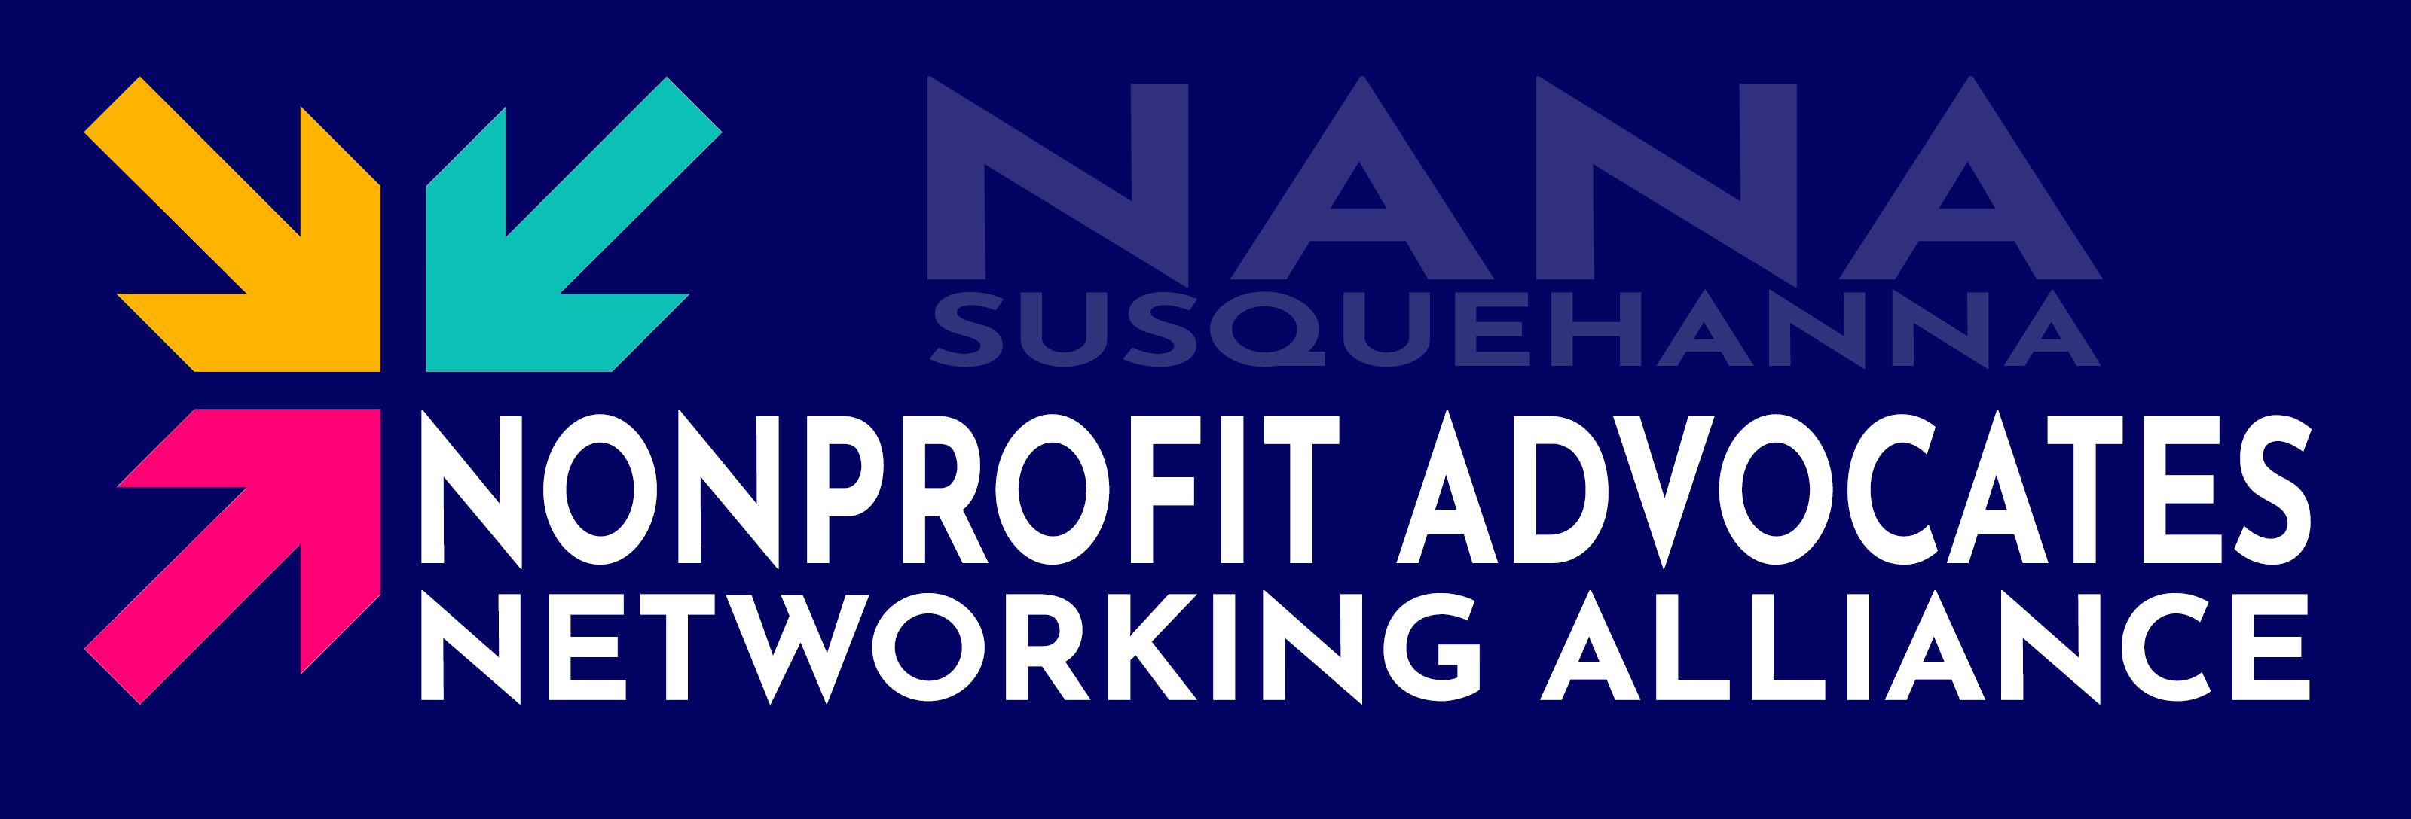
Invitation to Host Nonprofits

What if your nonprofit had a standing team of business advisors —
showing up every month to help you grow, solve problems, and build community?
Introducing NANA …

The Nonprofit Advocates Networking Alliance (NANA) is a mission-driven community engagement program that connects nonprofits with the local business community through ongoing relationship-building and advisory support.
The first NANA Chapter is NANA Susquehanna, serving nonprofits in Harford and Cecil County, MD. In addition to functioning as a traditional networking group, each NANA group within the Chapter serves as a standing business advisory and advocacy panel, providing nonprofits with consistent access to professional insight, community connections, and mission-aligned supporters.
Furthermore, as more and more nonprofits come on board, a wide network of organizations is formed – where group members can visit other groups, widening the exposure of both the organization and the individual member!

$0  Cost to Host Nonprofits | 20%  of Member Dues Go Directly to You | 15-30  Business Advisors in Your Corner

HOW IT WORKS
One Hour. One Nonprofit. Real Impact.

Each NANA Group is built around a single host nonprofit. Every month, 15–30 business professionals gather for a structured one-hour meeting at your location. A trained NANA facilitator guides the entire session — so you and your team can focus entirely on sharing your work and getting value from the room. Here's how each meeting flows:
15 min | Mingle & Connect  Arrive, meet fellow members, and welcome guests. The relationships you build here are the ones that outlast the meeting. *

5 min | Introductions  Quick roundtable — name and business only. The nonprofit representative closes the introductions and sets up the advisory session.

30 min | Advisory Session  The nonprofit shares a brief update and one focused strategic challenge. Members contribute ideas, connections, and expertise from their professional experience.

10 min | Wrap-Up & Commitments  The facilitator synthesizes key takeaways. Members offer follow-up commitments. *
* Groups might add optional, informal conversation periods before or after the meeting.
After Every Meeting
NANA automatically sends every member an Attendance List — so they can follow up, schedule one-on-ones, and build the relationships that started in the room with you and each other. As the host nonprofit, you receive a Wrap-Up Email summarizing commitments made on your behalf.

WHY JOIN NANA?
Better Networking. Real Purpose. Lasting Relationships.

Hosting a NANA Group is one of the most powerful — and cost-effective — ways to build sustained community engagement around your mission. You're not simply sharing your space with a networking club. You're gaining a dedicated, recurring panel of business professionals who become genuinely invested in your success.

Monthly Revenue Stream  20% of all membership dues from your group go directly to your organization every month — ongoing, reliable, and growing as your group grows. | Strategic Advisory Support  Bring a real challenge each month. Members contribute professional insight on marketing, fundraising, operations, board development, and more.
Expanded Community Awareness  Dozens of business professionals learn about your mission firsthand — at your location — becoming ambassadors for your cause in the wider community. | Professional Introductions  Members actively connect you with donors, volunteers, board candidates, vendors, and community partners from their own networks.
Website & Marketing Visibility  Your organization is featured on the NANA website and in monthly digital communications reaching all chapter members. | Annual Event Platform  Your nonprofit is represented at the annual NANA Gala and Nonprofit Advisory Group (NAG) conference — events with 150+ attendees.
No Cost to Participate  There is no fee for nonprofits to host a NANA Group. Your organization receives support, visibility, and revenue — not an invoice. | Ongoing Relationship Building  Unlike a one-time donation or grant, NANA creates 12 months of repeated, deepening engagement between your team and a growing network of supporters.

NANA does not eliminate networking – it elevates it. Members still build professional relationships, exchange contacts, and create business opportunities. But they do it in a room full of people who share a common purpose, which makes every connection more authentic and more durable. This makes the connections made by your nonprofit infinitely more valuable than

WHAT YOUR NONPROFIT BRINGS
A Real Challenge. A Welcoming Space. A Genuine Commitment.

NANA is designed to be lightweight for host nonprofits. We handle the facilitation, communications, and member recruitment. What we ask from you is straightforward:
✓ A suitable meeting space for 15–30 attendees, available monthly (typically 60–75 minutes). This does not necessarily need to be at your location, but there are benefits to that, if at all feasible.
✓ One organizational representative present at each meeting to share updates and the advisory challenge
✓ A genuine strategic challenge each month — not a rehearsed pitch, but a real question your team is wrestling with
✓ A commitment to engage authentically and follow up on member commitments
✓ Openness to building lasting relationships with your NANA Group members over time

What kind of challenges can you bring? Anything your organization is navigating: Awareness & Marketing, Corporate Partnerships, Volunteer Engagement, Donor Engagement & Fundraising, Board Development & Leadership, Program Growth, Community, Operations, Future Vision. A good advisory question is specific, strategic, and genuinely important to your organization right now – NANA even provides a Topic Bank if you’re having trouble getting started with ideas!

THE BIGGER PICTURE
You’re Joining More Than a Group.

Your NANA Group is your Home Base within the NANA Susquehanna Chapter. But as the chapter grows, so does your reach. As more nonprofits and members join the chapter, the NANA network becomes an interconnected web of mission-aligned organizations and business professionals — all of whom have some awareness of your work.
NANA members visit other groups, share referrals across organizations, and stay connected long after any single meeting. Your nonprofit benefits not just from your own group, but from belonging to a chapter-wide community built around shared values.
1  Group that you host | Any  Group you can visit | All  Members you can connect with
NANA members tend to champion the organizations they believe in, connect them with donors and volunteers, and maintain relationships long after they would have faded in a transactional setting — because the foundation of every NANA relationship isn't a networking event — it's a shared commitment to something that matters.

CHAPTER EVENTS
Come Together Beyond the Monthly Meeting.

In addition to the monthly NANA Group meetings, NANA Susquehanna offers other ways to connect with your community! Whether you're looking to celebrate the incredible work happening across the region, meet with other nonprofits for educational sessions, or simply unwind and build relationships in a relaxed setting, there's something for everyone. From our Annual Gala to our Nonprofit Advisory Group to our monthly Downtime Networking events, NANA Susquehanna creates space for meaningful connection at every level — because great communities aren't built in a single meeting.

The Nonprofit Advisory Group (Annual)  Our annual daytime conference brings together 150+ nonprofit professionals and business leaders for a day of peer learning, community connection, networking and strategic conversation. As a NANA member, this event is part of your community. | NANA Chapter Gala (Annual)  Our annual evening reception brings together all active members, host nonprofits, alumni, and prospective members from across the chapter — celebrating the relationships and outcomes built throughout the year.

Downtime Networking (Monthly)  NANA groups will join with Downtime Networking on the 2nd Thursday of the Month to host a Happy Hour that is open to the entire community. Join us at Downtime Networking to further expand your relationships in a social environment! | .

MEMBER AND SPONSOR BENEFITS
Simple Pricing. Real Value.

The members and sponsors who join your NANA Group aren't just filling seats — they're professionals who believe in what you're building and want to be part of it. In return, NANA Susquehanna is committed to making sure that investment means something. Every tier of participation is designed to deliver genuine value: visibility within a trusted network, access to meaningful connections, and the kind of ongoing engagement that turns supporters into long-term advocates. The graphic on the next page illustrates what members and sponsors receive in return for their participation, organized by membership and sponsorship tier:
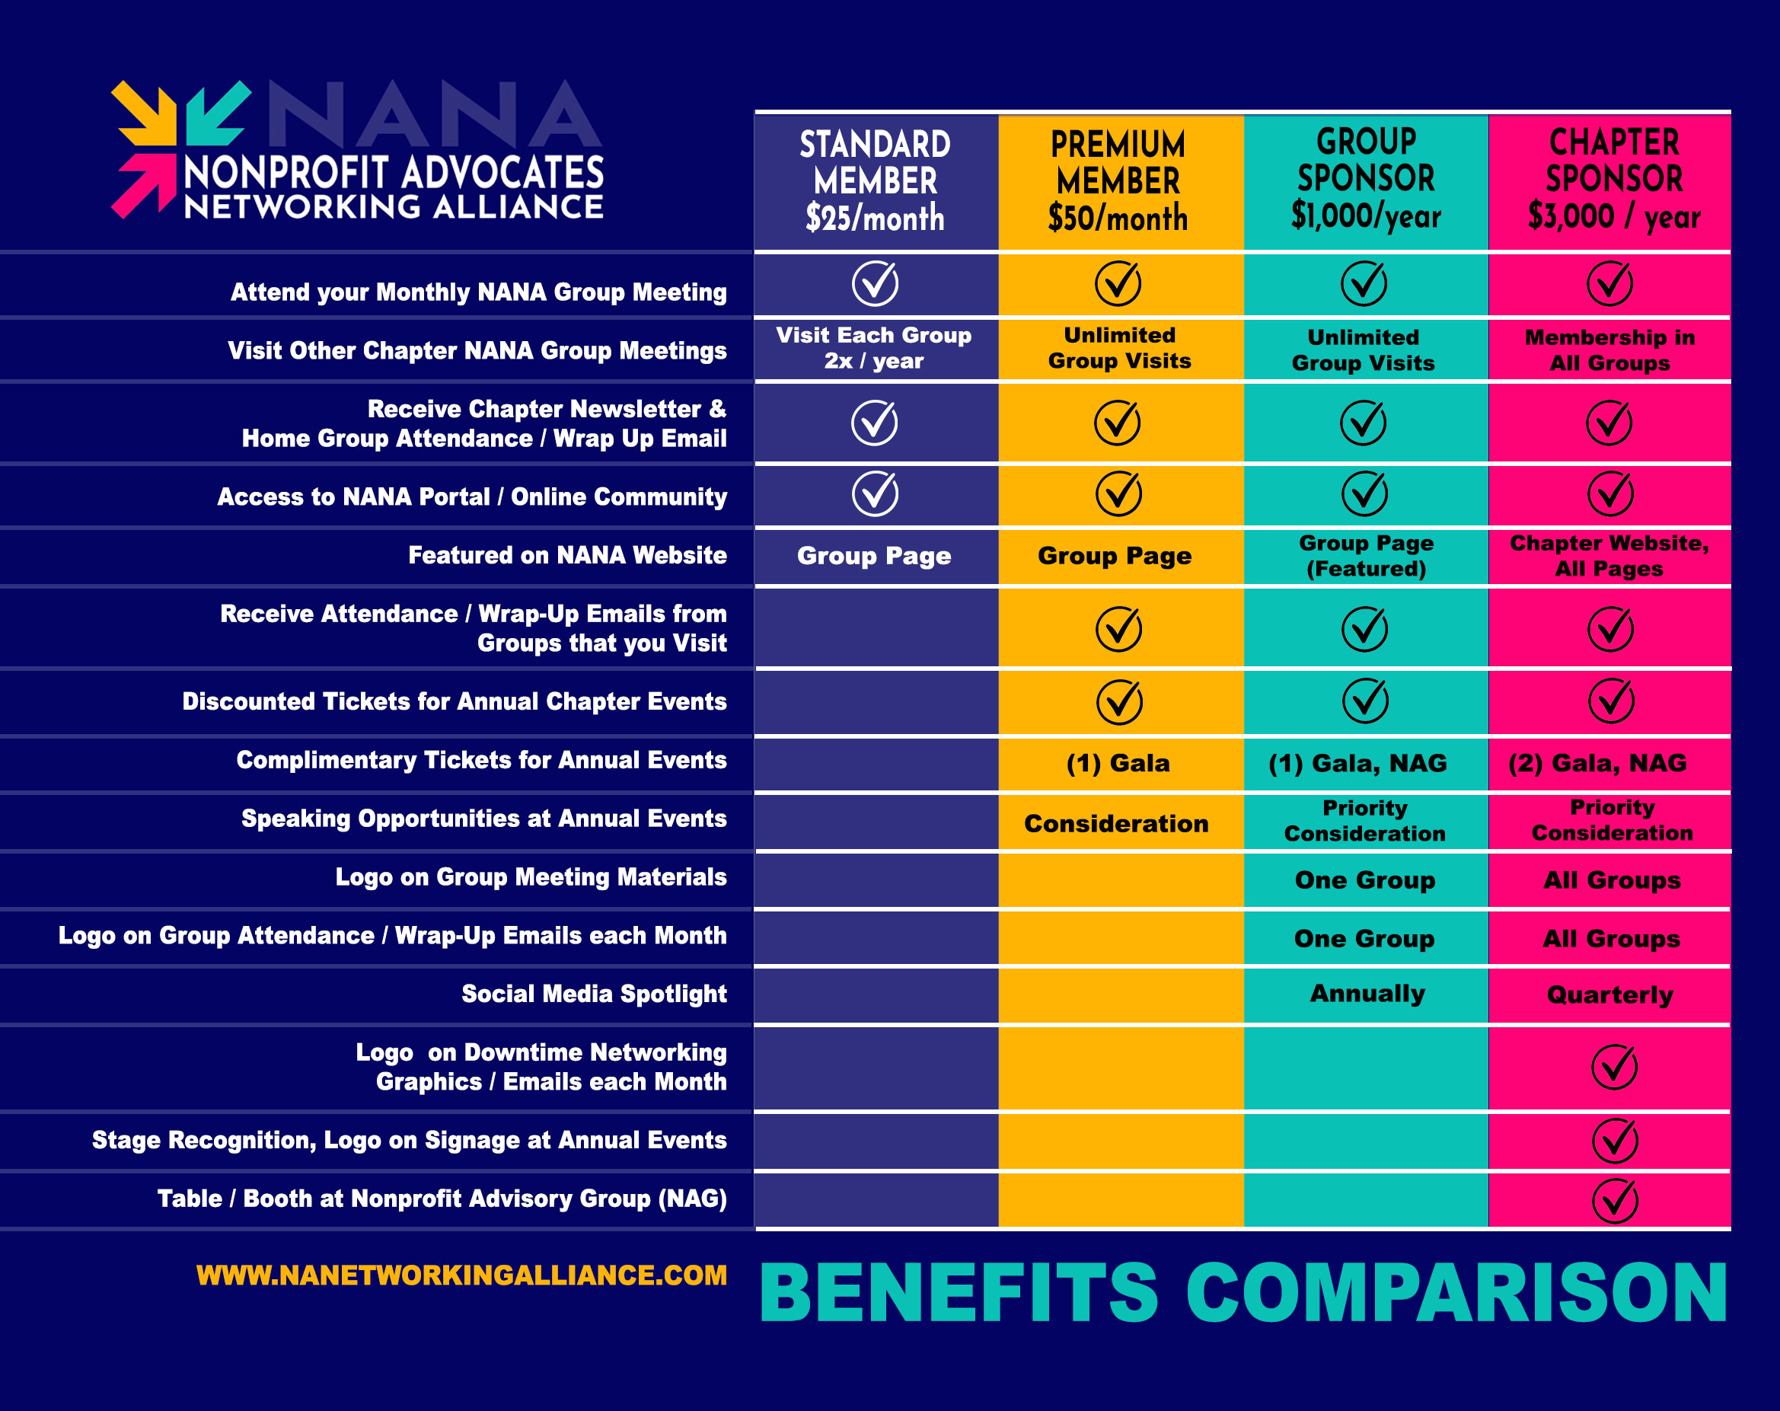

Ready to Join Us?
Sign up at nanetworkingalliance.com
Questions? Reach out — we’d love to tell you more.


Scan for more information or to Request a NANA Group!

