Acts 19: The Word Prevails in Ephesus

1. Paul Returns to Ephesus
Paul had already visited Ephesus briefly near the end of his second missionary journey.
During that earlier visit:
  - Paul reasoned with the Jews in the synagogue.
    - They asked him to remain longer.
    - Paul declined but expressed his desire to return.
  - Priscilla and Aquila remained in Ephesus.
    - They later encountered and instructed Apollos.
Acts 18:24–28
Paul returned to Caesarea, visited the church, and eventually returned to Syrian Antioch.
- After some time, he departed again.

Paul's Third Missionary Journey Begins - Acts 18:23
Paul traveled through Galatia and Phrygia, strengthening the disciples, before passing through the “inland country” and arriving at Ephesus.
Paul's route: Syrian Antioch → Galatia & Phrygia → inland Asia Minor → Ephesus

For Discussion
Why do you think Paul repeatedly returned to strengthen existing disciples rather than focusing exclusively on reaching new places?

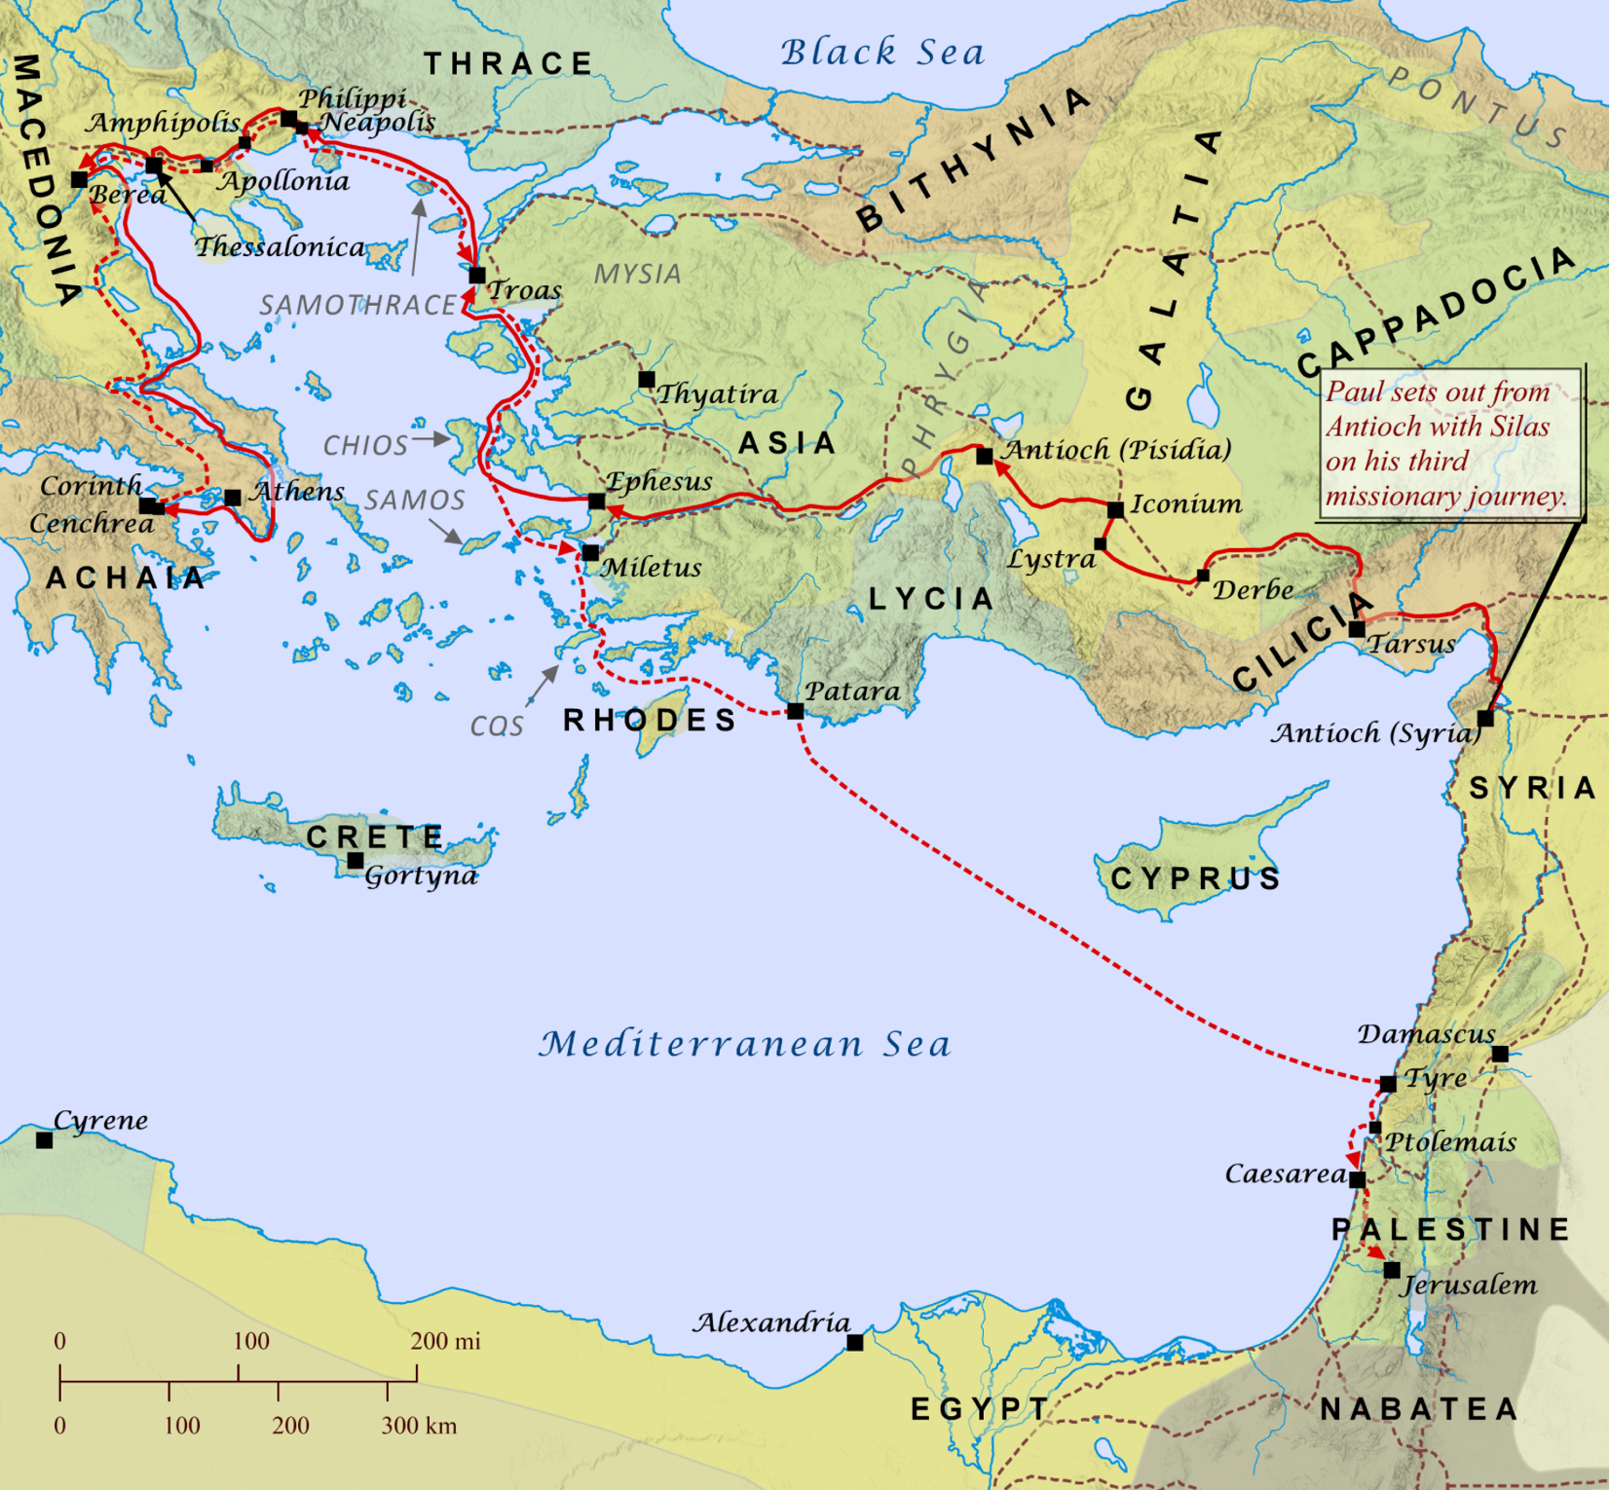

2. Welcome to Ephesus

Acts 19:1

“And it happened that while Apollos was at Corinth, Paul passed through the inland country and came to Ephesus. There he found some disciples.”

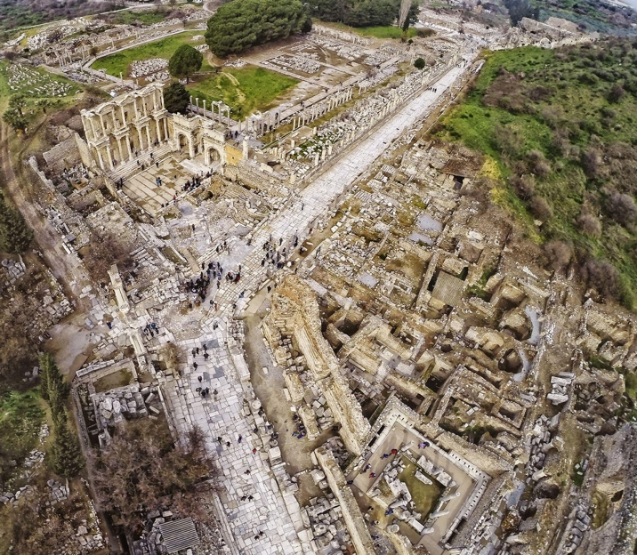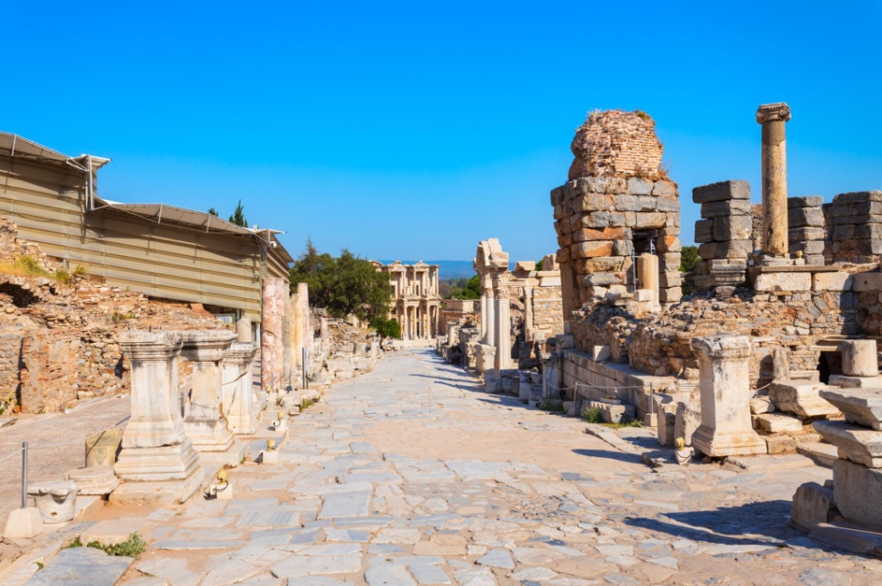
Ephesus was one of the great cities of Roman Asia.
It was:
- Wealthy and Famous for it’s temple to Artemis
- Spiritually Active: Famous for occult, magic, spells, curses, and pagan worship

The Temple of Artemis

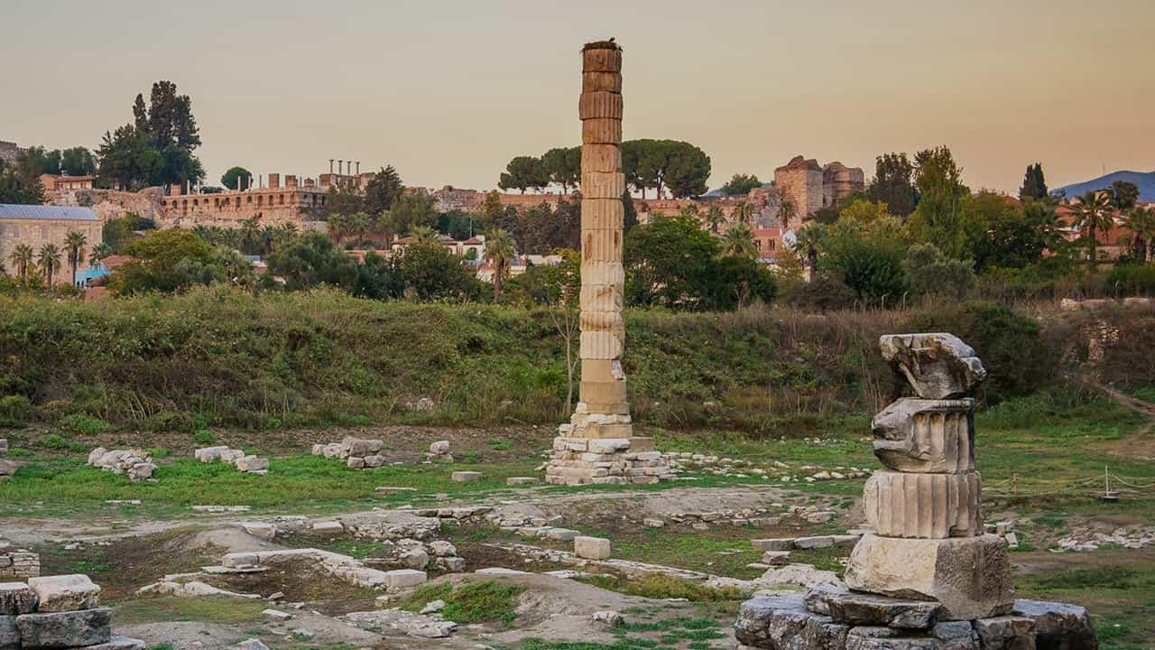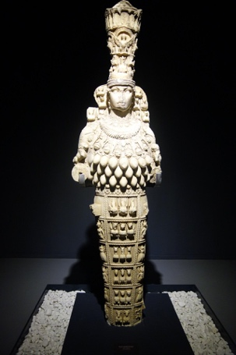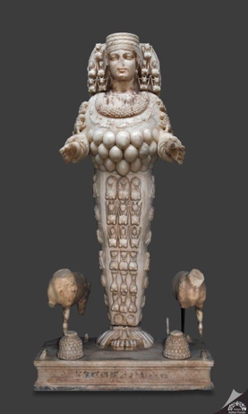
The enormous Temple of Artemis was considered one of the Seven Wonders of the Ancient World.
Artemis worship was woven into the city's:
- Religious life;
- Cultural Identity
- Commerce
- Tourism industry/economy
Acts 19:35 also refers to the Ephesian belief concerning a sacred object/image that had “fallen from heaven.”

Ephesus and Magic
Ephesus was also associated in antiquity with magic, incantations, amulets, and attempts to access or manipulate spiritual powers.
- The Ephesia Grammata (“Ephesian writings/letters”) became associated with magical words and formulas.
  - Basically, they were like magic spells you could wear for:
    - protection
    - Luck
    - Warding off demons
    - Blessings on business ventures, etc
This background helps us understand why Luke spends so much of Acts 19 describing:
- Powerful miracles
- evil spirits
- traveling exorcists
- invocation of spiritual names
- magical practices
- expensive books associated with magic

For Discussion
- How does knowing this background change the way we begin reading Acts 19?

3. Disciples of John Meet Jesus

Acts 19:1–7

“And it happened that while Apollos was at Corinth, Paul passed through the inland country and came to Ephesus. There he found some disciples. And he said to them, “Did you receive the Holy Spirit when you believed?” And they said, “No, we have not even heard that there is a Holy Spirit.” And he said, “Into what then were you baptized?” They said, “Into John’s baptism.” And Paul said, “John baptized with the baptism of repentance, telling the people to believe in the one who was to come after him, that is, Jesus.” On hearing this, they were baptized in the name of the Lord Jesus. And when Paul had laid his hands on them, the Holy Spirit came on them, and they began speaking in tongues and prophesying. There were about twelve men in all.”
Paul encounters approximately twelve men whom Luke calls disciples.
When Paul speaks with them, however, he discovers that their understanding has not progressed beyond the ministry of John the Baptist.
They know John's baptism.
  - John's ministry was preparatory.
  - He called Israel to repentance and told the people to believe in the One who was coming after him.
Paul identifies that One: Jesus.
These men had received John's message, but they had not yet understood its fulfillment in Jesus Christ.
- Paul essentially leads them to Christ.
They are:
- baptized in the name of the Lord Jesus;
- prayed for by Paul;
- filled with the Holy Spirit;
- enabled to speak in tongues and prophesy.

John's Ministry Always Pointed Beyond John

For Discussion
- Why was John's message of preparation no longer sufficient once the One to whom John pointed had come?

4. From the Synagogue to the Hall of Tyrannus

Acts 19:8–10

“And he entered the synagogue and for three months spoke boldly, reasoning and persuading them about the kingdom of God. But when some became stubborn and continued in unbelief, speaking evil of the Way before the congregation, he withdrew from them and took the disciples with him, reasoning daily in the hall of Tyrannus. This continued for two years, so that all the residents of Asia heard the word of the Lord, both Jews and Greeks.”
Paul begins where we have seen him begin repeatedly throughout Acts: The synagogue.
For three months, Paul speaks boldly, reasoning and persuading concerning The Kingdom of God.
- Eventually some become hardened and begin speaking against “the Way.”
- Paul withdraws with the disciples and begins teaching daily in the hall of Tyrannus.
This continues for approximately Two years.
Then Luke gives us an unbelievable summary of the results of Paul's ministry:
“All the residents of Asia heard the word of the Lord, both Jews and Greeks.” ~ Acts 19:10
How did that happen???
- Paul couldn’t personally be everywhere in Asia Minor.
The gospel was spreading through people.

GATHER → GROW → GO → MULTIPLY
Acts 19 gives us an interesting picture of how discipleship can spread.
- GATHER: People come together around Christ and His Word.
- GROW: Disciples are taught and strengthened.
- GO: Disciples carry what they have received to others.
- MULTIPLY: New disciples and new communities of believers emerge.

For Discussion
- What is the difference between building a ministry around one gifted teacher and building disciples who are equipped to carry the gospel to others?

5. Ephesus and the Lycus Valley

Paul had never visited the churches of the Lycus Valley:

“because of the hope laid up for you in heaven. Of this you have heard before in the word of the truth, the gospel, which has come to you, as indeed in the whole world it is bearing fruit and increasing—as it also does among you, since the day you heard it and understood the grace of God in truth, just as you learned it from Epaphras our beloved fellow servant. He is a faithful minister of Christ on your behalf and has made known to us your love in the Spirit.” ~ Colossians 1:5-8

“For I want you to know how great a struggle I have for you and for those at Laodicea and for all who have not seen me face to face” ~ Colossians 2:1

“Epaphras, who is one of you, a servant of Christ Jesus, greets you, always struggling on your behalf in his prayers, that you may stand mature and fully assured in all the will of God. For I bear him witness that he has worked hard for you and for those in Laodicea and in Hierapolis.” ~ Colossians 4:12-13

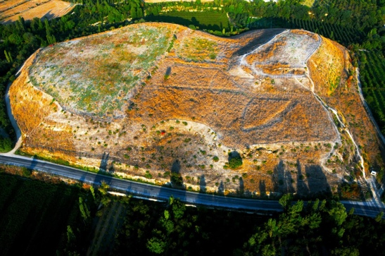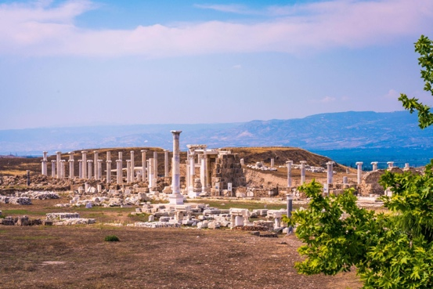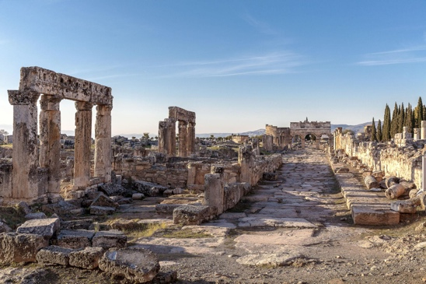

[Left to Right: Colossae Mound, Laodicean Ruins, Hierapolis Ruins]

East of Ephesus lay three cities that become important in the New Testament:
- Colossae
- Laodicea
- Hierapolis
Paul indicates that believers in Colossae and Laodicea had not personally seen him when he wrote to them.
- Yet the gospel had reached them.

Epaphras
Colossians 1:6–8 - The Colossians learned the gospel from Epaphras.
Colossians 4:12–13 - Epaphras also had a deep concern for believers in:
  - Colossae, Laodicea, and Hierapolis.
Scripture doesn’t explicitly tell us where Epaphras first encountered Paul or the gospel.
- But Acts 19 gives us a very important clue: “All the residents of Asia heard the word of the Lord.”

For Discussion
- What might this tell us about the importance of multiplication in the early church?

6. Real Power vs. Counterfeit Power

Acts 19:11–12

“And God was doing extraordinary miracles by the hands of Paul, so that even handkerchiefs or aprons that had touched his skin were carried away to the sick, and their diseases left them and the evil spirits came out of them.”
Luke describes extraordinary events during Paul's Ephesian ministry.
His wording is important:
“God was doing extraordinary miracles by the hands of Paul.”
In other words, Paul is not the source of the power… God is

God was doing the work.
  - Even handkerchiefs and work aprons associated with Paul were carried to the sick, resulting in healing and deliverance from evil spirits.
In a city already fascinated with spiritual power, God was showing His superior power through the ministry of Paul

Acts 19:13–17

“Then some of the itinerant Jewish exorcists undertook to invoke the name of the Lord Jesus over those who had evil spirits, saying, “I adjure you by the Jesus whom Paul proclaims.” Seven sons of a Jewish high priest named Sceva were doing this. But the evil spirit answered them, “Jesus I know, and Paul I recognize, but who are you?” And the man in whom was the evil spirit leaped on them, mastered all of them and overpowered them, so that they fled out of that house naked and wounded. And this became known to all the residents of Ephesus, both Jews and Greeks. And fear fell upon them all, and the name of the Lord Jesus was extolled.”
Traveling Jewish exorcists observe what is happening through Paul.
They attempt to invoke “the name of the Lord Jesus.”
  - Among them are seven sons of a Jewish chief priest named Sceva.
Their words are revealing:
  - “I adjure you by the Jesus whom Paul proclaims.”
  - In the ancient world, magical and exorcistic practices could involve invoking names, formulas, and spiritual beings in an attempt to exercise influence over spiritual forces.
These men have discovered another name associated with extraordinary power:
- Jesus.
But the evil spirit responds: “Jesus I know, and Paul I recognize, but who are you?”
- The encounter ends disastrously for the seven men.

For Discussion
- Why do you think invoking Jesus' name produced such different results for Paul and for the sons of Sceva?
- What does their phrase “Jesus whom Paul proclaims” tell us about their relationship to Jesus?

7. The Books Begin to Burn

Acts 19:17–20

“And this became known to all the residents of Ephesus, both Jews and Greeks. And fear fell upon them all, and the name of the Lord Jesus was extolled. Also many of those who were now believers came, confessing and divulging their practices. And a number of those who had practiced magic arts brought their books together and burned them in the sight of all. And they counted the value of them and found it came to fifty thousand pieces of silver. So the word of the Lord continued to increase and prevail mightily.”
News of the encounter spreads throughout Ephesus.
Luke tells us: “The name of the Lord Jesus was extolled.”
- Many believers come forward confessing their former practices.
- Those who had practiced magic bring their books together and burn them publicly.
Luke estimates their combined value at 50,000 pieces of silver.
- The amount was equal to about 137 years of labor – Millions of Dollars
Luke clearly intends us to understand: This was enormously costly.

For Discussion
- Why burn these books instead of selling them?
- What does their decision tell us about repentance?
- Is there a difference between regretting something and decisively turning away from it?

Luke's Summary

Acts 19:20

'So the word of the Lord continued to increase and prevail mightily.”

8. Paul Looks Toward Jerusalem and Rome

Acts 19:21–22

“Now after these events Paul resolved in the Spirit to pass through Macedonia and Achaia and go to Jerusalem, saying, “After I have been there, I must also see Rome.” And having sent into Macedonia two of his helpers, Timothy and Erastus, he himself stayed in Asia for a while.”
Something important changes in the story.
- Paul begins looking beyond Ephesus.
  - His intended movement now points toward:
    - Macedonia → Achaia → Jerusalem → Rome
- Paul says:
  - “After I have been there, I must also see Rome.”
- From this point forward
  - Acts will increasingly move toward Jerusalem and ultimately Rome.

9. Demetrius, the Riot, and the Great Theater:

Acts 19:23–27

“About that time there arose no little disturbance concerning the Way. For a man named Demetrius, a silversmith, who made silver shrines of Artemis, brought no little business to the craftsmen. These he gathered together, with the workmen in similar trades, and said, “Men, you know that from this business we have our wealth. And you see and hear that not only in Ephesus but in almost all of Asia this Paul has persuaded and turned away a great many people, saying that gods made with hands are not gods. And there is danger not only that this trade of ours may come into disrepute but also that the temple of the great goddess Artemis may be counted as nothing, and that she may even be deposed from her magnificence, she whom all Asia and the world worship.”
A silversmith named Demetrius gathers craftsmen whose livelihood is connected with Artemis worship.
He recognizes that Paul's ministry is creating a serious problem.
- Paul is hurting his bottom line
  - So many people are following Jesus that it makes a dent in his business
  - Their trade is in danger.
- Religion
  - Artemis may be discredited.
- Cultural Identity
  - Ephesus is known to be the Temple Keeper of Artemis
    - The goddess worshiped throughout Asia and the world may lose her greatness.
- Demetrius summarizes Paul's message:
  - Paul has persuaded people that “gods made with hands are not gods.”

For Discussion
- Why would Paul's preaching create an economic problem for the silversmiths?
- What does Demetrius seem to care about most?

“Great Is Artemis of the Ephesians!”

Acts 19:28–41

“When they heard this they were enraged and were crying out, “Great is Artemis of the Ephesians!” So the city was filled with the confusion, and they rushed together into the theater, dragging with them Gaius and Aristarchus, Macedonians who were Paul’s companions in travel. But when Paul wished to go in among the crowd, the disciples would not let him. And even some of the Asiarchs, who were friends of his, sent to him and were urging him not to venture into the theater. Now some cried out one thing, some another, for the assembly was in confusion, and most of them did not know why they had come together. Some of the crowd prompted Alexander, whom the Jews had put forward. And Alexander, motioning with his hand, wanted to make a defense to the crowd. But when they recognized that he was a Jew, for about two hours they all cried out with one voice, “Great is Artemis of the Ephesians!” And when the town clerk had quieted the crowd, he said, “Men of Ephesus, who is there who does not know that the city of the Ephesians is temple keeper of the great Artemis, and of the sacred stone that fell from the sky? Seeing then that these things cannot be denied, you ought to be quiet and do nothing rash. For you have brought these men here who are neither sacrilegious nor blasphemers of our goddess. If therefore Demetrius and the craftsmen with him have a complaint against anyone, the courts are open, and there are proconsuls. Let them bring charges against one another. But if you seek anything further, it shall be settled in the regular assembly. For we really are in danger of being charged with rioting today, since there is no cause that we can give to justify this commotion.” And when he had said these things, he dismissed the assembly.”
The city erupts.
The crowd seizes Paul's companions Gaius and Aristarchus
- and rushes into the Great Theatre of Ephesus.
Paul wants to enter the assembly, but the disciples prevent him.
- Even some of the “Asiarchs” - influential provincial officials who were friendly toward Paul, urge him not to enter.
Luke gives us an interesting description of the crowd:
- “Most of them did not know why they had come together.” ~ Acts 19:32
Eventually the crowd recognizes that Alexander is Jewish.
- For approximately two hours, they shout: “Great is Artemis of the Ephesians!”
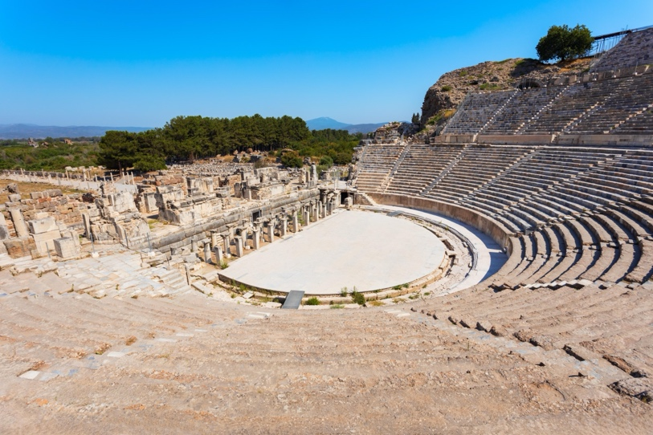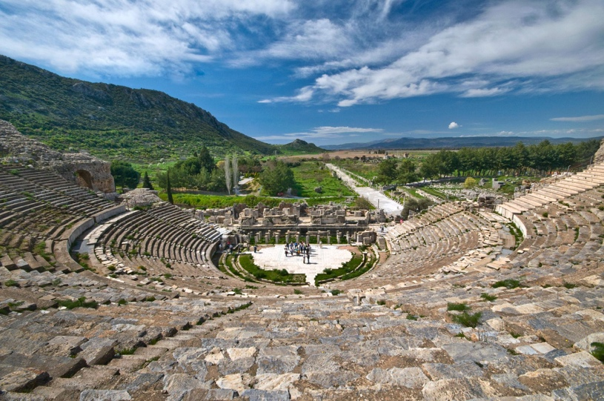
The theatre still stands today.
- It could accommodate roughly 20,000–25,000 people.
Imagine this space filled with people shouting the same words for two hours.

The Town Clerk:
The town clerk finally quiets the crowd.
He reminds them that:
- Ephesus is known as the temple keeper of Artemis
- Demetrius and the craftsmen have access to the courts
  - Legitimate accusations should be handled legally
- The city risks being accused of rioting
Finally the crowd settles down and goes home.

For Discussion
- What does Luke's description of the riot tell us about the relationship between religion, economics, civic identity, and public opinion in Ephesus?

10. Acts 19 and Paul's Letter to the Ephesians
Paul's experiences in Ephesus provide interesting background for reading his later letter to believers associated with the city.
As you read these passages, listen for language that sounds particularly significant after studying Acts 19:

Ephesians 1:19–23 - Power, authority, dominion, and the exaltation of Christ

Ephesians 2:1–6 - Former spiritual condition and new life in Christ

Ephesians 3:7–12 - The church and the rulers and authorities in the heavenly places

Ephesians 5:6–14 - Darkness and light

Ephesians 6:10–18 - Spiritual warfare and the armor of God

Final Discussion
- After studying Acts 19, what words or ideas in Ephesians now stand out to you differently?
- What connections do you see between Paul's experiences in Ephesus and the things he later emphasizes in his letter?

