Use of an Innovative Material for Biotech Applications in Agriculture

M. Rippa², E. Lahoz^{1*}, M. Cermola¹, P. Mormile², V. Battaglia¹
¹ CREA - Centro di ricerca Cerealicoltura e colture industriali, Via Torrino 3, 81100 Caserta
²Istituto di Scienze Applicate e Sistemi Intelligenti “Eduardo Caianiello” del CNR, Via Campi Flegrei 34, 80072 Pozzuoli (Na)
Abstract
Pesticide treatments are largely used in agriculture in the control of a wide range of biotic stresses. Huge quantity of chemicals is employed in agriculture. Number and interval of treatments depend on plant growth, washout, risk of infection, disease pressure, quality of distribution on leaves, and scheduled application. This cause concern about environment and human health, and an economic impact on farmers activity. Sustainable methods to reduce impact of chemicals pollution and residues on soil and plant should be explored not only with a complete elimination of chemicals but also reducing the amount and number of chemical applications per year, by using new biotech materials that the research world is proposing. Formulation and adjuvants could play an important role in increasing bioavailability and regulate frequency of applications. The addition of an appropriate adjuvant to a foliar fungicide can significantly improve coverage, absorption, efficacy and can reduce the total amount applied in a season. Among different chemicals, polysaccharides, particularly, galactomannans are used in edible films or coatings for food make them very interesting for any potential use in agriculture. The results of use of a new natural polysaccharide based on locust bean gums is presented and, according to interesting results of our trials, it is proposed for different biotech application, ranging from reduction of chemical treatments to seed coating and application on plant with beneficial microorganisms. In particular, the results of experimental use of galactomannan adjuvant as in copper fungicide applications and formulant for beneficial microorganisms are reported. Data demonstrated that: i) the use of this natural adjuvant increase persistence on leaves of copper fungicides reducing the amount of copper need to control Plasmopara viticola on grape and ii) increase the efficacy and activity of the beneficial microorganisms such as Trichoderma spp. and Clonostachys rosea as seed coating on wheat.

Keywords: natural adjuvant, crop protection, copper reduction, pulsed thermography, SEM, Clonostachys rosea

Introduction
Copper compounds are largely used in agriculture in the control of a wide range of plant diseases caused by bacteria and fungi. Copper has been used for the first time as fungicide in 1761; for more than 100 years it was the only fungicide used to control the fungus Plasmopara viticola the causal agent of downy mildew. However, its effect is not sufficient to provide protection unless combined with several other methods and even then, if the climatic conditions are too favorable to the disease, organic farmers have little means to combat downy mildew effectively except for copper sprays (Finckh et al., 2015) Copper is the subject of new interest for two opposite reasons: the first is the increased interest for the use of natural compound and organic farming and the second the concern about its ecotoxicological profile particularly due to accumulation in the soil (Mackie et al., 2012). This new scenario modified the phytoiatric use of copper in the rate, strategy and created the need to reduce the total amount used. Copper does not degrade into the soil, leading to its accumulation into agricultural soils (up to 1.280 mg kg⁻¹ of soil. against 5-20 mg kg⁻¹ in the soils not used for agriculture) and watercourses, and it is toxic for terrestrial fauna. World Health Organization (WHO) assessed that daily assumption of copper should not exceed 0.5 mg kg⁻¹. For this reason, the amounts of copper compounds are limited in organic farming: 7 kg year⁻¹ ha⁻¹, according to EU regulation (889/2008). Sustainable methods to reduce toxicological impact of copper pollution and copper residues on vegetable products for human consumption should be explored. The number and the interval of copper applications depend on plants growth, on washout, on risk of infection and the quality of distribution on leaves. The formulation and the adjuvant could play an important role to increase bioavailability and to regulate frequency of application on grape. The addition of an appropriate adjuvant with foliar fungicide can significantly improve coverage, absorption, and efficacy and reduce the total amount for season. Field studies evaluated coverage, absorption, and efficacy of commercial adjuvants with diverse chemistries on multiple hosts–pathogen systems. Adjuvants are additives used for many purposes: to increase persistence on leaves, to regulate the absorption, spray retention the rain fastness the foliar wash off and runoff losses and pesticide translocation. Adjuvant can influence the efficacy of pesticides (Grayson et al., 1996), obtaining contemporary economic and environmental benefits. Only 3% of adjuvants were referred to fungicides use; actually, the number of works on this matter decreased further. Field studies on adjuvants with the aim to improve fungicide utility and efficacy have been demonstrated with relatively few chemistries and crop species. Among different chemical groups the polysaccharides have been tested on economically relevant crops, prevalently to investigate its interaction with the plants and its eventual ability to induce resistance to fungal pathogens, such as chitosan, carrageenan, fucans, laminarins and ulvans. In addition, adjuvant is also necessary in biocontrol agent formulations, for the application on seeds mainly for the use in organic farming. The roles of adjuvant are both to increase shelf life and efficacy of biological control agents. However, some adjuvants may have harmful effects on non-target organisms and ecological environments. Herein, to promote research and improvement of microbial pesticides, the types of microbial pesticide formulations and research progress of adjuvants and their applications in microbial pesticides are decisive. New manufacturing technologies and co-formulants for organic farming, often sustainable, offer safer use and a lower environmental footprint with improved efficacy. For many of the reasons mentioned above, ingredient suppliers are asked to develop greener, more robust, highly compatible solutions that can perform well in water-dispersible granules, suspension concentrates and capsule suspensions. Here, it is considered a new polysaccharide gel used as a natural adjuvant to reduce the amount of copper need to control downy mildew of grapevine and to increase shelf life and efficacy of Trichoderma and Clonostachys isolates used as beneficials in agriculture. The use of natural polysaccharides extracted from locust bean gums as adjuvant of copper fungicides and beneficials have never been reported. In the present work trials were carried out with the aim to i) evaluate the effect and mechanisms of a new polysaccharide adjuvant (derived from locust bean gums) associated to copper oxychloride fungicide on the efficacy to control downy mildew of grapevine with a reduced amount of copper fungicide; ii) evaluate if this adjuvant used in the formulation helps the beneficial microorganisms to increase the performance when applied as seed coating.
Use of new polysaccharide adjuvant as sticker in the application of copper-based fungicides.
Ten trials were carried out from 2014 to 2023 with the aim to confirm the ability of our polysaccharide adjuvant derived from locust bean gums (GA) in increasing persistence and maintaining a good efficacy of copper oxychloride fungicide. The following treatments were compared: i) untreated control (UC); ii) new polysaccharide adjuvant applied alone (GA); iii) copper oxychloride plus GA adjuvant applied every 7 days (CuGA7); iv) copper oxychloride plus GA adjuvant applied every 14 days (CuGA14); v) copper oxychloride alone every 7 days (Cu7); vi) copper oxychloride alone every 14 days (Cu14).
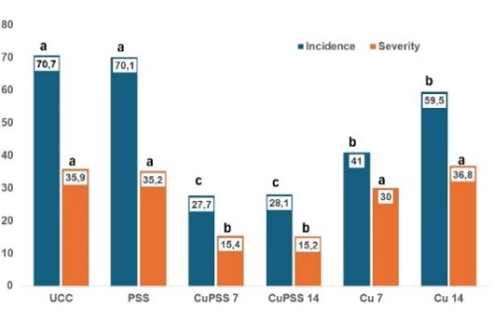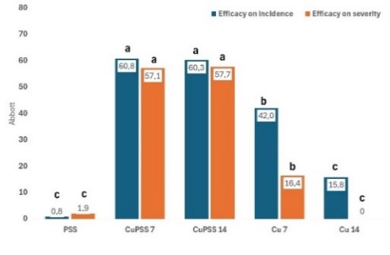
Fig. 1: Incidence and Severity (left) and efficacy (right) assessment in the following treatments: UCC (Untreated control); GA (polysaccharide adjuvant derived from locust bean gum alone); CuGA7 (Cu Oxychloride + GA every 7 days); CuGA14Cu (Oxychloride + GA every 14 days); Cu7 (Cu Oxychloride every 7 days); CuGA14 (Cu Oxychloride every 14 days). Means with the same letters are not significant different at Tukey’s test (p = 0.05)

In figure 1 are reported mean data of incidence, severity of symptoms and efficacy on P. viticola on grapes of the compared treatments. The trials had the same variance so that statistical analyses were performed considering the trials as replications of one trial. The efficacy was higher for the treatments where adjuvant was added and was the same between the applications made every 7 days (CUGA7) and 14 days (CUGA14). The number of applications per year in treatments made every 7 days were seven, while were only four per year when fungicide was applied every 14 days. Data demonstrated that GA is an appropriate adjuvant that could improve disease control and may allow longer fungicide application intervals. GA reduced the annual amount of copper from 7.9 kg ha⁻¹ applying copper oxychloride every 7 days (7 applications per year) to 4.5 kg ha⁻¹ when applied every 14 days mixed to GA. In years in which P. viticola infection resulted in huge product loss, especially in organic cultivations (>70%), the use of GA as adjuvant gave the possibility to use copper fungicides having longer persistence, contemporary maintaining the permissible total amount of copper per year and a satisfactory effectiveness, maintaining the allowed minimum residue level of copper on grape berries. Scanning electron microscopy (SEM) associated to microanalyses and pulsed thermography were also used to study the characteristics of our adjuvant.

Fig. 2: Leaf surface treated with copper oxychloride alone after 8 days from Application (A). Copper is scattered with low presence of particles. Leaf surface treated with copper oxychloride mixed with locust bean gum preparation (GA) observed by SEM after 8 days from application. Copper particles are uniformly distributed on leaf (B).

In figure 2 are reported two SEM observations of leaf pieces after 8 days from copper application without adjuvant, on the left, where copper is scattered with low presence of particles and with adjuvant, on the right, where copper particles are abundant and uniformly distributed. Micro analyses of particles indicated that the visible particles observed were made up of copper. These results pointed out the GA was able to increase copper fungicide persistence. The use of Active Thermography (AT) is a well-known non-contact and non-invasive imaging technique that in recent years it is gaining great interests in agriculture. It has been used to evaluate physical and physiological characteristics of plants such as: transpiration rates, heat capacity of the leaves, local water content, response to UV interaction and it fits well with emerging demands of the precision agriculture management strategy. According to this technique, the surface of the sample under investigation is stimulated using an external heat source and its thermal response is detected and recorded using an infrared camera. Applied on leaf, copper-based fungicide (CBF) remains deposited, thermal recovery and it is not absorbed into plant tissues causing accumulation problems that needs to be monitored and controlled also by using modern technologies. In this work, thermographic methods to detect and to monitor the presence of CBF on grapevine leaves were used. Our experimental results demonstrate that our adjuvant increase the time of persistence of copper on leaves. In figure 3A is shown the experiment setting while in figure 3B is shown a thermography where a color scale is related to the presence of copper particles on leaf. While in figure 3C is reported the time course of quantity of copper on leaves recovery and copper presence on leaves is the times of thermal recovery in presence of adjuvant were reported. The time of thermal recovery increased about the quantity of copper presents on leaves. In figure 3D were reported the data of analyses made by chemical methods in the same days of thermography assessment that confirmed the relationship between the time of thermal recovery and the real concentration of copper found on leaves. The results of thermography confirmed both the efficacy of this method and again the ability of the new polysaccharide adjuvant to increase the persistence of copper, resulting as reported above in the reduction of copper per year needs to control P. viticola.

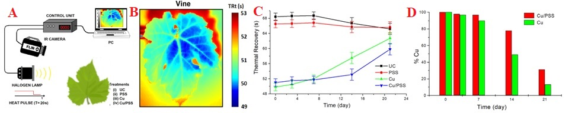
Fig. 3: Experimental setting (A), spatial map of the TRt calculated for two leaves with Cu treatment grapevine leaf (B),
Rt analysis on grapevine leaves in treatments: UC, GA, Cu⁺⁺, and Cu⁺⁺ + GA. Percentage of Cu⁺⁺ measured during the monitoring for Cu⁺⁺ and Cu⁺⁺ + GA treatments (D).
Locust bean gums derived adjuvant as seed coating material.
Seed coating is considered one of the best methods to promote sustainable agriculture where the physical and physiological properties of seeds can be improved to facilitate planting, induces plant growth promotion, and alleviate abiotic and biotic stresses. In our work we applied on wheat seeds our isolate of beneficial fungi belonging to the species Clonostachys rosea by film coating. A trial was carried out with the aim to compare the performance of our beneficial fungal isolate as seed coating in presence of new adjuvant or not. In table 1 are reported the results of plant growth and physiological parameters related to nitrogen metabolism assessed on 40 plants per treatment of wheat plants 60 days after sowing. The data demonstrated that the presence of our natural adjuvant increased the ability of C. rosea to induce both a greater growth promotion and nitrogen metabolism index than in absence of the new polysaccharide adjuvant.
Table 1: …………..
Treatment | Epicotyl height (cm) | Hypocotyl length (cm) | Fresh weight  (g) | SPAD  index | Chlorophyll
Untreated control | 37.0 ± 1.0 c | 8.0 ± 0.5 b | 1.6 ± 0.1 c | 30.9 | 0.36
C. rosea | 39.9 ± 1.8 b | 8.4 ± 0.4 b | 3.9 ± 0.3 b | 42.6 | 0.68
C. rosea + GA adjuvant | 42.5 ± 1.1 a | 9.1 ± 0.6 a | 4.3 ± 0.4 a | 38.9 | 0.60

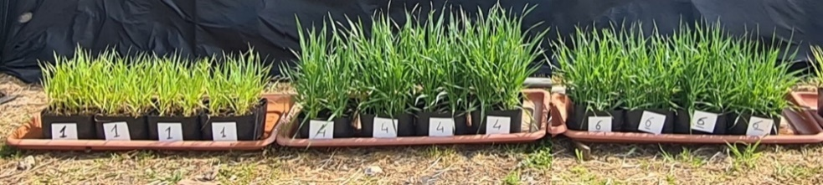
Conclusion
We demonstrated the efficiency of our adjuvant in reducing the quantity per year of chemical copper fungicides and the environmental impact of these class of fungicides and the total safety of this new compounds based on polysaccharide component of locust bean gums also green pesticides has been gradually accepted by the pesticide industry; consequently, they are actively promoting the use of more environmentally friendly solvents and substances. Compared to chemical pesticides, desirable properties of microbial pesticides include target specificity, low environmental persistence, and low non-target biological toxicities. At present, most microbial pesticide adjuvants are very similar to those of chemical pesticides. It is necessary to establish standard administration systems for various adjuvants used for microbial pesticides. That is, all adjuvants of microbial pesticides should be subject to the same risk assessments as that of the active ingredients. Since the active ingredients of microbial pesticides are microorganisms, the effects of adjuvants on the survival and proliferation of the microorganisms should be considered. That is, biocompatibility between the adjuvants and microorganisms used for microbial pesticides should be determined in storage periods. The effects of adjuvants on the proliferation of microorganisms in crop fields should also be investigated after the application of microbial pesticides. Focus should also be placed on ensuring adjuvants have stronger adsorption capacity, higher dispersion performance, and better safety to enhance biocontrol efficiency of microbial pesticides by improving physical and chemical properties of adjuvants. Microbial pesticides are key products for the development of sustainable and efficient green agriculture. They will replace highly toxic and highly residual chemical pesticides with the help of sustainable green adjuvants. The new adjuvant based on polysaccharide composition derived from locust bean gum is completely natural and helps fungicides and beneficials to have better performance.
Acknowledgements

References
- B. T. Grayson, J. D. Webb., D. M. Batten., and D. Edwards (1996). Effects of adjuvants on the therapeutic activity of dimethomorph in controlling vine downy mildew. I. Survey of adjuvant types. Pesticides. Science, 46,199-206.
- K.A. Mackie, T. Müller, E. Kandeler (2012). Remediation of copper in vineyards – A mini review. Environmental. Pollution, 167, 16–26.
- M.R. Finckh, L. Tamm, and C. Bruns (2015). Organic potato disease management, in Plant Diseases and their Management in Organic Agriculture, Ed. by Finckh M.R., van Bruggen A.H.C. and Tamm L. APS Press. St Paul. MN. 239–257 pp.
- E. Lahoz, P. Tarantino, P. Mormile, Malinconico Mario, B. Immirzi, M. Cermola, R. Carrieri (2018). Evaluation of a new natural adjuvant obtained from locust bean gum to reduce the amount of copper necessary to control downy mildew of grapevine. J Plant Dis Prot 125:287–296 https://doi.org/10.1007/s41348-017-0136-2
- M. Rippa, V. Battaglia, M. Cermola, M. Sicignano, E. Lahoz, P. Mormile (2022). Monitoring of the copper persistence on plant leaves using pulsed thermography. Environ Monit Assess 194: 160 https://doi.org/10.1007/s10661-022-09807-x

