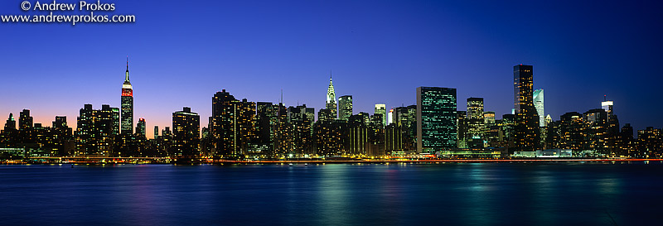

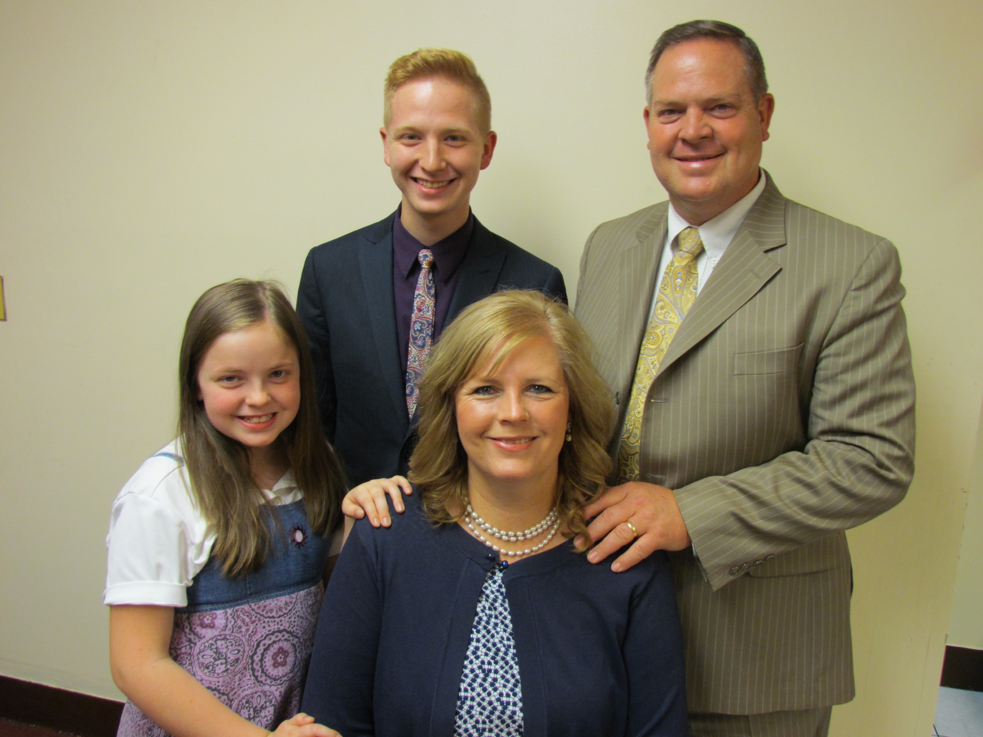
Dear Praying Friends, April 10, 2018
The Dice Family
Church Planting Missionaries in New York City

G
reetings from the Mission Field of many people within our nation's borders, New York City! There are over 167 different nationalities in Queens, NY, alone! We have 20 different nationalities in our church in Jamaica, Queens! There are only 25-30 Independent Baptist Churches that I know of in the five boroughs. We need laborers to come and start churches in this city of 8.6 million people!

T
he winter here has been long! We had extreme cold and over a foot of snow in January. In March we had four Nor'easters, snowstorms, each one week after week in March. We make the most of the time though knocking doors in buildings to reach people with the gospel. We had a nice day, the day before Resurrection Sunday, and knocked doors in nearby projects. We had a wonderful time being able to talk to many people about the Lord! A family of five came on Easter from those projects! We had a total of sixteen visitors on Easter, tied our high day with 127 attending, and one older lady, Adelle, trusting Christ! On the next Sunday, 4-8-18, we had two ladies saved, Daizy and Celithia, and seven baptized. Our Son Nathanael, having his salvation settled was baptized. Our daughter Esther was saved at Omni-night at Solid Rock Baptist Church in Berlin, NJ! She also was baptized! We invited some local pastors to come preach on Friday evenings in January. Pastor Bryan Phalon came early in January, then Pastor Phil Erickson came later in January, and brought a big group from their church. For our Valentine Banquet we had Pastor Matt Swiakowski come to preach! The last of February we had Evangelist Joe Kaiser come for our Winter Camp! These services were a real blessing to all of us! I have been preaching through a series in Hebrews, chapter by chapter, on Wednesday evenings and the addresses to the churches by Jesus Christ in Revelation 2 and 3 on Sunday evenings.

I
went to Capital Connection in Washington DC with Esther in March! This was a tremendous time of ministry! Bro. Chuck Harding and Pastor Mike Creed did a great job organizing this year's event. We have 11 districts in Long Island and New York City. I and some upstate pastors went to the offices of our Federal Representatives. We presented each with a handsome leather bound book written in the 1800's by Benjamin F. Morris. It is The Christian Life and Character of the Civil Institutions of the United States. I have been reading this book, and it is tremendous. I recommend it wholeheartedly! I was able to pray with our district representative, Rep. Gregory Meeks and his Executive Secretary, Linda. We also saw and prayed with Rep. Tom Suozzi, and Pastor Major witnessed the gospel to him! We also prayed with four of the staff of Rep. Yvette Clarke! This is an amazing time with preaching in the evenings and also hearing different leaders speak to us in joint sessions. I pray more pastors will go next year from all over the country! March 2019! Take a look at Awake America - Capital Connection 2018 on the internet, it will give you the details of this year. It is very interesting!

T
his past week was Spring Break in New York City! On Monday Ben Potter came to see Queens with me. He is praying about starting a church here. I showed him six areas I am praying for, to have churches started. Pray for God's leading for him! We maximize on this time off having our Spring Revival. Pastor Rick Dawson came and preached for us. He is our sending church pastor. It has been a great week for all of us! During the week of our revival our home boiler began leaking from a crack. Our home church sent us $2,700.00 to replace the boiler! Praise God! Our church is growing and excited about the Lord! I pray this is the year God gives us a larger building! We have been saving, praying, and looking into buildings! What is amazing is that there are four properties that are available right now in our area! This will take a supernatural work of God for us to have a building! I often challenge our people saying, "We must do our part before God will do His part. We must do what we can do, and God will do what we cannot do!" Pray with us for the salvation of these people we minister to, pray for us to get a larger facilities, and pray for God to strengthen, provide, and that His hand would be upon us as we serve Him! We appreciate your gifts at Christmas time, your cards, your love and prayers! Thank you for investing financially in us and in this needed ministry to the people in New York City!

In Christ,
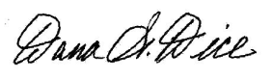
Sending Church: Clearview Baptist Church 10 Gospel Rd., Heber Springs, AR 72543 (501)362-5674
Mission Address: B.I.M.I. P.O. Box 9 Harrison, TN 37341 (423)344-5050
Field Address: 89-11 204th Street, Hollis, NY 11423 my cell (646)382-4583 e-mail danajulienyc@juno.com

Our Website - dicefamily.org

