Simply Equine, LLC
Riding Agreement
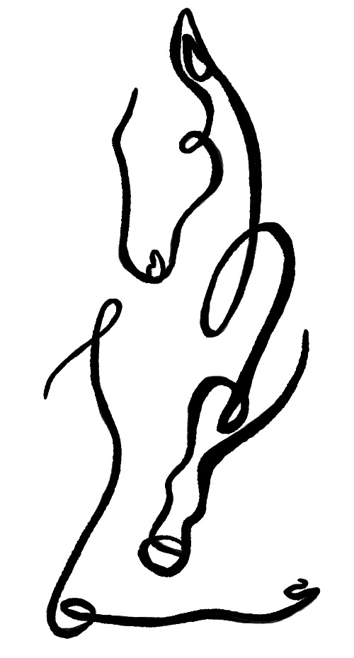

Thank you for choosing Simply Equine, LLC to help you learn all about horses! We are excited to work with you! Please take a moment to give us your information and complete our rider release form and training agreement.

Students information:

Rider’s Name:________________________________Date of Birth:____________________
Street Address:________________________________________________________
City, State, Zip:________________________________________________________
Home Phone:_________________________________________________________
Cell Phone:___________________________________________________________
Parent/Guardian/Conservator (if applicable):_________________________________
Email:_______________________________________________________________
Allergies:____________________________________________________________
Previous Injuries / Special Needs: _________________________________________
____________________________________________________________________

- The Services

- Simply Equine, LLC will provide student with access to one riding lesson per week, and one unmounted group horsemanship class per month. The riding lessons will either be a 30 minute private or 45-60minute semi-private of 2-3. Simply Equine, LLC Riding School will be closed 3 weeks per year to give the lesson horses a break, to run special events, and to give riding instructors a break. The weeks that are off will be communicated via the lesson calendar available on our website.

- Riders will be automatically grouped together with riders of similar ability and level. This is paramount to our barn culture and philosophy of creating a community that encourages camaraderie, friendship, and support. We feel this leads to higher quality riding, lessons, and just plain more fun.

- Riders will start with a 30 minute private lesson until their instructor recommends they are ready to join an appropriate group lesson.

- Students will receive access to a 15 minute goal setting session every month.

Initial:____________

- Student Requirements

- Students who can, must show up on time, or 20 minutes early to groom and tack.
- Student must be wearing proper riding attire- boots with heels, an ASTM/ SEI certified riding helmet, and riding pants
- Student must be coachable, positive, and have a good attitude!
- We are trying to build a family-like community full of people like YOU, and after the 4th lesson we generally like to ask for the name of 1 person who you would like us to contact and invite to join the program.

Initial:____________

3. Compensation and Payment Terms

- Student will put a credit or debit card on file, and it will be automatically charged $____tuition every 4 weeks - Charges will begin on the first day of enrollment and continue every 4 weeks thereafter. If Student needs to change the credit card on file, please call (315) 945-8105 and leave the new credit card number, expiration date, and CVC on the voicemail.
- Simply Equine, LLC requires a 30 day minimum cancellation notice. We have incredible expenses and financial commitments to be able to offer this program- and we depend on students who can make some commitment- as well as give us plenty of notice if they are quitting so that we have time to pull students in from the waiting list to take their place. Students must cancel in writing by sending an email to SimplyEquineLLC@gmail.com for their cancellation to be valid.
- To keep pace with consistent rising costs, we implement a 5% price increase every April 1 and reserve the right to raise additionally based on costs.
- Simply Equine, LLC may occasionally take photographs and videos. These photos may be used for our literature or advertising and will not provide any financial compensation.

Initial:______________

4. Scheduling

- Student will receive a dedicated time and a day of the week where there will be an appropriate school horse and with a group of riders with similar ability reserved each week. Please remember that Simply Equine, LLC will be closed 3 weeks per year.
- If Student cannot make their time during a week- Simply Equine, LLC will allow a maximum of one makeup lesson per month- provided that Student cancels with confirmation to … (315) 945-8105 at least twenty four hours prior to the lesson. All makeup lessons will take place on ___________. If a lesson is not made up within 30 days it will expire. Monthly tuition is still due in full when student misses their lessons. In the event that the weather prevents riding- unmounted horsemanship lessons will be substituted. In the event that weather prevents the barn from being open- video analysis of your riding or theory lessons will be done via zoom at your regular riding time. The best way to get the most value out of the program is to make it a priority and a commitment not to miss your dedicated lesson time(s).

- If Student would like to make a long-term change to their dedicated lesson time, they may do so by calling or texting (315) 945-8105 to check schedule availability.

Initial:____________

5. Cancellation.

Simply Equine, LLC requires a 30 day cancellation notice. Student remains financially obligated during those 30 days, even if they elect not to participate in riding lessons during that time. Student will be continually re-enrolled at their current upfront/ monthly rate until Simply Equine, LLC is contacted via email or text message (SimplyEquineLLC@gmail.com; (315) 945-8105 and the payment plan is updated. The quarterly calendar is available on our website ‘SimplyEquineLLC.com’.

Upon canceling your subscription, we will schedule an exit interview to hear any useful feedback from you. We are always trying to improve our program and value Student feedback.

Initial:____________

7. No Guarantee

The company does not warrant or guarantee any specific level of performance or results. The results of your riding program are largely based on the efforts of the student.

Initial:____________

8. Communications

- Please note that instructors do not have time to discuss Student goals and concerns during lesson hours. Please schedule a goal setting meeting to make sure there is a good time set aside for these conversations.

- Student agrees to communicate all scheduling changes or any other concerns about the program either through the barn telephone at (315) 945-8105 or email ‘SimplyEquineLLC@gmail.com’.

Initial:____________

- Safe Sport - Recognizing, Reducing, & Responding to Misconduct and Abuse in Sport
I acknowledge that USEF’s Safe Sport Policy and Minor Athlete Abuse Prevention Policies are intended to protect athletes from abuse and risks of harm in sport, and that the Training Session between an adult and Minor Athlete is permitted. I consent and agree that I have had the opportunity to review USEF’s Safe Sport Policy and Minor Athlete Abuse Prevention Policies, available at http://safesport.usef.org.

Initial:____________

10. Credit Card Authorization Statement
I authorizeSimply Equine, LLC to charge my credit card for agreed-upon services and fees. *No Chargebacks: I agree not to initiate any chargebacks against Simply Equine, LLC for payments made. Chargebacks are prohibited and may result in additional fees and legal action.
By signing below or providing my credit card information verbally or electronically, I confirm that I have read and understand the terms of this authorization statement.

11. Release of Liability

I acknowledge the risks and potential for risks of horseback riding and activities in and around a facility where horses are kept and farm machinery operated. However, I feel that the possible benefits to me/my son/my daughter/my ward are greater than the risk assumed. Intending legally to bind myself, my heirs, and assigns, executors or administrators, I hereby waive and release forever all claims for loss or damages of any kind against Simply Equine, LLC and its staff for any and all injuries and losses that I/my son/my daughter/my ward may sustain while participating. This release includes without limitation the risk of negligent.

Student | Simply Equine, LLC
Name: _________________________ | Name: ___________________________
Company: ______________________ | Company: _Simply Equine, LLC _____
Signature: ______________________ | Signature: ________________________
Date: __________________________ | Date: ____________________________

