
Due Diligence Report
APN: 800-11946-000
Property Details
Owners Name
  Austin Metro Q4/John Leyendecker
Owners Address | 558 Sayers Rd.  Bastrop, TX 78602
APN | 800-11946-000

Property Facts
Address
  1001 Mississippi Lane, Horseshoe Bend, AR 72512
County | Izard
State | AR
Subdivision / Block / Lot | STATE/NA/218
Legal Description (Unofficial) | LOT: 218, ADDITION: State
S-T-R | 16-18-07
Parcel Size | 0.49 Acre
Number of Parcels | 1
GPS Coordinates
  GPS Center | 36.21660, -91.73365
  GPS NW | 36.216409, -91.733843
  GPS NE | 36.216971, -91.733875
  GPS SE | 36.216314, -91.733682
  GPS SW | 36.216599, -91.733339
Google Map Link | https://maps.app.goo.gl/jXg1q1AsA5U4ehLD9
Property Record | https://online.updf.com/pdf/share?shareId=804301089091362817
Last Transfer Info
  Deed Type | Warranty Deed
  Deed Transfer Date | 11/07/2023
  Deed Record Location | Book 2023 Page 15725

County Website Information
County | https://www.izardcountyar.org/
Assessor | https://www.izardcountyar.org/assessor | 870-368-7810
Treasurer | https://www.izardcountyar.org/treasurer | 870-368-4394
Recorder / Clerk | https://www.izardcountyar.org/circuit-county-clerk | 870.368.4316
Planning / Zoning | Not specified, contact using the following phone number. | 870-368-4328
GIS Website | Arkansas GIS Office

Property Tax Information
Assessed Property Value | 400.00
Back taxes Owed | 0.0
Tax Liens | 0.00
Annual Property Taxes | 60.56

Actual Property Details / Information
Access Road | Mississippi Lane
Road Surface | Paved
Road Maintenance | City of Horseshoe Bend
Elevation | 708 ft
Terrain | Slight Slope, Treed
Closest Highway | AR-289, I-167
Closest Major Cities | Little Rock, AR (140 Mi) Memphis, TN (153 mi) Springfield, MO (156 mi)
Nearby Attractions | Diamond Lake, Crown Lake, Box Hound Marina Resort and RV Park, Turkey Mountain Golf Course
Walk Score | Extremely Car Dependent
Bike Score | Extremely Car Dependent
Transit Score | Extremely Car Dependent
County Details
Zoning | Vacant Residential Land
Property Use Code | Not specified
What Can Be Built | House
What Can You Do On / Near the Property | Reside
Camping Notes | No camping in the city limits except in the designated campgrounds. A camper is allowed on the property for a period of 12 months, with a building permit. At the end of the 12 months, you can no longer live in the RV or camper, and you cannot have it connected to the utilities even if your home is not complete.
RVs/Notes | An RV is allowed on the property for a period of 12 months, with a building permit. At the end of the 12 months, you can no longer live in the RV or camper, and you cannot have it connected to the utilities even if your home is not complete.
Mobile Home Notes | Mobile homes are not allowed.
Water | City water is available. Contact the Horseshoe Bend Water Department at 870-670-5885 for more information
Sewer / Septic | Contact the Arkansas Department of Health at (501) 661-2000.
Electric | Contact the North Arkansas Electric Cooperation at 870-895-3221.
Gas | No natural gas
Waste | Trash pick-up is available. Contact the Horseshoe Bend Water Department at 870-670-5885 for more information.
HOA Fees | There are no HOA/POA within the county except for the Pioneer Village Addition.
Notes | Sheds can be no more than 300 sq ft unless it is a detached garage which can be 900 sq ft.

GIS Photo View | 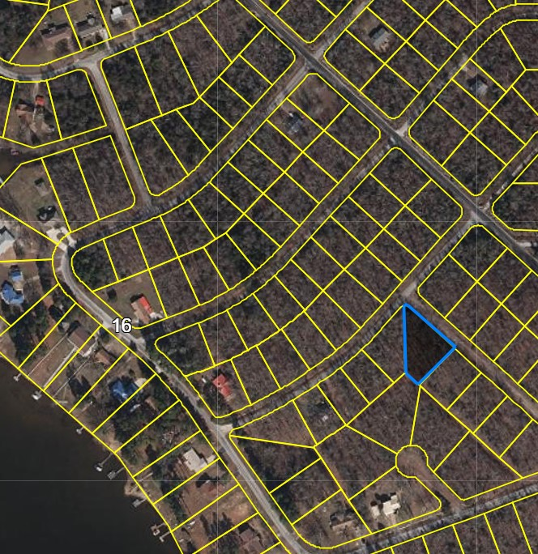
Aerial Photo View | 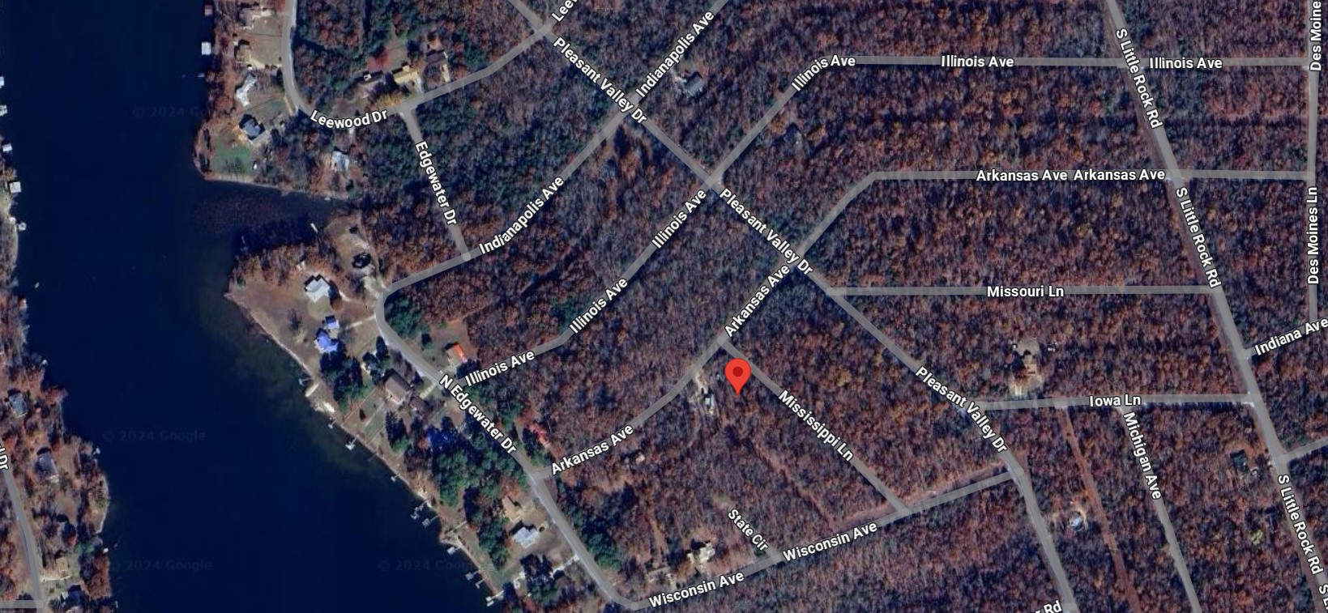
Property Directions  View | 