
Due Diligence Report
APN: 800-04885-000
Property Details
Owners Name
  Mary Morgan and Mary Hileman
Owners Address | 795 Winter Ave, Akron, OH, 44314
APN | 800-04885-000

Property Facts
Address
  201 West Lansing Drive, Horseshoe Bend, AR, 72512
County | Izard
State | AR
Subdivision / Block / Lot | Golf Park II/NA/116
Legal Description (Unofficial) | Lot 116, Golf Park II Addition, Horseshoe Bend Estates, a subdivision in Izard County, as the same is shown and designated on the plat of same filed in the office of the County Clerk of Izard County, Arkansas, on the 5th day of March, 1973, and subject to road and utility easements; restrictions in the applicable Bill of Assurance, as well as mineral reservations record, if any, of previous grantors in the chain of title.
S-T-R | N/A
Parcel Size | 0.48 Acre
Number of Parcels | 1
GPS Coordinates
  GPS Center | 36.223780, -91.749367
  GPS NW | 36.223816, -91.749631
  GPS NE | 36.223773, -91.749148
  GPS SE | 36.223427, -91.74917
  GPS SW | 36.223453, -91.749663
Google Map Link | https://maps.app.goo.gl/4i8FkGcn7aVxVrKn8
Property Record | https://online.updf.com/pdf/share?shareId=807888229675048961
Last Transfer Info
  Deed Type | Correction Deed
  Deed Transfer Date | 04/30/2019
  Deed Record Location | Book 2019 Page 4824

County Website Information
County | https://www.izardcountyar.org/
Assessor | https://www.izardcountyar.org/assessor | 870-368-7810
Treasurer | https://www.izardcountyar.org/treasurer | 870-368-4394
Recorder / Clerk | https://www.izardcountyar.org/circuit-county-clerk | 870.368.4316
Planning / Zoning | Not specified, contact using the following phone number. | 870-368-4328
GIS Website | Arkansas GIS Office

Property Tax Information
Assessed Property Value | 400.00
Back taxes Owed | 0.0
Tax Liens | 0.00
Annual Property Taxes | 60.56

Actual Property Details / Information
Access Road | Lansing Road
Road Surface | Paved
Road Maintenance | City of Horseshoe Bend
Elevation | 715 ft
Terrain | Slight Slope, Treed
Closest Highway | I-167 AR-56
Closest Major Cities | Little Rock, AR (138 Mi) Memphis, TN (153 mi) Springfield, MO (155 mi)
Nearby Attractions | Diamond Lake, Crown Lake, Box Hound Marina Resort and RV Park, Turkey Mountain Golf Course
Walk Score | Extremely Car Dependent
Bike Score | Extremely Car Dependent
Transit Score | Extremely Car Dependent
County Details
Zoning | Vacant Residential Land
Property Use Code | Not specified
What Can Be Built | House
What Can You Do On / Near the Property | Reside
Camping Notes | No camping in the city limits except in the designated campgrounds. A camper is allowed on the property for a period of 12 months, with a building permit. At the end of the 12 months, you can no longer live in the RV or camper, and you cannot have it connected to the utilities even if your home is not complete.
RVs/Notes | An RV is allowed on the property for a period of 12 months, with a building permit. At the end of the 12 months, you can no longer live in the RV or camper, and you cannot have it connected to the utilities even if your home is not complete.
Mobile Home Notes | Mobile homes are not allowed.
Water | City water is available. Contact the Horseshoe Bend Water Department at 870-670-5885 for more information
Sewer / Septic | Contact the Arkansas Department of Health at (501) 661-2000.
Electric | Contact the North Arkansas Electric Cooperation at 870-895-3221.
Gas | No natural gas
Waste | Trash pick-up is available. Contact the Horseshoe Bend Water Department at 870-670-5885 for more information.
HOA Fees | There are no HOA/POA within the county except for the Pioneer Village Addition.
Notes | Sheds can be no more than 300 sq ft unless it is a detached garage which can be 900 sq ft.

GIS Photo View | 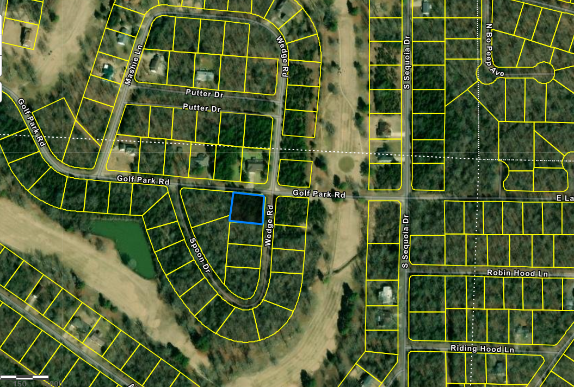
Aerial Photo View | 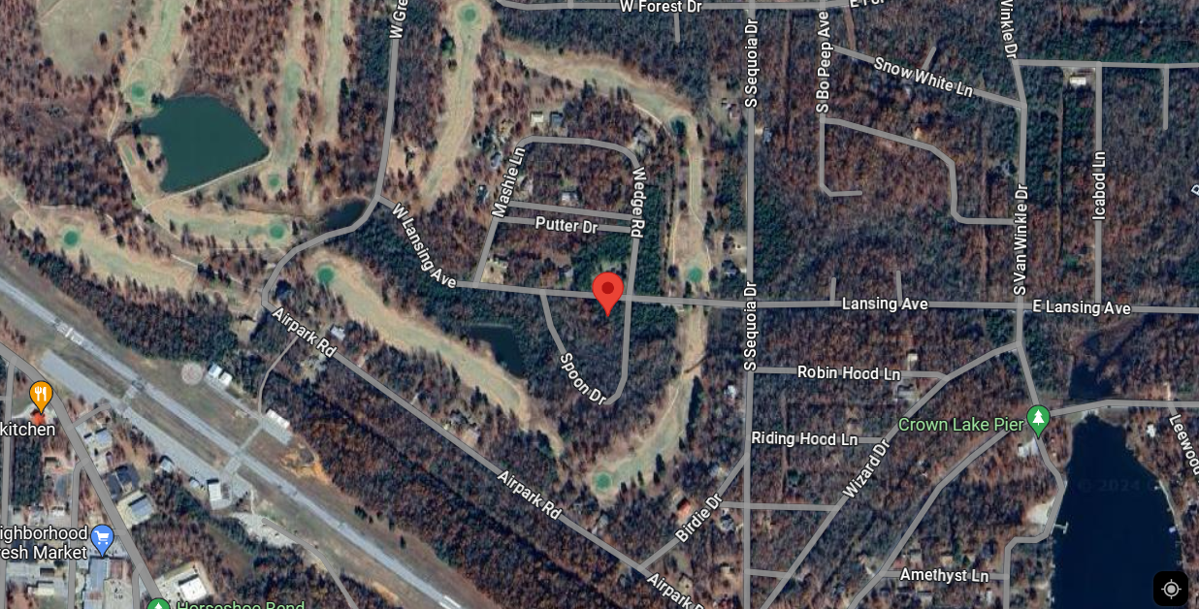
Property Directions  View | 