Heritage Land Solutions, LLC
Due Diligence Report
APN: 800-14054-000
Property Details
Owners Name
  BEAGAN RICHARD JR & JENNIFER L
Owners Address | 708 FURRS MILL RD  LEXINGTON, VA 24450
APN | 800-14054-000

Property Facts
Address
  605 WALNUT LN
County | Izard
State | Ar
Subdivision / Block / Lot | WHITE OAK/N/A / 359
Legal Description (Unofficial) | (Legal Description): Section: Township: Range: Acreage: Lot: 359 Block: City: HORSESHOE BEND Addition: WHITE OAK SD: 101
S-T-R | Not specified
Parcel Size | .24
Number of Parcels | 1
GPS Coordinates
  GPS Center | -91.76316, 36.20494
  GPS NW | -91.76343, 36.20486
  GPS NE | -91.76314, 36.20513
  GPS SE | -91.76291, 36.20486
  GPS SW | -91.76348, 36.20474
Google Map Link | https://www.google.com/maps/@36.2141105,-91.7770853,5059m/data=!3m1!1e3?entry=ttu
Property Record | https://www.actdatascout.com/RealProperty/ParcelView?countyIdYearRpid=5065202331786
Last Transfer Info
  Deed Type | Warranty Deed
  Deed Transfer Date | 4/25/2023
  Deed Record Location | Book 2023 Page 5378

County Website Information
County | https://www.izardcountyar.org/
Assessor | https://www.izardcountyar.org/assessor | 870-368-7810
Treasurer | https://www.izardcountyar.org/treasurer | 870-368-4394
Recorder / Clerk | https://www.izardcountyar.org/circuit-county-clerk | 870.368.4316
Planning / Zoning | Not specified, contact using the following phone number. | 870-368-4328
GIS Website | https://www.actdatascout.com/RealProperty/ParcelView?countyIdYearRpid=5065202331786

Property Tax Information
Assessed Property Value | 400.00
Back taxes Owed | 0.00
Tax Liens | 0.00
Annual Property Taxes | $141.49

Actual Property Details / Information
Access Road | Walnut Ln
Road Surface | Paved
Road Maintenance | City of Horseshoe Bend
Elevation | 738 ft
Terrain | Slightly Sloped, Treed
Closest Highway | US HWY-412, RT-289
Closest Major Cities | Little Rock, AR (147Mi) Memphis, TN (230 mi) Springfield, MO (154 mi)
Nearby Attractions | Summit’s Valley Shire and Sport Horses, Crown Lake, Box Hound Marina Resort and RV Park, Turkey Mountain Golf Course
Walk Score | Extremely Car Dependent
Bike Score | Extremely Car Dependent
Transit Score | Extremely Car Dependent
County Details
Zoning | Vacant Residential Land
Property Use Code | Not specified
What Can Be Built | House
What Can You Do On / Near The Property | Reside
Camping Notes | No camping in the city limits except in the designated campgrounds. A camper is allowed on the property for a period of 12 months. At the end of the 12 months, you can no longer live in the RV or camper, and you cannot have it connected to the utilities even if your home is not complete.
RVs/Notes | An RV is allowed on the property for a period of 12 months. At the end of the 12 months, you can no longer live in the RV or camper, and you cannot have it connected to the utilities even if your home is not complete.
Mobile Home Notes | Mobile homes are not allowed.
Water | City water is available. Contact the Horseshoe Bend Water Department at 870-670-5885 for more information
Sewer / Septic | Contact the Arkansas Department of Health at (501) 661-2000.
Electric | Contact the North Arkansas Electric Cooperation at 870-895-3221.
Gas | No natural gas
Waste | Trash pick-up is available. Contact the Horseshoe Bend Water Department at 870-670-5885 for more information.
HOA Fees | There are no HOA/POA within the county except for the Pioneer Village Addition.
Notes | • Sheds can be no more than 300 sq ft unless it is a detached garage which can be 900 sq ft.

GIS Photo View | 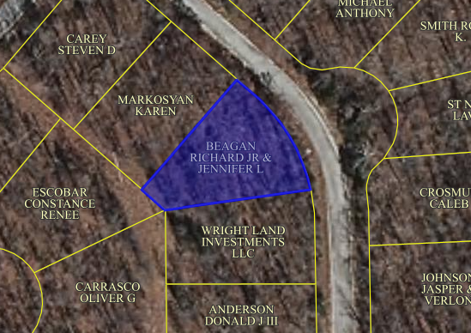
Aerial Photo View | 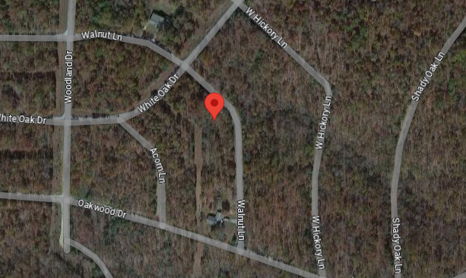
Property Directions View | 