`
Due Diligence Report
APN: 800-11338-000
Property Details
Owners Name | Blecke
Owners Address | PO Box 1012, Melbourne, AR 72556
APN | 800-11338-000

Property Facts
Address
  803 Primrose Lane, Horseshoe Bend, AR 72512
County | Izard
State | AR
Subdivision / Block / Lot | South Shore/NA/271
Legal Description (Unofficial) | South Shore, 803 Primrose Lane, Lot 271
S-T-R | N/A
Parcel Size | 0.34 Acre
Number of Parcels | 1
GPS Coordinates
  GPS Center | 36.194164, -91.735674
  GPS NW | 36.193849, -91.736173
  GPS NE | 36.194221, -91.735781
  GPS SE | 36.193944, -91.735384
  GPS SW | 36.193754, -91.735583
Google Map Link | https://maps.app.goo.gl/XsYchWzvAnXVJN4a6
Property Record | https://online.updf.com/pdf/share?shareId=849859050756644864
Last Transfer Info
  Deed Type | Warranty Deed
  Deed Transfer Date | 05/04/2020
  Deed Record Location | Book 2020 Page 5203

County Website Information
County | https://www.izardcountyar.org/
Assessor | https://www.izardcountyar.org/assessor | 870-368-7810
Treasurer | https://www.izardcountyar.org/treasurer | 870-368-4394
Recorder / Clerk | https://www.izardcountyar.org/circuit-county-clerk | 870.368.4316
Planning / Zoning | Building & Zoning – City of Horseshoe Bend (wordpress.com) | 870-368-4328
GIS Website | Arkansas GIS Office | 901-793-2853

Property Tax Information
Assessed Property Value | 400.00
Back taxes Owed | 0.0
Tax Liens | 0.00
Annual Property Taxes | 53.72

Actual Property Details / Information
Access Road | Primrose Lane
Road Surface | Paved
Road Maintenance | City of Horseshoe Bend
Elevation | 640ft
Terrain | Flat, Treed
Closest Highway | I-167 AR-56
Closest Major Cities | Little Rock, AR (138 Mi) Memphis, TN (153 mi) Springfield, MO (155 mi)
Nearby Attractions | Diamond Lake, Crown Lake, Box Hound Marina Resort and RV Park, Turkey Mountain Golf Course
Walk Score | Extremely Car Dependent
Bike Score | Extremely Car Dependent
Transit Score | Extremely Car Dependent
County Details
Zoning |  | Vacant Residential Land
Property Use Code |  | Res. Vacant or HSB LOTS
What Can Be Built |  | House
What Can You Do On / Near the Property |  | Reside
Camping Notes |  | No camping in the city limits except in the designated campgrounds. A camper is allowed on the property for a period of 12 months, with a building permit. At the end of the 12 months, you can no longer live in the RV or camper, and you cannot have it connected to the utilities even if your home is not complete.
RVs/Notes |  | An RV is allowed on the property for a period of 12 months, with a building permit. At the end of the 12 months, you can no longer live in the RV or camper, and you cannot have it connected to the utilities even if your home is not complete.
Mobile Home Notes |  | Mobile homes are not allowed.
Water |  | City water is available. Contact the Horseshoe Bend Water Department at 870-670-5885 for more information
Sewer / Septic |  | Contact the Arkansas Department of Health at (501) 661-2000.
Electric |  | Contact the North Arkansas Electric Cooperation at 870-895-3221.
Gas |  | No natural gas. Propane.
Waste |  | Trash pick-up is available. Contact the Horseshoe Bend Water Department at 870-670-5885 for more information.
HOA Fees |  | There are no HOA/POA within the county except for the Pioneer Village Addition.
Notes |  | Taxes are current for 2023/2024 for the amount of  53.72 that should be paid on October 15, 2024. There  was a nonpayment for 4 years of delinquent taxes so the  property is certified to the State of Commissioner of  State Lands.
GIS Photo View | 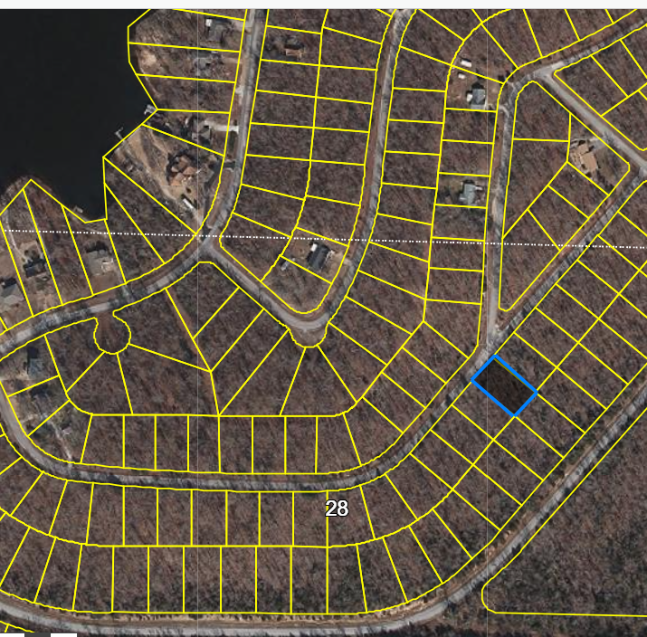
Aerial Photo View | 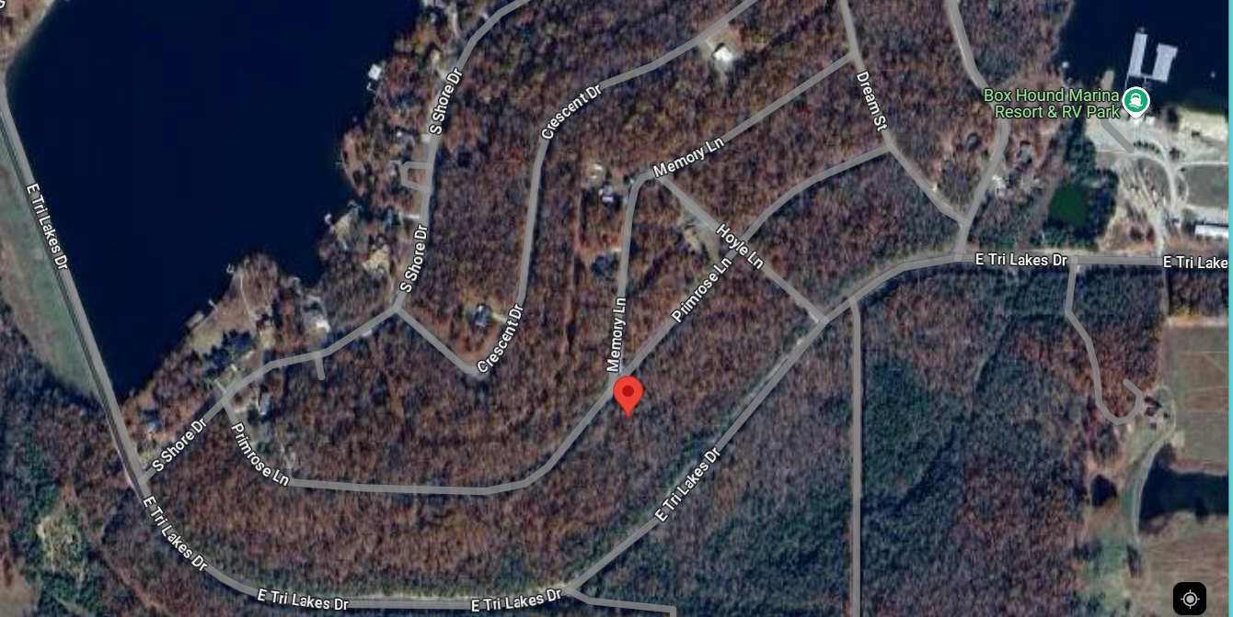
Property Directions  View | 