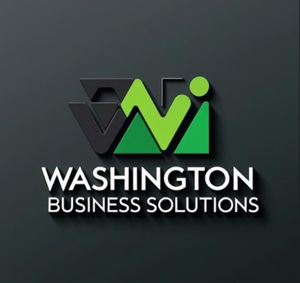

AI & Automation Solutions for Government and Small Business
About
Core Competencies  • AI Consulting & Implementation  • Workflow Automation & Process Optimization  • AI-Powered Document Processing  • IT Support & Systems Assistance  • Digital Transformation Strategy  • Program & Project Management  • Technology Training & Adoption  AI Solutions  • AI Workflow Automation  • AI Document Processing  • AI Reporting & Data Dashboards  • AI Chatbots & Virtual Assistants  • Operational Process Automation  NAICS Codes  • 541611 – Management Consulting  • 541512 – Computer Systems Design  • 541519 – Other Computer Related Services  • 541618 – Other Management Consulting  • 611430 – Professional Development Training | Leadership Experience  • AI Consulting & Computer Training  • Change Management  • Disaster Recovery Exercises  • User Acceptance Testing (UAT)  • IT Support & System Troubleshooting  • Process Improvement Initiatives  • Consulting & Workflow Automation  Differentiators  • Focused on practical AI solutions that improve  operational efficiency  • Combines technology consulting with business process  improvement  • Solutions designed to reduce manual workloads  • Strong emphasis on technology adoption and workforce  Enablement  Contact  Sharon Washington  Founder & AI Consultant  Phone: 202-365-3422  WBizSolutions.com
Washington Business Solutions is a technology consulting firm specializing in Artificial Intelligence (AI), automation, and digital transformation solutions for government agencies and organizations seeking to modernize operations. We help organizations identify inefficient workflows, automate manual processes, and implement AI-powered tools that improve productivity, enhance reporting, and support data-driven decision making. In addition to our consulting services, we provide comprehensive computer training programs designed to upskill teams in essential digital competencies.

