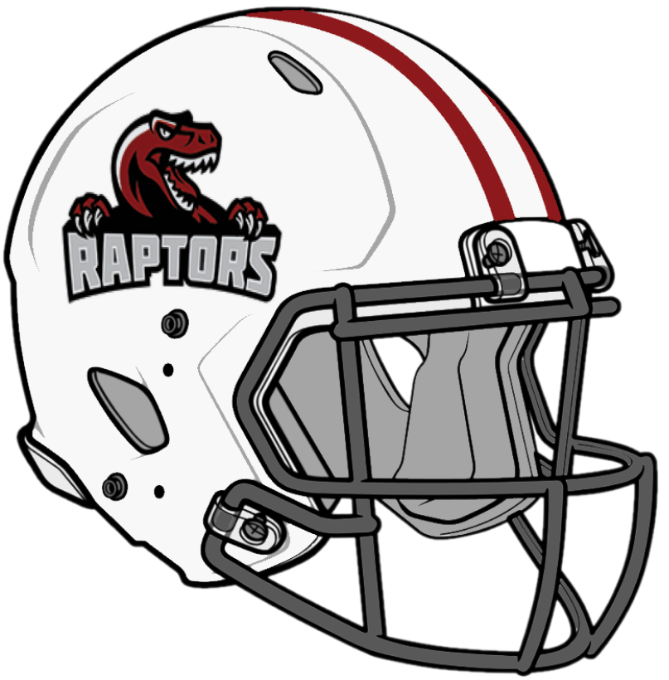 Rapids Raptors Coaches 2026

I am interested in Coaching: (check ONE) Football:_____ Cheerleading:_____

Name: _________________________________________________ Phone: _____________________

ADDRESS: ___________________________________________________________________________

CITY: ____________________________________________ STATE: __________ ZIP: ____________

Section One: Cheerleaders Preferences
__Cheerleader Head Coach __I will only coach on the team that my child is on
__Cheerleader Assistant Coach __I will only coach on a team my child is not on
__I will coach wherever needed.

Section Two: Football Preferences
__Football Head Coach __I will only coach on the team that my child is on
__Football Assistant Coach __I will only coach on a team my child is not on
__I will coach wherever needed.

Section Three: Coaching Experience
Tell us about your coaching experience __________________________________________________________

__________________________________________________________________________________________

__________________________________________________________________________________________

Coaches are selected by the Rapids Raptors Youth Football Board of Directors based on experience, knowledge of the game, commitment, and support of the rules of Rapids Raptors Youth Football teams, coaching and teaching philosophy and attendance at all Rapids Raptors Coaching clinics and required meetings. Background ground checks are done on all coaches for both football and cheerleading.

All coaches must attend a pre-season meeting to discuss schedules, league rules, rules of conduct for coach’s players and parents, safety, and team draft procedures. All coaches must sign a background check form along with a sports ethics form to be a Rapids Raptors Coach.

A minimum of 1 head football coach and 2 assistants will be needed for each football team. Only the official head coach and 2 official assistant coaches can use their coaching hours to meet the volunteer commitment.

A minimum of 1 head cheerleader coach and 2 assistants will be needed for each team. Only the official head coach and 2 official assistant coaches can use their coaching hours to meet the volunteer commitment.

