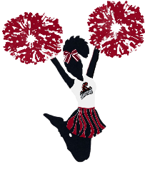
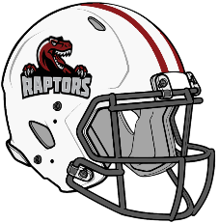
Rapids Raptors Sponsor Form
Name |  |  |  |  |  |  | Business
Phone |  |  |  |  |  |  | Logo | Send to wrrapidsraptors@gmail.com
Web Site |  |  |  |  |  |  | Social Media
Sponsor Type
Season* |  |  |  | Charity |  |  |  |  |  | Other
Donation Type
Cash |  |  | Check |  |  |  | Service |  |  |  | Product
$ |  |  | $ |  | #
Sponsor Gift
T-Shirt |  | Helmet |  |  |  | Certificate |  |  | Decal |  |  | Nothing
Size: |  | Helmet for Display Only

* Season sponsors commit to $250+ donation of money, goods, or services. Season sponsors will have their logo and website listed on www.wrraptors.org sponsors’ page. Also season sponsors will have their logo printed on the back of player t-shirts.

