
Ads Certification
  - Instructor Guide

Contents
Course Overview 1
Welcome, Goals, and Agenda 5
Platform Overview & Navigation 8
Campaign Foundations 11
Campaign Creation 24
Management and Optimization 41
Analytics 52
Wrap-Up & Next Steps 57
Resources 60
Appendices 62
Appendix A: Navigate to Ad Composer & Select Ad Account 64
Appendix B: Ads Composer Workflow Options 65
Appendix C: Various campaign Setup Options 66
Appendix D: Create a new audience 67
Appendix E: Configuring Budget & Schedule 68
Appendix F: Placement Variations 69
Appendix G: Apply Dayparting 70
Appendix H: Selecting Existing Creatives 71
Appendix I: Placement Asset Customizations 72
Appendix J: Creative Variations 73
Appendix K: Configuring creative for ad sets 74
Exercises 75
Exercise 1: Create an Ad Campaign 76

 | Course Overview

About this Course
This course gives an in-depth overview of Modern Advertising.

Sprinklr’s Modern Advertising simplifies and enhances the advertising workflow. Plan, Execute, Analyze and Optimize advertising campaigns within Sprinklr.

Target Audience
This course is designed for Sprinklr Modern Advertising users who have at least 3-6 month’s experience within the platform.

Prerequisites
Before attempting this course, students should have completed the On Demands courses (if not at least 3 month’s experience).

Learning Objectives
Students who complete this course will be able to:
- Execute ad campaign setup and foundational tools
- Utilize ad campaign reporting
- Implement ad campaign creation
- Apply ad campaign optimization and management

For the Instructor | For Students
- Instructor Guide (IG)  - Student Guide (SG)  - Deck (PPT)  - Link to Sprinklr U Survey  - Laptop & Charger  - Dongles & Cables (in case host can’t provide) | - SG  - Laptop and Charger  - Notepad (if preferred)

Agenda Day 1
Tasks | Expected Time
Welcome, Agenda, and Goals | 15 mins
Platform Overview and Navigation | 30 mins
Campaign Foundations: Tools & Settings + Workshop | 60 mins
Campaign Foundations: Settings + Workshop | 60 mins
Campaign Creation: Ads Composer, Audience Manager, Content Creation | 2.5 hours
The listed times are approximate. Verify them during classroom preparation.

Agenda Day 2
Tasks | Expected Time
Welcome, Agenda, and Review Day 1 | 15 mins
Management & Optimization: Ads Manager + SBA + Workshops + Rule Engine | 2.5 hours
Analytics: Ads Reporting + Settings + Workshops | 90 mins
Review for Exam + Questions | 20 mins

Class Preparation Checklist
Task
Download newest version of materials:
- Instructor Guide
- Student Guide
- PowerPoint Slide Deck
- Logins for each student
If printing, make one copy of the Student Guide for each student
Rehearse all demos and exercises from Instructor Guide
Test Wi-Fi connection and strength

Classroom Setup
- Arrive early to set up the classroom
- Arrange tables for groups of 6, or as permitting

Instruction Notes
The following notes refer to slides in the PowerPoint presentation as well as actions to perform for in-platform demonstrations. The notes also refer to the Student Guide and tips on demonstrating tasks. Use these materials to prepare for the session and guide you during delivery.

Icon Glossary
 | Speaking points, transitions, and miscellaneous information
 | Equipment logistical tips
 | References to Student Guide and On-Demand Courses
 | Ideas for customizing course materials
 | Tips and tricks for performing a task more effectively

 | - Lesson 1 of 7  Welcome, Goals, and Agenda

Time
- 15 min

Materials
- Slides 1 - 7
- Laptop
- LCD Projector

Objective
- To set student expectations for the course.

Context
- Students need to understand the goals of the certification so they can pass the exam and take it back to the job.
Process
 |   Slide 1 |  | - Welcome to the Sprinklr Ads Certification course! That’s where everyone wanted to be, right?  - Good, let’s get started!
 | 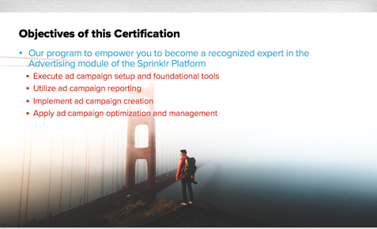  Slide 2 |  | - In this certification, you’ll learn the ins and outs of Sprinklr Modern Advertising. You’ll be an expert at executing ad campaigns and setting up foundational tools. You’ll be able to create and utilize reporting dashboards. You’ll learn how to create and manage ad content within the platform, as well as optimize your ad campaigns that are running. You’ll know best practices to use Modern Advertising efficiently.
 |   Slide 3 |  | - First, let’s introduce ourselves.  .
 | 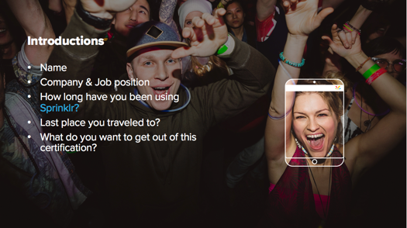  Slide 4 |  | - Tell us your name, company/job position, how long you’ve been using Sprinklr, and what you hope to get out of this certification. Also tell us something else about yourself.  - Where is the last place you traveled to?!  - I’ll start.
 | 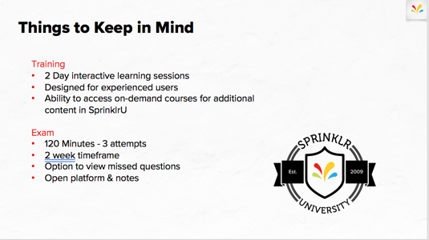  Slide 5 |  | - Let’s go over everything that encompasses a certification.  - On the training side: this will be a 2 day course with workshops. We’ll be in the platform within a training environment so you can feel free to play around. This course is designed for experienced users. It is a lot of information over the 2 days, so you will have access to on-demand courses on SprinklrU to review what we cover.  - After Day 2 concludes, I’ll submit you to take the exam. You will have 120 min to complete it and up to 3 attempts to pass. There is a 2 week timeframe for you to complete the exam, as well as access to the testing environment. The exam is open notes and open platform so please take notes!  .
 | 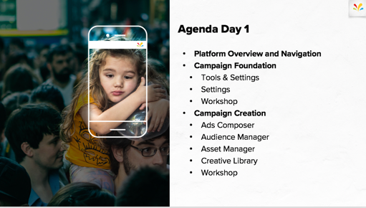  Slide 6 |  | - Here is our agenda for Day 1:  - First, we’ll do a quick overview of the platform and walk through the navigation  - Then, we’ll dive into Campaign Foundations – setting up Advertising tools and value-add features before creating campaigns. We’ll also jump into overall Platform setup – entities that go across the entire environment like Custom Fields, Accounts, Web Analytics.  - Next, we’ll cover how to launch an ad campaign with Sprinklr. We’ll walkthrough Ads Composer, Audience Manager, Asset Manager and Creative Library to showcase the different workflows to create a campaign.
 | 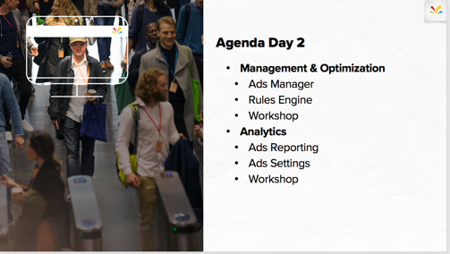  Slide 7 | - Tomorrow we’ll cover what happens after you setup and launch your ad campaign: Optimizations and Reporting.  - Then we’ll be sure to review and cover any questions before assigning you the exam.

 | - Lesson 2 of 7  Platform Overview & Navigation

Time
- 30 min

Materials
- Slides 8-14

Objective
- To introduce Sprinklr’s Modern Advertising, assign logins and review important concepts/terminology.

Context
- A basic understanding of Modern Advertising within the Sprinklr platform, the basics of logging in permissions and access.
Process
 | 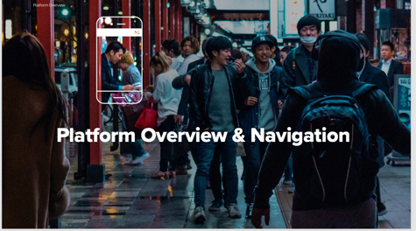  Slide 8 | - First, let’s make sure we walk through the platform overview to make sure we have a shared understanding of Sprinklr ‘s Modern Advertising.
 | 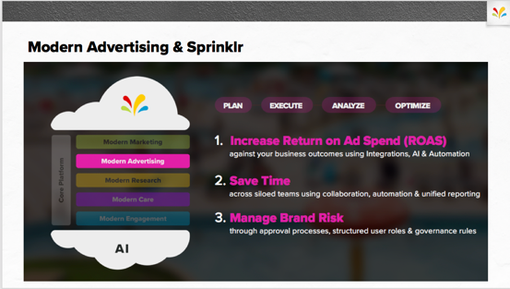  Slide 9 | - Sprinklr Modern Advertising sits along side the Modern Marketing, Modern Research, Modern Care and Modern Engagement offerings linked by 1 core platform and powered by AI.  .
 |  | - Modern Advertising’s offerings are broken out by Plan, Execute, Analyze and Optimize (the full workflow of an advertising campaign).  - Modern Advertising is used by clients to Increase Return on Ad Spend, Save Time across multiple teams and business units, and help manage Brand Risk.
 | 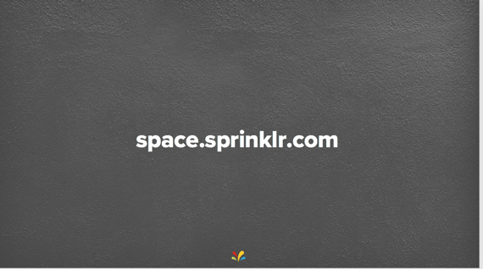  Slide 10 | - First, let’s make sure you all have access to the testing environment.  - Please open your browser and type in space.sprinklr.com
 | 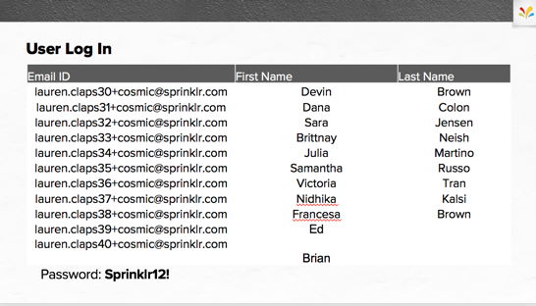  Slide 11 | - Find your Name and User ID to login to the platform. The general password is at the bottom on the slide – it’s the same for everyone  - You’ll be prompted to change your password once you login. Please do so and let me know once you have access.  .
- MAKE SURE THIS SLIDE HAS BEEN UPDATED!
- Unique user IDs are needed for each student. Please edit the email, First Name and Last Name (as well as password if different) before sharing
 | 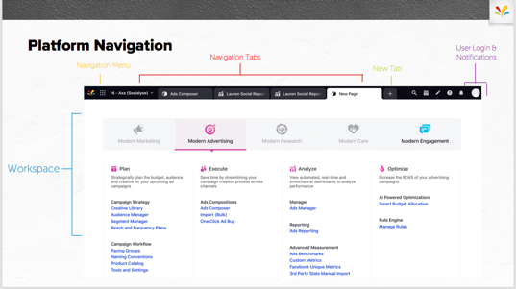  Slide 12 | - Now that you have access, let’s walkthrough the platform. When you login, you’ll see a few menu options – please select Modern Advertising (let me know if you don’t have access for some reason)  - You’ll see the Menu Icon (9 dots) which will bring you back to this menu view. Next, you’ll see the different navigation tabs – the + icon will add in more tabs to Sprinklr view so you can easily toggle.
 | 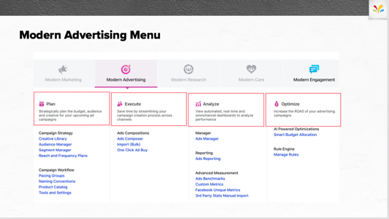  Slide 13 | - Modern Advertising’s menu of tools is categorized by the lifecycle of an ad campaign. Plan, Execute, Analyze and Optimize. We’ll be covering all over these over the next two days.  .
 | 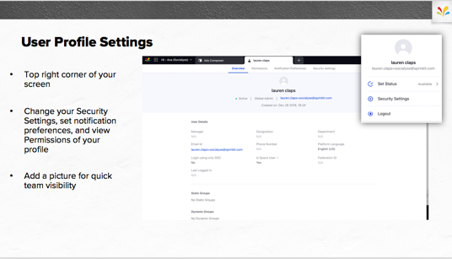  Slide 14 | - In the upper right hand corner, you’ll see an icon for User Profile Settings. Here you can access the overview of your role, user groups you’ve been applied to, permissions you’ve been given and security settings. You can even change notifications so you personalize exactly what you want Sprinklr to notify you on.

 | - Lesson 3 of 7  Campaign Foundations

Time
- 60 min

Materials
- Slides 15-50

Objective
- To review the concepts within Tools & settings in Modern Advertising & Sprinklr that will feed into the Ads workflow. To review the concepts within Settings in Platform Setup & Sprinklr’s Unified front office platform that will feed into the Ads workflow.

Context
- You’ll align on the knowledge and concepts needed to fully grasp the Tools and Settings lesson.

Process
 |  | 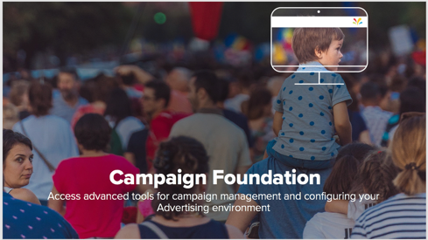  Slide 15 |  | - In the Campaign Foundations section, we want to make sure you have a full understanding of how to set up foundational tools that you’ll be applying to an ad campaign.
 |  | 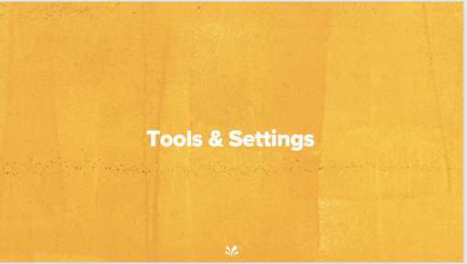  Slide 16 |  | - First, let’s go into tools that will be applied only with Modern Advertising. These are value-add features that will help manage your ad campaigns. You’ll find the majority of these features under the PLAN section of the menu.
 |  | 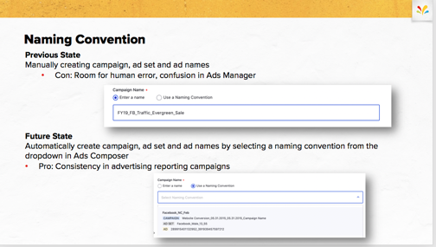  Slide 17 |  | - Naming Conventions is the first tool we’ll cover. Naming Conventions automatically and dynamically name ad campaigns, ad sets and ad variants based on select variables of your campaign or custom fields.
 |  |  | - This feature might replace an excel sheet being used to configure your naming sequences.
 | 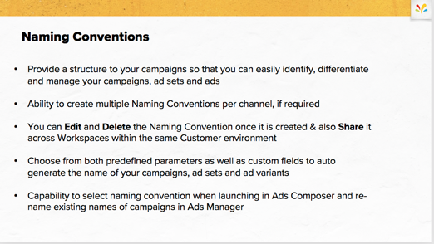  Slide 18 |  |  |  | - Provide a structure to your campaigns so that you can easily identify, differentiate and manage your campaigns, ad sets and ads  - Ability to create multiple Naming Conventions per channel, if required  - You can Edit and Delete the Naming Convention once it is created & also Share it across Workspaces within the same Customer environment  - Choose from both predefined parameters as well as custom fields to auto generate the name of your campaigns, ad sets and ad variants  - Capability to select naming convention when launching in Ads Composer and re-name existing names of campaigns in Ads Manager  .
 | 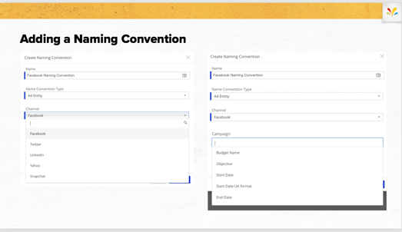  Slide 19 |  |  |  | - Adding a naming convention is fairly easy. Once you navigate to it within the platform, you’ll see a list of previously created naming conventions.  - To Create new, select Create Naming Convention in the upper right hand corner and select which channel. Once all mandatory fields are selected, you’ll be able to create a naming convention at each of the 3 levels by scrolling through the dropdown or searching for the variable.
 | 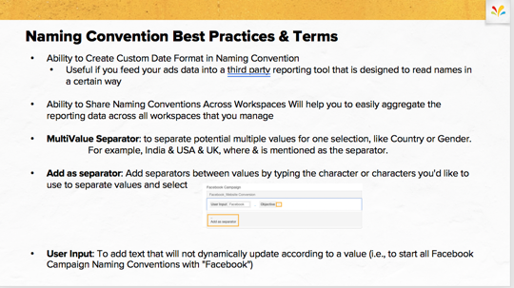  Slide 20 |  |  |  | - Here are a few Best Practices to keep in mind when creating and using Naming Conventions.  - Ability to Create Custom Date Format in Naming Convention  - Useful if you feed your ads data into a third party reporting tool that is designed to read names in a certain way  - Ability to Share Naming Conventions Across Workspaces Will help you to easily aggregate the reporting data across all workspaces that you manage  - MultiValue Separator: to separate potential multiple values for one selection, like Country or Gender. For example, India & USA & UK, where & is mentioned as the separator.  - Add as separator: Add separators between values by typing the character or characters you'd like to use to separate values and select  - User Input: To add text that will not dynamically update according to a value (i.e., to start all Facebook Campaign Naming Conventions with "Facebook".

 |  |  | 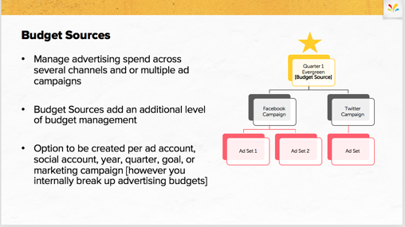  Slide 21 |  | - Budget Sources are the first of 2 tools to help you monitor advertising spend. Think of Budget sources as the highest level of budgets, the Director of Marketing or Supervisor might be using this tool.  - You can implement across multiple channels or campaigns.  - Budget Sources add an additional level of budget management – so it’s a step above the campaign level spend cap  - You can build these to monitor by ad account, social account, year, quarter, goal, or marketing campaign [however you internally break up advertising budgets
 |  |  | 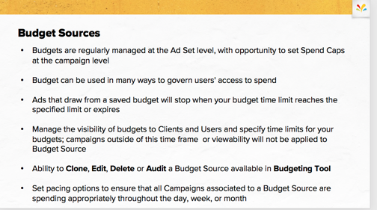  Slide 22 |  | - Budgets are regularly managed at the Ad Set level, with opportunity to set Spend Caps at the campaign level  - Budget can be used in many ways to govern users' access to spend  - Ads that draw from a saved budget will stop when your budget time limit reaches the specified limit or expires  - Manage the visibility of budgets to Clients and Users and specify time limits for your budgets; campaigns outside of this time frame or viewability will not be applied to Budget Source  - Ability to Clone, Edit, Delete or Audit a Budget Source available in Budgeting Tool  - Set pacing options to ensure that all Campaigns associated to a Budget Source are spending appropriately throughout the day, week, or month
 |  |  | 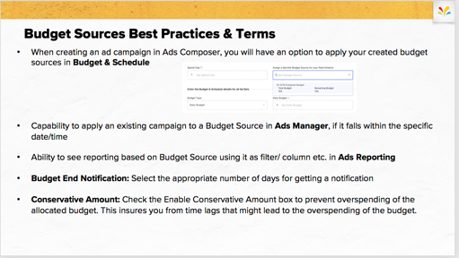  Slide 23 |  | - When creating an ad campaign in Ads Composer, you will have an option to apply your created budget sources in Budget & Schedule  - Capability to apply an existing campaign to a Budget Source in Ads Manager, if it falls within the specific date/time  - Ability to see reporting based on Budget Source using it as filter/ column etc. in Ads Reporting  - Budget End Notification: Select the appropriate number of days for getting a notification  - Conservative Amount: Check the Enable Conservative Amount box to prevent overspending of the allocated budget. This insures you from time lags that might lead to the overspending of the budget.
 |  | 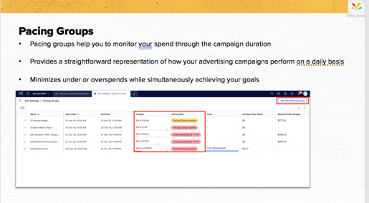  Slide 24 |  | - Pacing Groups are the second option for monitoring campaign spends in groupings. This feature is more geared toward the media manager who is executing campaign and wants to see a more detailed breakdown of spend.  - Pacing groups help you to monitor your spend through the campaign duration  - Provides a straightforward representation of how your advertising campaigns perform on a daily basis  - Minimizes under or overspends while simultaneously achieving your goals
 |  |  | 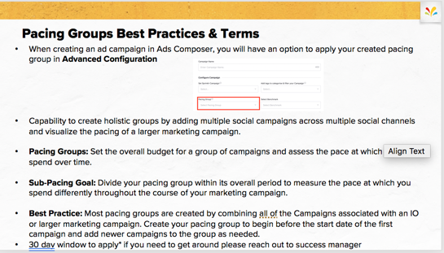  Slide 25 |  | - When creating an ad campaign in Ads Composer, you will have an option to apply your created pacing group in Advanced Configuration  - Capability to create holistic groups by adding multiple social campaigns across multiple social channels and visualize the pacing of a larger marketing campaign.  - Pacing Groups: Set the overall budget for a group of campaigns and assess the pace at which they spend over time.  - Sub-Pacing Goal: Divide your pacing group within its overall period to measure the pace at which you spend differently throughout the course of your marketing campaign.  - Best Practice: Most pacing groups are created by combining all of the Campaigns associated with an IO or larger marketing campaign. Create your pacing group to begin before the start date of the first campaign and add newer campaigns to the group as needed.  - 30 day window to apply* if you need to get around please reach out to success manager  - Conservative Amount: Check the Enable Conservative Amount box to prevent overspending of the allocated budget. This insures you from time lags that might lead to the overspending of the budget.
 |  |  | 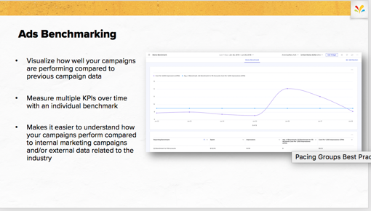  Slide 26 |  | - Ads Benchmarks are a great tool to help to report against dynamic goals that your campaign might have. For example, if you have a Q4 goal of sales, but flighted to align with the holiday season (Cyber Monday, Black Friday) you would want to create an Ads Benchmark to compare your changing goals to your performance.  - Ads Benchmarks will help you: Visualize how well your campaigns are performing compared to previous campaign data  - Measure multiple KPIs over time with an individual benchmark  - Makes it easier to understand how your campaigns perform compared to internal marketing campaigns and/or external data related to the industry
 |  |  | 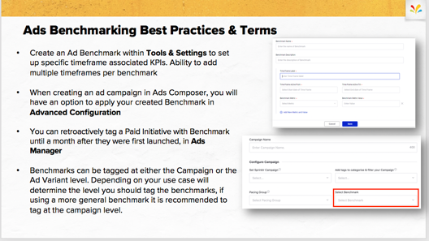  Slide 27 |  | - You will create an Ad Benchmark within Tools & Settings to set up specific timeframe associated KPIs. Remember you have the ability to add multiple timeframes per benchmark  - When creating an ad campaign in Ads Composer, you will have an option to apply your created Benchmark in Advanced Configuration  - You can retroactively tag a Paid Initiative with Benchmark until a month after they were first launched, in Ads Manager  - Benchmarks can be tagged at either the Campaign or the Ad Variant level. Depending on your use case will determine the level you should tag the benchmarks, if using a more general benchmark it is recommended to tag at the campaign level.
 |  | 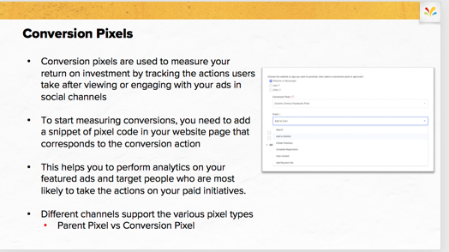  Slide 28 |  | - Conversion pixels are used to measure your return on investment by tracking the actions users take after viewing or engaging with your ads in social channels.  - To start measuring conversions, you need to add a snippet of pixel code in your website page that corresponds to the conversion action.  - This helps you to perform analytics on your featured ads and target people who are most likely to take the actions on your paid initiatives.  - Different channels support the various pixel types.  - Parent Pixel is the main pixel tracking all events on the channel site vs Conversion Pixel will track events that happen on your website from traffic coming from the channel.
 |  | 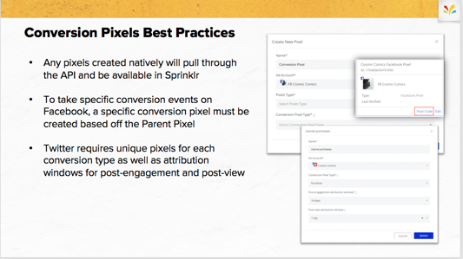  Slide 29 |  | - Please keep in mind that any pixels created natively will pull through the API and be available in Sprinklr  - To take specific conversion events on Facebook, a specific conversion pixel must be created based off the Parent Pixel  - Twitter requires unique pixels for each conversion type as well as attribution windows for post-engagement and post-view
 |  |  |   Slide 30 |  | - Now we’ll jump into the platform and build some of these tools within Cosmic Comics.
 |  |  | 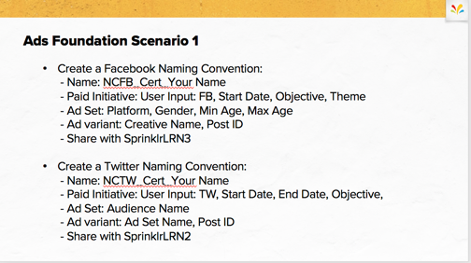  Slide 31 |  | - The first Ads Foundation Scenario is going to require you to build a Naming Convention for both Facebook and Twitter.  - I’ll give everyone 10 min to complete and we will review.  - Please make sure to add your separators!
 |  |  | 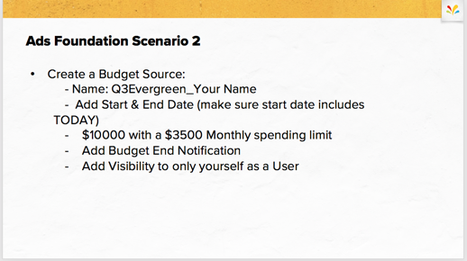  Slide 32 |  | - For Scenario number 2, please build a Budget Source to help you monitor your entire social advertising of Q3 evergreen campaigns.  - I’ll give everyone 10 min to complete and we will review.  - Please make sure to only share it with yourself!
 |  |  | 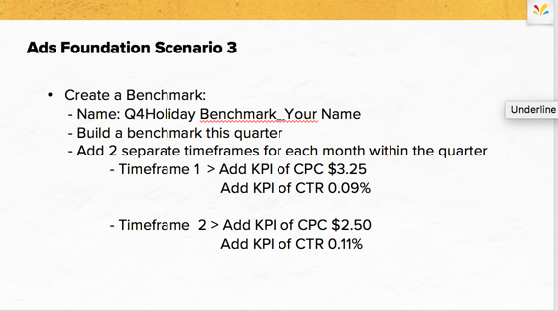  Slide 33 |  | - For Scenario number 3, you will create a Ads Benchmark help you report against your KPIs through the quarter.  - I’ll give everyone 10 min to complete and we will review.  - Please make sure to add both timeframes and both KPIs! |  |  | Slide 33 | - For Scenario number 2, please build a Budget Source to help you monitor your entire social advertising of Q3 evergreen campaigns.  - I’ll give everyone 10 min to complete and we will review.  Please make sure to only share it with yourself!
 |  |  | 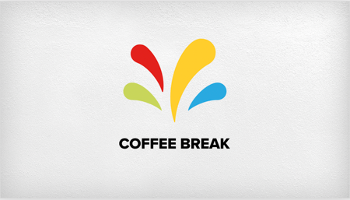  Slide 34 |  | - Let’s take a 15 min coffee break before we get into Platform Setup of Sprinklr

 | 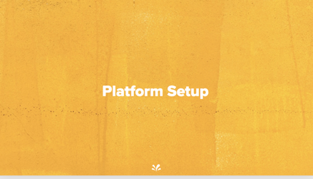  Slide 35 | - In the Setting section of Campaign Foundations, we want to align on of foundational tools that go across the entire Sprinklr platform and make sure you’ll have the ability to create and apply to the advertising workflow.  - Everything we go over in this section located NOT in Modern Advertising, but under that menu in Unified Front Office Platform
 | 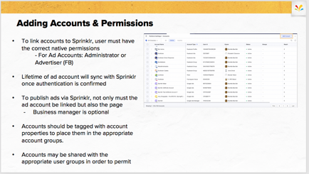  Slide 36 | - The very first step (that was completed in enablement) is to add the accounts and permission them to users within the platform.  - To link accounts to Sprinklr, user must have the correct native permissions - For Ad Accounts: Administrator or Advertiser (FB)  - Lifetime of ad account will sync with Sprinklr once authentication is confirmed  - To publish ads via Sprinklr, not only must the ad account be linked but also the page  - Business manager is optional and only needed for product catalogs and other advanced tools  - Accounts should be tagged with account properties to place them in the appropriate account groups.  - Accounts may be shared with the appropriate user groups in order to permit.
 | 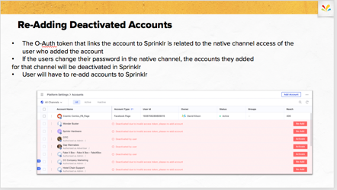  Slide 37 | - The O-Auth token that links the account to Sprinklr is related to the native channel access of the user who added the account  - If the users change their password in the native channel, the accounts they added for that channel will be deactivated in Sprinklr (Linkedin needs re-auth every 60 days)  - User will have to re-add accounts to Sprinklr
 | 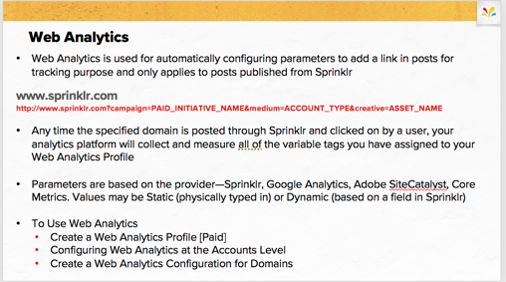  Slide 38 |  | - Web Analytics is used for automatically configuring parameters to add a link in posts for tracking purpose and only applies to posts published from Sprinklr  - Any time the specified domain is posted through Sprinklr and clicked on by a user, your analytics platform will collect and measure all of the variable tags you have assigned to your Web Analytics Profile  - Parameters are based on the provider—Sprinklr, Google Analytics, Adobe SiteCatalyst, Core Metrics. Values may be Static (physically typed in) or Dynamic (based on a field in Sprinklr)  - To Use Web Analytics  - Create a Web Analytics Profile [Paid]  - Configuring Web Analytics at the Accounts Level  - Create a Web Analytics Configuration for Domains
 | 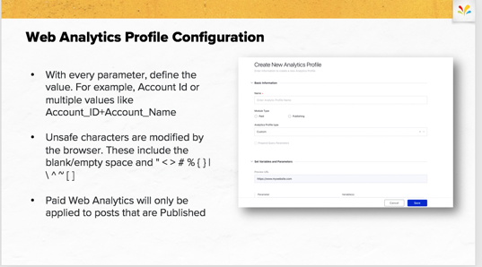  Slide 39 |  | - With every parameter, define the value. For example, Account Id or multiple values like Account_ID+Account_Name  - Be careful of unsafe characters are modified by the browser. These include the blank/empty space and " < > # % { } | \ ^ ~ [ ]  - Paid Web Analytics will only be applied to posts that are published within Sprinklr. You will not be able to append web analytics to campaigns published elsewhere.
 | 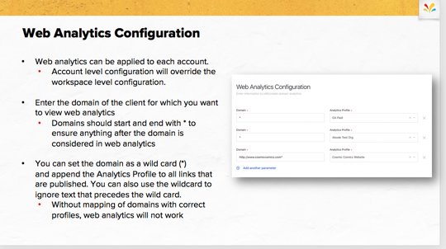  Slide 40 |  | - Web analytics can be applied to each account.  - Account level configuration will override the workspace level configuration.  - Enter the domain of the client for which you want to view web analytics  - Domains should start and end with * to ensure anything after the domain is considered in web analytics  - You can set the domain as a wild card (*) and append the Analytics Profile to all links that are published. You can also use the wildcard to ignore text that precedes the wild card.  - Without mapping of domains with correct profiles, web analytics will not work.

 | 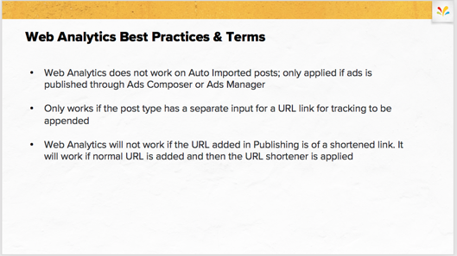  Slide 41 | - Web Analytics does not work on Auto Imported posts; only applied if ads is published through Ads Composer or Ads Manager  - Only works if the post type has a separate input for a URL link for tracking to be appended  - Web Analytics will not work if the URL added in Publishing is of a shortened link. It will work if normal URL is added and then the URL shortener is applied
 | 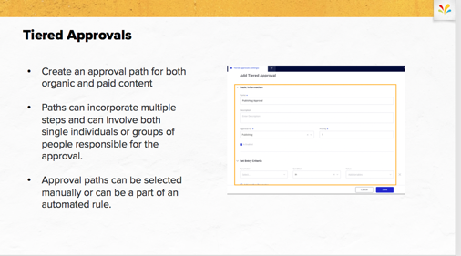  Slide 42 | - Create an approval path for both organic and paid content  - Paths can incorporate multiple steps and can involve both single individuals or groups of people responsible for the approval.  - Approval paths can be selected manually or can be a part of an automated rule.
 | 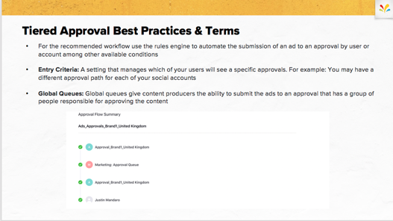  Slide 43 | - For the recommended workflow use the rules engine to automate the submission of an ad to an approval by user or account among other available conditions  - Entry Criteria: A setting that manages which of your users will see a specific approvals. For example: You may have a different approval path for each of your social accounts  - Global Queues: Global queues give content producers the ability to submit the ads to an approval that has a group of people responsible for approving the content.
 | 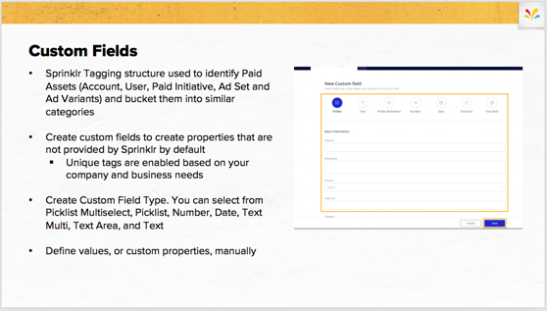  Slide 44 | - Hopefully you’ve heard and seen custom fields used throughout the Sprinklr platform previously.  - Custom Fields are Sprinklr’s Tagging structure used to identify Paid Assets (Account, User, Paid Initiative, Ad Set and Ad Variants) and bucket them into similar categories  - Create custom fields to create properties that are not provided by Sprinklr by default  - Unique tags are enabled based on your company and business needs  - Create Custom Field Type. You can select from Picklist Multiselect, Picklist, Number, Date, Text Multi, Text Area, and Text  - Define values, or custom properties, manually
 | 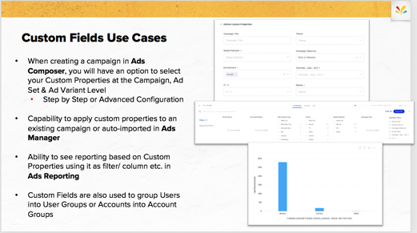  Slide 45 | - When creating a campaign in Ads Composer, you will have an option to select your Custom Properties at the Campaign, Ad Set & Ad Variant Level  - Step by Step or Advanced Configuration  - Capability to apply custom properties to an existing campaign or auto-imported in Ads Manager  - Ability to see reporting based on Custom Properties using it as filter/ column etc. in Ads Reporting  - Custom Fields are also used to group Users into User Groups or Accounts into Account Groups.
 | 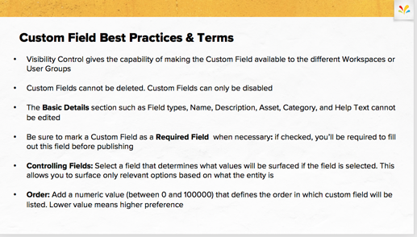  Slide 46 | - When creating a campaign in Ads Composer, you will have an option to select your Custom Properties at the Campaign, Ad Set & Ad Variant Level  - Step by Step or Advanced Configuration  - Capability to apply custom properties to an existing campaign or auto-imported in Ads Manager  - Ability to see reporting based on Custom Properties using it as filter/ column etc. in Ads Reporting  - Custom Fields are also used to group Users into User Groups or Accounts into Account Groups.
 | Slide 47 | - Now we’ll jump into the platform and set up some of these functions within Cosmic Comics.
 | 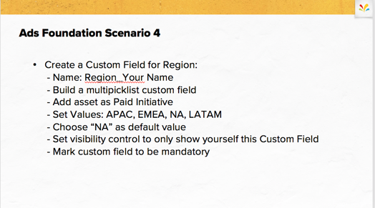  Slide 48 | - The 4th Ads Foundation Scenario is going to require you to create a new custom field. We’ll be applying this later on within the Ads workflow.  - I’ll give everyone 10 min to complete and we will review.  - Please make sure to only share this with yourself!
 | 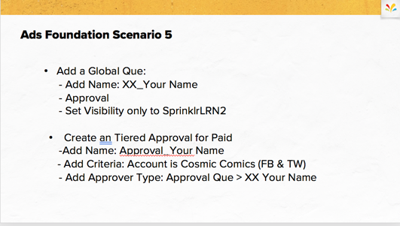  Slide 49 | - For Scenario number 5, please build a Global Que and a Tiered Approval for Paid.  - I’ll give everyone 10 min to complete and we will review.  - Please make sure to only share it with yourself!
 | 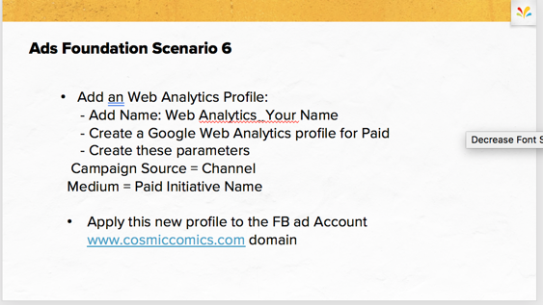  Slide 50 | - For Scenario number 6, please create a Web Analytics Profile for Paid with the following parameters.  - I’ll give everyone 10 min to complete and we will review.  - Please make sure to apply the new profile to the FB Ad account for cosmic comics at this URL.

 | - Lesson 5 of 7  Campaign Creation

Time
- 60 min

Materials
- Slide 52 - 75

Objective
- To describe and demonstrate the Ads Composer workflow, Audience Manager and Content Creation.

Context
- Showcase the step by step workflow to launch an ad campaign within Sprinklr at a high level, and then deep dive into each section in detail.

Process
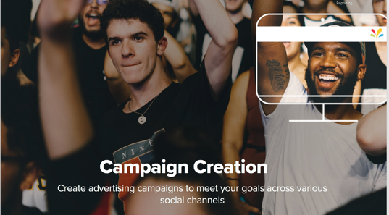  Slide 51 |  | - Now that you have a basic understanding of foundational tools and value-add features within Sprinklr, let’s get into the workflow of launching advertising campaigns.
Slide 52 |  | - Now that you have a basic understanding of foundational tools and value-add features within Sprinklr, let’s get into the workflow of launching advertising campaigns.
Slide 53 |  | - Now that you have a basic understanding of foundational tools and value-add features within Sprinklr, let’s get into the workflow of launching advertising campaigns.
Slide 54 |  | - Now that you have a basic understanding of foundational tools and value-add features within Sprinklr, let’s get into the workflow of launching advertising campaigns.
Slide 55 |  | - Now that you have a basic understanding of foundational tools and value-add features within Sprinklr, let’s get into the workflow of launching advertising campaigns.
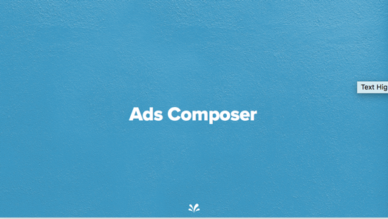  Slide 56 |  | - Ads Composer is the first section we’ll cover and main tool used to create a new advertising campaign within Sprinklr.
- You can locate Ads Composer by navigating to the Modern Advertising Menu and under Execute section, Ads Composer should be visible under Ads Compositions.
- Please let me know if you do not see it within your menu.
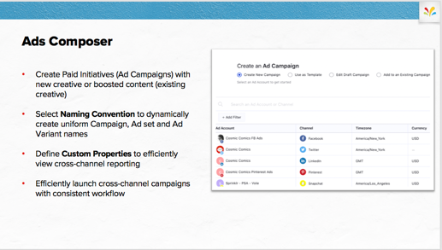  Slide 57 |  | - Create Paid Initiatives (Ad Campaigns) with new creative or boosted content (existing creative)  - Select Naming Convention to dynamically create uniform Campaign, Ad set and Ad Variant names  - Define Custom Properties to efficiently view cross-channel reporting  - Efficiently launch cross-channel campaigns with consistent workflow.
 | 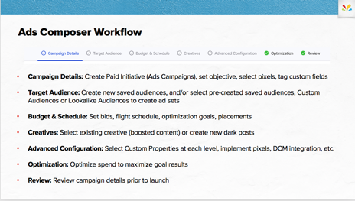  Slide 58 |  | - Campaign Details: Create Paid Initiative (Ads Campaigns), set objective, select pixels, tag custom fields.  - Target Audience: Create new saved audiences, and/or select pre-created saved audiences, Custom Audiences or Lookalike Audiences to create ad-sets.  - Budget & Schedule: Set budgets, bids, flight schedule, optimization goals, placements.  - Creatives: Select existing creative (boosted content) or create new dark posts.  - Advanced Configuration: Select Custom Properties at each level, implement pixels, DCM integration, etc.  - Optimization: Optimize spend to maximize goal results.  - Review: Review campaign details & error messages prior to launch.
- As mentioned, this workflow is consistent for any channel you’ll select to launch an ad campaign.
- Adding an Ad account and having the organic page linked to the account are mandatory prerequisites before you can start composing ads.
- Let’s take a look at how the workflow looks in the platform.
Switch from PPT to Platform
 |   Slide 59 |  | - Navigate to Ads Composer within Modern Advertising  - Point out step up & account selection using Appendix A: Select Ad Account and Appendix B: Workflow options.  - Once an Ad Account is selected, you’ll be pushed to Campaign Details. Take a moment to point out the step by step workflow, note how as you go through each step, you’ll see a green check mark or red exclamation depending on if all mandatory fields were selected or not.  - Within Step 1, Campaign Details, you’ll be setting your campaign objective, selecting pixels, naming your campaign.  - Select an Objective  - Objectives will populate from the three most frequently used objective types within the Ad Account  - Users can see all of the campaign objectives by selecting Show More Objective Options  - Add a Naming Convention  - Enter a Naming Convention manually  - Users can select a naming convention from the drop down that has been configured previously  - Campaign Setup  - Note that anything selected at the campaign details tab sets other parameters for the rest of the campaign. (for example: the objective you choose sets options for ad formats). Appendix C: Campaign Setup  - Define Custom Properties  - Fill out picklist, multiselect picklist or text Custom Fields at the campaign level  - Note that mandatory Custom Fields will be denoted with a red dot  - Next is Step 2, Target Audience, note that this is a similar view as Audience Manager, but audiences available for selection are drilled down by the Ad account previously selected.  - Select a saved audience from view that has been previously used  - Option to search by audience name or targeting parameter  - Hover on the three dot icon to view details of selected audience or click the (+ 1 targeting) hyperlink  - Option to clone/use audience as template  - Create a new audience using Appendix D: Create a new audience.  - Ability to create a new saved audience only  - Select parameters of audience based on channel dimensions (different by channel)  - Option to layer previously created Custom Audiences  - Capability to Save audience or Save & Segment  - Note that selecting multiple audiences or creating new will generate multiple ad sets automatically  - Selected Target Audience tab (review selected audiences)  - Option to add another audience  - Option to clone and edit or remove audience  - Define Custom properties at the ad set level  - Next step is Budget & Schedule where you will set your budgets, placements, bidding, dayparting, etc. of your campaign & ad sets.  - Option to configure all Ad Sets individually or consistently Appendix E: Configuring Budget & Schedule  - Smart Search option to filter by name or targeting dimensions & Copy values to filtered ad sets  - Budget details at Campaign level  - Spend Cap  - Mandatory for certain channels (Twitter)  - Option for to enable Facebook’s Budget Optimization tool  - Ability to assign a Sprinklr Budget Source  - Budget & Schedule at ad set level  - Budget Type: Lifetime vs Daily  - Start Date & End Date (option to change time zone)  - Mandatory fields denoted by red dot  - Option to enable Dynamic Creative for all ad sets (Facebook Specific Feature)  - Add the individual assets, such as images and headlines, and automatically generate optimized creative combinations for your audience  - Configure Placement Details Appendix F: Placement Variations  - Differs by channel’s offerings  - Automatic vs Edited  - FB: Platform, Device, Position  - TW: Search, User Profile, Users Timeline  - Enter Bidding Details  - Optimize for ___ (CPC, CPM, etc.) is based on objective selected (FB)  - Automatic Bid vs Manual (TW)  - Delivery Type can be changed to accelerated if manual bidding enabled (FB)  - Ability to layer dayparting delivery Appendix G: Apply Dayparting  - All times of day vs specific days and times for ads to run  - Based on good, average and poor performance  - Click the next button in the lower right corner and move the Creative tab where you can select an existing post(s) or create new ad variants.  - This view will populate all existing dark and organic posts for selection. Appendix H: Selecting existing post  - Option to change out page/handle if multiple apply to one ad account  - Ability to search post by post text, post ID or permalink  - Filter by post status (scheduled, drafted, etc.) or post visibility (dark or organic)  - Sort by published time, modified time, engagement metrics, etc.  - Moon icon in the upper left corner will denote the post was dark (not visible on the organic page at any point)  - Social metrics will populate beneath post if previously live  - Timeframe hyperlinked to show ad on native channel (permissions necessary to view)  - Select existing creative by clicking on the post – it will be framed out by blue outline with a check mark  - Option to hover on the three dot icon and Use as Template (copies values of previous post but opportunity to edit as needed  - Select multiple existing posts by highlighting each post that will be used  - Create new creative by selecting option at the top  - Creative header: Select the page that the ad will be published from  - Post Type: select from drop down (based off what objective was selected)  - Creative details: differs by post type selected.  - Select photo or video from SAM, URL or file from desktop (twitter cards must be created prior in SAM and applied here)  - Facebook only: option for placement variations. Appendix I: Placement Asset Customizations  - Option to add Web Analytics profile to append parameters to URL once ad is published.  - Blue hyperlink (text, headline) quick tool to create multiple variations of ads Appendix J: Creative variations.  - View preview of ad variant on right side pane with options to change placement preview (mobile, righthand rail, feed, etc.)  - Option to publish ad as dark post, publish posts w campaign, schedule on native.  - Review Creatives  - Default is to create each ad across all ad sets within the ad campaign  - Option to check box to configure creatives for each ad set individually Appendix K: Configuring creative for ad sets  - Add additional ad variants by selecting Add another creative  - Remove applied Creatives by hovering over the three dot icon of any Creative and selecting Remove  - Define ad variant custom properties  - Click Next to finalize the creative selections  - Demonstrate features of Advanced Configuration. Set custom properties at all three levels of your ad campaign, third party tracking, pixels, & Sprinklr tools like pacing groups & benchmarks.  - Campaign level  - Enable Budget rebalancing  - Apply Third party tracking (DCM)  - Add Pacing Groups & Ads Benchmarks  - Option to change Dark post Story ID  - Define custom properties  - Ad set level  - Define Custom Properties – option to copy values to all ad sets  - Ad variant level  - Apply view tags to URL, tracking pixels, mobile app tracking & URL tags  - Define custom properties – ability to copy all values within ad set or to all within campaign  - Optimization – new feature to apply Smart Budget Allocation (Sprinklr’s advanced optimization tool) to your ad campaign. This is an optional step and we’ll go into it in depth in the value-add lesson.  - The final step within Ads Composer is Review before publishing the ad campaign.  - Review all aspects of the ad campaign built, at each level  - Guided error notifications will populate at the top of the screen if you have campaign errors or warnings  - Campaign errors are missing mandatory fields; campaign cannot launch without these populated.  - Campaign warnings are notifications that custom fields are missing values.  - Option to save campaign as Draft  - Does not send to API, campaign will only be available in Sprinklr.  - Option to create a shell campaign if waiting on final creative or targeting.  - Publish or Publish as Paused  - Send to API, campaign will be available on native channels  - Publish will start to spend as soon as campaign goes through creative review  - Publish as paused will have active ad sets & ad variants (creative will go through native approval), but campaign paused  - Option to Send for Approval  - Campaign will go through formal approval process via Sprinklr.  - Campaign will send to API once approved.  - All campaigns (as published, drafted, send for approval) will push you to Ads Manager. You’ll be able to find & view the ad campaign and make edits from there.
Switch from Platform to PPT
 | 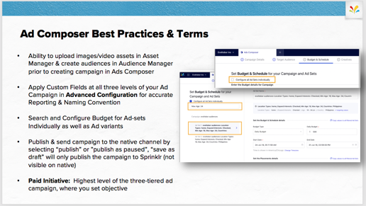  Slide 60 |  |  | - Let’s take a moment to review best practices and terms of the Ads Composer workflow.  - Ability to upload images/video assets in Asset Manager & create audiences in Audience Manager prior to creating campaign in Ads Composer  - Apply Custom Fields at all three levels of your Ad Campaign in Advanced Configuration for accurate Reporting & Naming Convention  - Search and Configure Budget for Ad-sets Individually as well as Ad variants  - Publish & send campaign to the native channel by selecting “publish” or ”publish as paused”, “save as draft” will only publish the campaign to Sprinklr (not visible on native)  - Paid Initiative: Highest level of the three-tiered ad campaign, where you set objective
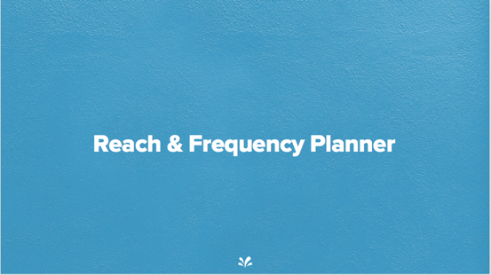  Slide 61 |  |  | - If you need to build a Reach & Frequency campaign within Sprinklr – Reach & Frequency Planner is a great tool to know.  - Reach and Frequency is a tool that estimates how much you will pay to reach your audience or obtain a CPM (Cost Per 1000 impressions) before you activate your campaign.  - It provides you with multiple predictions of the reach and frequency of your ad campaign in order to make an informed campaign decision without having to use a real budget to test and optimize them.
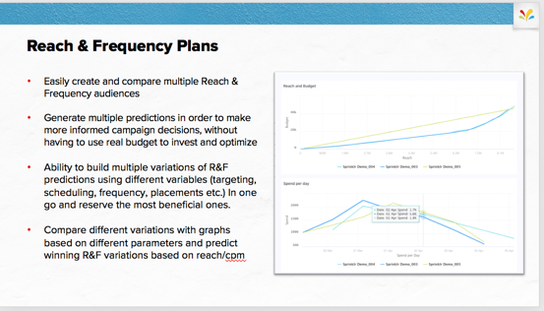  Slide 62 |  |  | - Easily create and compare multiple Reach & Frequency audiences  - Generate multiple predictions in order to make more informed campaign decisions, without having to use real budget to invest and optimize  - Ability to build multiple variations of R&F predictions using different variables (targeting, scheduling, frequency, placements etc.) In one go and reserve the most beneficial ones.  - Compare different variations with graphs based on different parameters and predict winning R&F variations based on reach/cpm
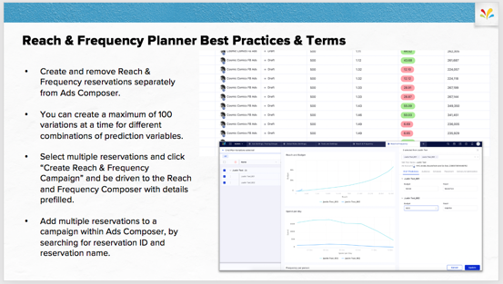  Slide 63 |  |  | - Create and remove Reach & Frequency reservations separately from Ads Composer.  - You can create a maximum of 100 variations at a time for different combinations of prediction variables.  - Select multiple reservations and click “Create Reach & Frequency Campaign” and be driven to the Reach and Frequency Composer with details prefilled.  - Add multiple reservations to a campaign within Ads Composer, by searching for reservation ID and reservation name.
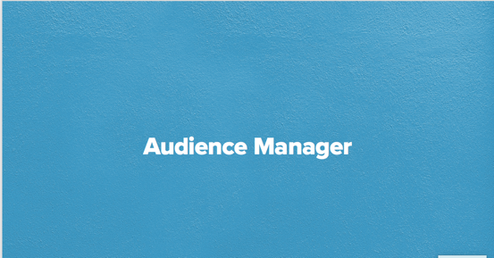  Slide 64 |  |  | - From the Audience Manager, you can create, view, manage, report and take action on all Audiences across your advertising channels and accounts, all in one place.  - Audience Manager is accessible from the Modern Advertising menu under Campaign Strategy.
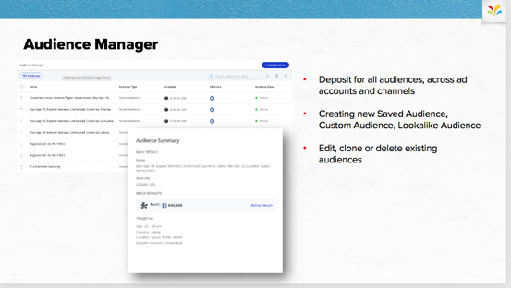  Slide 65 |  |  | - Audience Manager is essentially deposit for all audiences, across ad accounts and channels that you have permissions to.  - You can create new Saved Audience, Custom Audience, Lookalike Audience  - Edit, clone or delete existing audiences
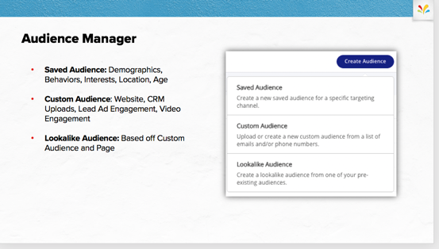  Slide 66 |  |  | - There are three types of audiences that you can create within the Audience Manager:  - Saved Audience: Demographics, Behaviors, Interests, Location, Age  - Custom Audience: Website, CRM Uploads, Lead Ad Engagement, Video Engagement  - Lookalike Audience: Based off Custom Audience and Page  - Remember: you MUST create new Custom and Lookalike audiences within Audience Manager – it is not possible to do so in Ads Composer.
Switch from PPT to Platform
 |  | Slide 67 |  |  | - Navigate to Audience Manager within Modern Advertising  - Walk through the navigation within Audience Manager.  - All Existing Audiences across channels will be shown based on permissions to add accounts  - Review columns  - All audiences will be synced with Sprinklr once ad account has been added  - Next, showcase ability to edit existing audiences. Hover on the three dot icon to Edit, clone, share and delete Existing Audiences.  - Create new audiences, you’ll be select Create Audience in the top-right corner of the Audience Manager  - Options to create Saved Audience, Custom Audience, Lookalike and Target Group  - To Create a Saved Audiences, select Create Saved Audience as the Audience Type. A Saved Audience can be used for specific channel targeting.  - Enter the Audience Details for your new Saved Audience, including an Audience Name and optional Description. Select the Audience Type, Channel for audience creation and the associated Ad Account for the channel.  - Enter channel-specific details if applicable. When a channel is selected, you may have the option to set a channel-specific Objective and its associated Page or Handle.  - Enter the targeting details like Location, Gender, Language, to define your audience based on the Audience Type. Appendix L: Create a Saved Audience  - The fields available in the Targeting section may vary depending on the channel and objective specified.  - For Facebook, you can include/exclude Custom Audiences in Detailed Targeting section and further narrow your selections between each other using Narrow Audience.  - For Pinterest, you can create and save your targeting inclusive of Custom Audience(s) only, without having to select a Keyword, Interest, or dynamically expand your interests and keywords based on your pin  - Select the custom field as desired in the Custom Properties section – unique to each client environment.  - Add Visibility and Permissions. They include the options to set the following:  - Visible in all workspaces - Check the box to make the saved audience visible in all the workspaces of your environment or select the particular Workspaces / Workspace Groups from the Workspace drop-down menu.  - View Globally - Check the box to make the saved audience visible to all the users and user groups of your environment or select the particular Users / User Groups from the Users / Users Groups drop-down menu.  - Edit Globally - Check the box to allow all the users and user groups of your environment to edit the saved audience or select the particular Users / User Groups from the Users / Users Groups drop-down menu.  - You can create Saved Audiences in the Audience Manager to be used later in Ads for efficient, easy-to-use targeting.  - Creating a Custom Audience in the Audience Manager allows you to directly import or manually enter Audience member details, or to configure an Audience based on past actions through one of your brand's social channels - for example, a list of users who have viewed your Facebook videos.  - Select Create Custom Audience as the Audience Type.  - Enter the basic details for your new Custom Audience, including Audience Name and an optional Description.  - Choose the type of audience you'd like to create, whether uploading or manually entering Audience details or creating an Audience based on interactions with your brand accounts. Appendix M: Types of a Custom Audience  - The availability of some Audience Types, like Facebook Video Engagement and Twitter Flexible Audience, will depend upon the channel selected for your Custom Audience.  - Select the custom field as desired in Custom Properties section.  - Add Visibility and Permissions.  - Creating a Lookalike Audience in the Audience Manager allows you to create an Audience using an existing Audience, creating targeting that looks for similarities to an existing Audience.  - Select Create Lookalike Audience as the Audience Type  - Enter the basic details for your new Lookalike Audience, including Audience Name and an optional Description.  - Enter Targeting Details for Lookalike Audience  - Select the Audience type for your Lookalike Audience (the Source Type will determine the Audience Sources you can select as the base for your Lookalike Audience).  - Select a specific existing Audience on which to base your new Lookalike Audience.  - Select a country to target.  - Use the slider to weigh similarity or reach as the optimization point for your Lookalike Audience.  - Audiences optimized for Similarity will be more like the Audience Source; (1-20%) Audiences optimized for Reach will be optimized to reach more individuals but may be less alike the Audience Source.  - A Target Group can be used to create audience presets for specific business locations. You can create Target Groups in the Audience Manager to be used later while creating Facebook campaigns with the Store Visits objective.

Switch from Platform to PPT
 | 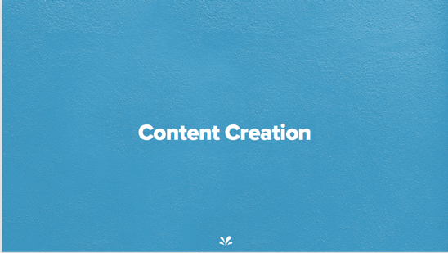  Slide 68 | - Previously we went through the workflow of creating new advertising content with the Ads Composer.  - Now let’s look at how to create content ahead of building an ad campaign and where to locate content that’s been previously used through your business’s social practice.  - Asset Manager and Creative Library are section with Sprinklr where you can work on Content Creation.
 | 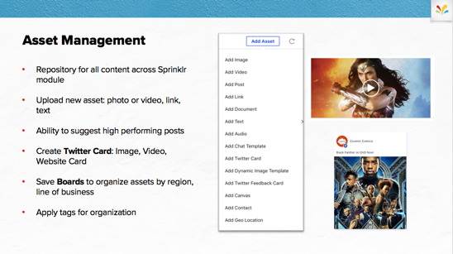  Slide 69 | - Asset Manager is the Repository for all content across Sprinklr module, Located within Modern Engagement Menu  - Upload new asset: photo or video, link, text  - Ability to suggest high performing posts  - Create Twitter Card: Image, Video, Website Card  - Save Boards to organize assets by region, line of business  - Apply tags for organization
 | 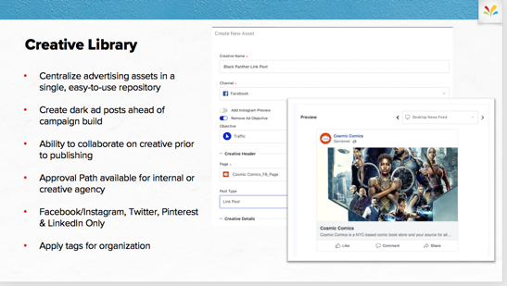  Slide 70 | - Creative Library is a feature within Modern Advertising which focuses on building an entire ad variant prior to associating it to an ad campaign.  - Create Library centralizes your advertising assets in a single, easy-to-use repository  - Create dark ad posts ahead of campaign build  - Ability to collaborate on creative prior to publishing  - Ability to send creative through Approval Path available for internal or creative agency  - Facebook/Instagram, Twitter, Pinterest & LinkedIn Only  - Apply Custom Fields or tags for organization
 | 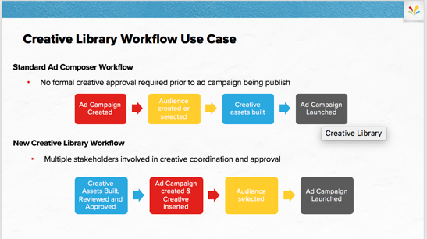  Slide 71 | - Let’s take a moment to showcase the creative library workflow and how you can use it in campaign creation.  - Creative library is a helpful tool that allows you to build you creative ahead of your campaign.  - We’ve seen clients with creative agencies separate teams or multiple stakeholders for approval have a lot of efficiencies with Creative Library.
Switch from PPT to Platform
 |   Slide 72 | - OK Let’s get into the platform and have you launch an ad campaign! Multiple steps go into this workflow, so we’ll make sure to cover all of them.
 | 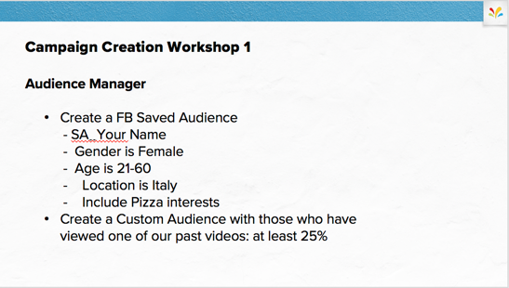  Slide 73 | - For Workshop 1, navigate to Audience Manager and create a new saved audience and a new custom audience for you to use in your upcoming campaign.
 | 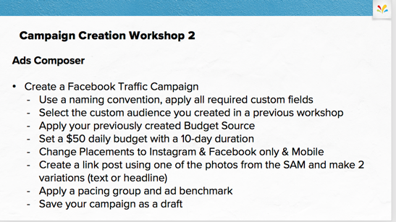  Slide 74 | - For the 2nd exercise, we are going to create a Traffic campaign on Facebook. Follow these steps and make sure to fill out all appropriate custom fields.  - At the end – make sure to save as draft instead of publishing. You’ll be pushed to Ads Manager to review your campaign.  - I’ll give you 15 min and let me know if there are any questions!
 | 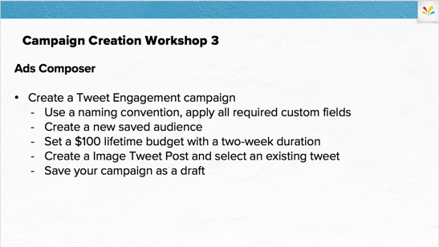  Slide 75 | - Now that you’ve done successfully launched a Facebook Campaign, let’s walk through how Ads Composer workflow looks on another Channel. Let’s create a Tweet Engagement campaign for Twitter.  - I’ll give you 15 min and let me know if there are any questions!
 | 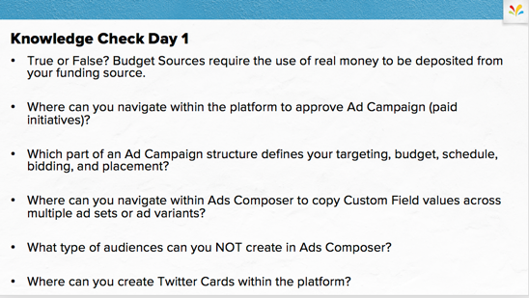  Slide 73 | - True or False? Budget Sources require the use of real money to be deposited from your funding source. FALSE  - Where can you navigate within the platform to approve Ad Campaign (paid initiatives)? Ads Manager & Engagement Dashboard  - Which part of an Ad Campaign structure defines your targeting, budget, schedule, bidding, and placement? Ad Set  - Where can you navigate within Ads Composer to copy Custom Field values across multiple ad sets or ad variants? Advanced Configuration  - What type of audiences can you NOT create in Ads Composer? Tailored, Custom, Lookalike  - Where can you create Twitter Cards within the platform? Asset Management +Bulk

 | - Lesson 5 of 7  Management and Optimization

Time
- 90 min

Materials
- Slide 75- 92

Objective
- To describe and demonstrate how to manage and optimize advertising campaigns within Sprinklr by using Ads Manager, Smart Budget Allocation and Rule Engine.

Context
- Sprinklr offers various workflows to manage and optimize campaigns whether its manually or using automation features.

Process
 | 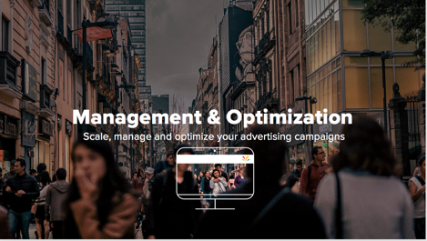  Slide 77 |  |  | - We’ve already seen the basic workflow to launch an ad campaign within Sprinklr but the next step in the lifecycle of your ad is to optimize it for what is performing well!  - Sprinklr Ads Manager centralizes all of your ad data across each of your channels simultaneously, giving you the power to optimize content in real-time. Specifically, you can:  - Assess what is or isn’t working and adjust aspects of your ad on the fly.  - Improve your return on your investment with Ads by developing data-based initiatives.  - Optimize your ad content, budget, audiences and more.
 | 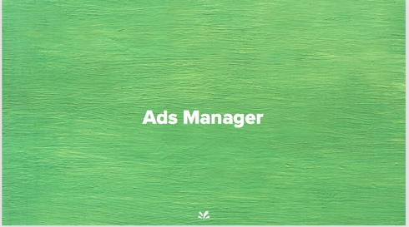  Slide 78 |  |  | - With the Ads Manager, you may customize your own views for a better download of active ad content.  - Optimizations can stretch across multiple campaigns at once with bulk actions such as macros.  - You can apply custom fields to past ad content for a historical view of granular data sets.  - Audit trails are available to track actions on all ads within Sprinklr.  - And simplified rules give you control of automated optimizations per campaign, ad set or ad variant.  - Data in the Ads Manager will upload every 15 minutes.
 |  | 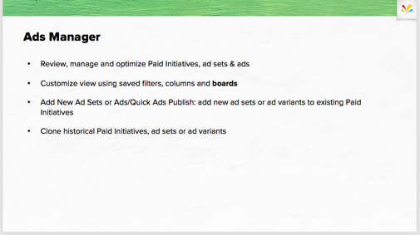  Slide 79 | - Review, manage and optimize Paid Initiatives, ad sets & ads  - Customize view using saved filters, columns and boards  - Add New Ad Sets or Ads/Quick Ads Publish: add new ad sets or ad variants to existing Paid Initiatives  - Clone historical Paid Initiatives, ad sets or ad variants
Switch from PPT to Platform
 | Slide 61 | - Navigate to Ads Manager within Modern Advertising  - Walk through the navigation at the top within Ads Manager.  - Three folders of ad campaign levels: Campaigns, Ad Sets, Ads  - Global Icon: Option to Change Skin. Default is all channels, but can drill down to both channel and ad account(s).  - Next, showcase ability to Filter the campaigns visible in Ads Manager. Click the filter icon to view filtering options. Appendix N: Customize View with Filtering  - Standard Filtering will give you the ability to select standard filtering options or Add other filters like Custom Fields that might be applicable.  - Switch to Advanced filters to showcase options to filter by Dimensions (that are not listed) or Metrics. Example: Paid Initiative Name CONTAINS Marvel  - Once filtering is completed, option to Clear All, Close (not save) with the Up Arrow, or Save Filter.  - Save Filter by Adding a Name and click Save & Apply.  - Note that all users with access with Ads Manager will be able to use saved filters. Keep organized but using an obvious name.  - Show the standard filters on the left side of Ads Manager: All, Errors, Active Campaigns. If additional filters have been saved, you will see a + # depending on the number of saved filters.  - Hover over the +# to see a list of all saved filters. Click one to be applied to Ads Manager view. Once applied, the Filter Icon will have a bubble with more details on the view.  - Click Manage Filters to edit, clone, or delete any saved filters.  - The magnifying glass icon will allow you type in what you’d like to quickly filter down to view.  - Example: type in “Marvel” and all campaigns with a name containing Marvel will populate.  - Next to the magnifying glass icon, highlight the ability to change the date range of the data coming through Ads Manager.  - Select a predefined date range on the left hand side from Today, Last 30 days, to Last Year. Custom Date Range is also available for any specific time frame needed.  - Lifetime will pull in all data from the history of the ad account. Use this date range for any campaigns scheduled for the future or in draft mode.  - Today will include the most up to date data, API syncing every 15 minutes.  - Option to change Timezone (upper right hand corner) to align with a specific region or the timezone set to the particular ad account.  - Filter Stats only (check box in bottom left hand corner): All Campaigns/Ad sets/Ads will be shown. Only the Stats/Metrics will be filtered for the given time duration.  - Next to date range, the reload icon is available to re-ping the API and make sure you have the most up to date data. You can also refresh your browser.  - Again, call out that the data will updated every 15 minutes for the paid API  - The Gear Icon will be where you can customize your column views. Appendix O: Customize with Columns Configuration.  - Select Column Configuration and a drop down of standard views and previously created/saved views will populate.  - Previously saved column configurations can be edited, cloned or deleted  - Select Modify or Build New to customize your own view of dimensions and metrics.  - A new window will pop-up to all you to select multiple dimensions and metrics at the campaign, ad set and ad variant level.  - These are categorized by level of the ad campaign and objectives. You may search for specific D&M at the top or search through the particular folders.  - Note that you can pull in DCM, Custom Metrics and various attribution windows to Ads Manager to optimize against.  - You may apply this new view or Apply and Save by adding a name to the view in the bottom left hand corner of the pop-up window.  - Color tag is the next icon and will help highlight performance within the Ads Manager view.  - Select the Color Tag and it will push you to Ads Settings. This is where you will build your IF/THEN statements to highlight good or poor performance Appendix P: Customize with Color Tags.  - Add Visibility and Permissions so that not every user has the color tag applied to their Ads Manager view.  - Call out that Macros are the wand icon, which is the in-platform bulk actions option. It will be covered in Optimization your campaign.  - The last icon on the right is Group By, which gives the possibility to show data in a pivot table view.  - You can have up to 2 dimensions layered and the campaigns will be grouped by those dimensions.  - Example: Group by Objective or Account to showcase this feature.  - Next, hover over the three dots icon (Sprinklr’s more action items) on the upper right hand corner. These are bigger actions you can take within Sprinklr.  - + Ads Composer is a shortcut to push you into Ads Composer workflow  - Next, Import/Export option allows you to export campaigns into excel, make changes needed and import back into Sprinklr.  - It is not possible to import campaigns across multiple channels, so call out that each upload should be channel specific.  - Quick Ads Publish is a short-handed workflow to create a new campaign, but most often used to create new ad sets or ads to existing campaigns.  - Save as Board option allows you to save both a filter and a column configurations together.  - Example: If you are filtering to Objective IS Traffic AND Website Clicks for FB and Twitter, you will want to view data that is website traffic, CPC, CTR, Link Clicks and maybe conversion data.  - Once you save a board it will be located in the Dashboard Menu left of the Ads Manager name. (3 horizontal lines on the upper left) contains all saved boards. You can navigate between boards you have created and those other users have shared with you.  - You can manage boards to edit, delete, clone or share with your team.  - Sync Account Data allows you to re-sync your entire ad account if Sprinklr is not matching to native.  - Example: If you create a pixel after you’ve added your ad account, and you are not able to see it in Sprinklr.  - Sprinklr syncs every 15 min for data but Pages, Permissions, Pixels might need a resync to pull in.  - Optimizing your campaign, ad set and ad variant can be done by hovering over the three dots on the left of the Name and selecting from the drop down.  - Click View & Edit on the Options menu to show the actions you can perform, including:  - View Audit (list of changes made to the item by who, when, etc.)  - Update Workflow details (Pacing group, benchmark, etc.)  - Update Budgeting, Optimization, Smart Budget, Creatives, and other details  - View Performance of an item (campaign/ ad-set/ ad)  - Apply Rules on any campaign, ad-set or ad-variant  - Appendix Q: Optimizing your Campaigns  - Appendix R: Optimizing your Ad Sets  - Appendix S: Optimizing your Ad Variants  - Apply Rules at all three levels of an ad campaign by hovering over the three dots and selecting Apply Rule  - Simplified Rules can be used by Advertisers who would like to use automation to assist with alerts or actions to campaigns.  - Appendix T: Simplified Rules  - Smart Budget Allocation will help Advertisers group campaigns together and optimize across them. By selecting multiple campaigns by checking the box left of the name, you will see a menu populate across the top. Hover over the three tops here and come down to the Smart Budget Allocation to apply these campaigns.  - Appendix U: Smart Budget Allocation

Switch from Platform to PPT
 | 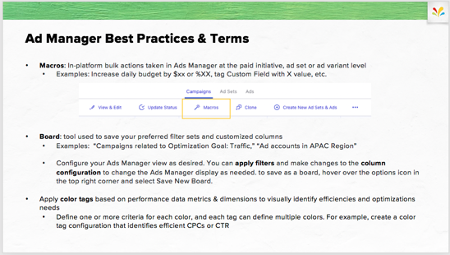  Slide 81 | - That was a lot of information on customization of Ads Manager view, optimizing and managing your ad campaigns. Let’s review some Best Practices and Terms.  - Macros: In-platform bulk actions taken in Ads Manager at the paid initiative, ad set or ad variant level  - Examples: Increase daily budget by $xx or %XX, tag Custom Field with X value, etc.  - Board: tool used to save your preferred filter sets and customized columns  - Examples: “Campaigns related to Optimization Goal: Traffic,” “Ad accounts in APAC Region”  - Configure your Ads Manager view as desired. You can apply filters and make changes to the column configuration to change the Ads Manager display as needed. to save as a board, hover over the options icon in the top right corner and select Save New Board.  - Apply color tags based on performance data metrics & dimensions to visually identify efficiencies and optimizations needs  - Define one or more criteria for each color, and each tag can define multiple colors. For example, create a color tag configuration that identifies efficient CPCs or CTR
 | Slide 82 | - Let’s review all the different type of customizations you can create and optimizations you can make within Ads Manager by doing it! |  | 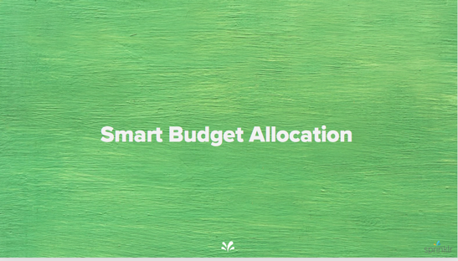  Slide 82 | - Smart Budget Allocation is an amazing value-add feature we briefly walked through in the platform, but let’s make sure we review this tool in depth.
 | 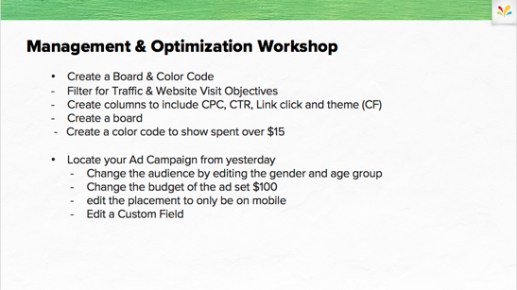  Slide 83 | - First, create a board and color code to help visualize the right campaigns and highlight their performance  - Next, try editing a campaign’s audience, budget, placement and custom field.  - I’ll give everyone 15 minutes to complete and walk round to help if needed!
 | Slide 84 | - Smart Budget Allocation is an amazing value-add feature we briefly walked through in the platform, but let’s make sure we review this tool in depth.
 | 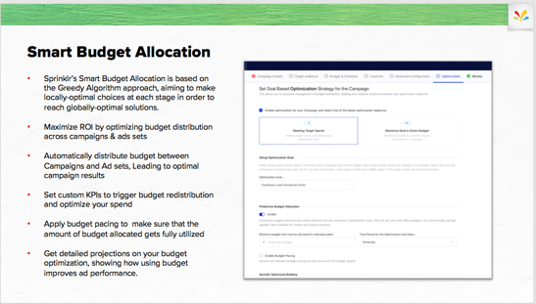  Slide 85 | - Sprinklr’s Smart Budget Allocation is based on the Greedy Algorithm approach, aiming to make locally-optimal choices at each stage in order to reach globally-optimal solutions.  - Maximize ROI by optimizing budget distribution across campaigns & ads sets  - Automatically distribute budget between Campaigns and Ad sets, Leading to optimal campaign results  - Set custom KPIs to trigger budget redistribution and optimize your spend  - Apply budget pacing to make sure that the amount of budget allocated gets fully utilized  Get detailed projections on your budget optimization, showing how using budget improves ad performance.
 | 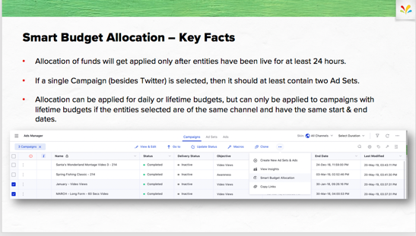  Slide 86 | - Allocation of funds will get applied only after entities have been live for at least 24 hours.  - If a single Campaign (besides Twitter) is selected, then it should at least contain two Ad Sets.  - Allocation can be applied for daily or lifetime budgets, but can only be applied to campaigns with lifetime budgets if the entities selected are of the same channel and have the same start & end dates.
 |   Slide 87 | - Previously, we learned how to use Automation in Ads Manager with Simplified Rules, but there is a larger automation function that layers across the entire Sprinklr Platform and is located with The Unified Front office Platform Setup.
 | 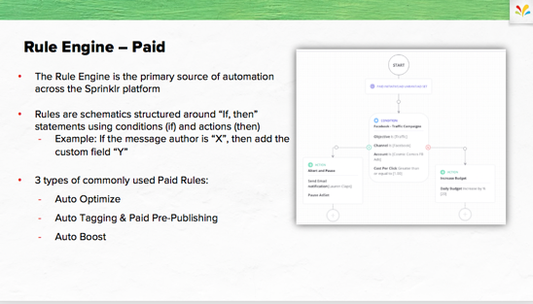  Slide 88 | - The Rule Engine is the primary source of automation across the Sprinklr platform  - If you have never seen it within your once Sprinklr instance, its because Paid Admins only have access.  - Rules are schematics structured around “If, then” statements using conditions (if) and actions (then)  - Example: If the message author is “X”, then add the custom field “Y”  - 3 types of commonly used Paid Rules:  - Auto Tagging & Paid Pre-Publishing  - ,Auto Boost  - Auto Optimize
 | 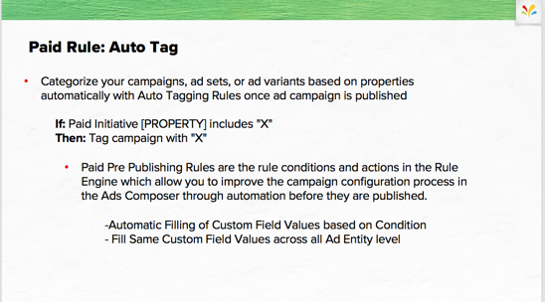  Slide 89 | - Categorize your campaigns, ad sets, or ad variants based on properties automatically with Auto Tagging Rules once ad campaign is published  - If: Paid Initiative [PROPERTY] includes "X"  - Then: Tag campaign with "X"  - Paid Pre Publishing Rules are the rule conditions and actions in the Rule Engine which allow you to improve the campaign configuration process in the Ads Composer through automation before they are published.  - -Automatic Filling of Custom Field Values based on Condition  - - Fill Same Custom Field Values across all Ad Entity level |  | Slide 85 | In Ads Manager, we walked through Simplified Rules which are only able to be applied to a particular campaign. The Rule Engine is the major source of automation within Sprinklr but due to it’s complexity, is only available to Paid Admins. It overlays across the entire platform, and can be located within the Unified Front office Platform Setup Menu
 | 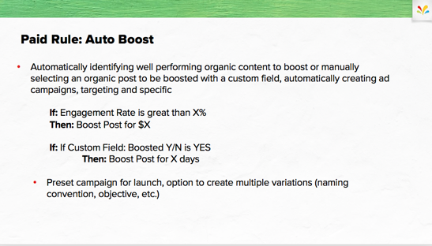  Slide 90 | - Automatically identifying well performing organic content to boost or manually selecting an organic post to be boosted with a custom field, automatically creating ad campaigns, targeting and specific  - If: Engagement Rate is great than X%  - Then: Boost Post for $X  - If: If Custom Field: Boosted Y/N is YES  - Then: Boost Post for X days  - Preset campaign for launch, option to create multiple variations (naming convention, objective, etc.)
 | 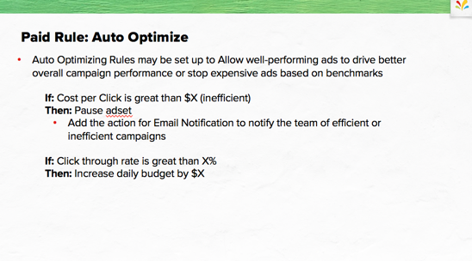  Slide 91 | - Auto Optimizing Rules may be set up to Allow well-performing ads to drive better overall campaign performance or stop expensive ads based on benchmarks  - If: Cost per Click is great than $X (inefficient)  - Then: Pause adset  - Add the action for Email Notification to notify the team of efficient or inefficient campaigns  - If: Click through rate is great than X%  - Then: Increase daily budget by $X |  | Slide 85 | In Ads Manager, we walked through Simplified Rules which are only able to be applied to a particular campaign. The Rule Engine is the major source of automation within Sprinklr but due to it’s complexity, is only available to Paid Admins. It overlays across the entire platform, and can be located within the Unified Front office Platform Setup Menu
 | Slide 92 | - Since you might not have access to the Rule Engine in your own environment, let’s jump into the platform and walk through how to set up a Paid Rule.
 | 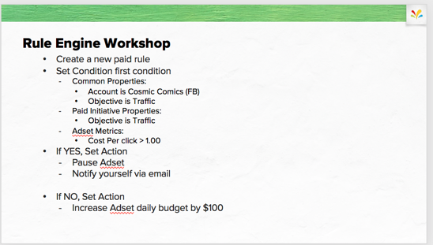  Slide 93 | - We’re going to build a rule to assist with optimizing Ads within all Traffic objective campaigns.  - Make sure to add in the action of being altered via email!  - I’ll give everyone 10 minutes to build this rule.

  - Lesson 6 of 7

Analytics

Time
- 90 min

Materials
- Slide 94-101

Objective
- To share how to create reporting dashboards within Sprinklr Modern Advertising.

Context
- After you launch an Ad campaign and optimize it, you’ll want to create a report to view performance data easily.

Process
 |   Slide 94 | - You may have experience with Sprinklr Reporting whether its within Advertising, Benchmarking, Listening or Organic/Engagement.  - The good news is the reporting UI is very similar across Sprinklr but there are some Advertising nuances that we’ll make sure to cover.
 | 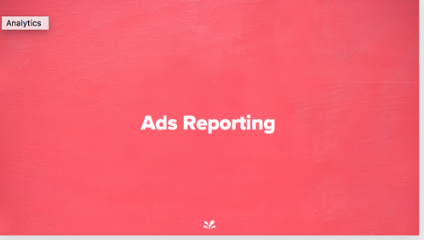  Slide 95 | - Ads Reporting dashboards show you how your ads are performing.  - They deliver this information in the form of graphic images, called widgets, that visually depict ad performance data.  - First, let’s make sure we have a shared understanding of what Ads Reporting is.
 | 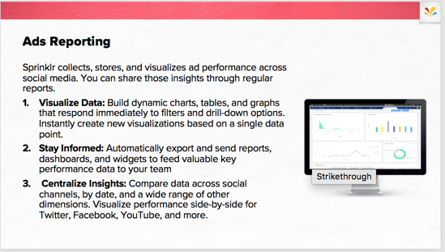  Slide 96 | - Sprinklr Ads Reporting can help you visualize data, stay informed, and centralize insights. Specifically, you can:  - Customize dashboards to analyze campaign performance for informed decisions.  - Visually compare ROI across social channels, from clicks to website conversions and activities.  - Choose the most effective past content to create new, equally successful content.  - Analyze all of your campaigns on one screen to shape a multi-channel marketing strategy.  - Evaluate performance across regions using customized widgets to define regional marketing strategies.
Switch from PPT to Platform
 |   Slide 9 | - Point out the elements of the Overall Dashboard, using Appendix A: Sprinklr Ads Reporting Dashboards and Appendix B: Dashboard Menu as guides.  - When you get to the Dashboard Options menu, note how few options are available on the standard dashboard.  - Select Clone to demonstrate cloning a dashboard and note how many new options are available, including Edit Layout.  - Click Edit Layout to show the Layout Editor  - Drag and drop selected widgets around on the screen.  - Click + Add Section to create a new tab.  - Click the check mark in the upper left of a widget and use the Move to Sections drop-down menu to add it to your new tab.  - Click Save to show your revised layout. Drag and drop a widget around the screen to show how that operation can be performed in regular view.  - Demonstrate filtering for assorted criteria, including campaign-specific data, custom properties, and social networks.  - Continuing the demo, click Add Section to demonstrate adding a tab.  - Adjust the Time Range menu, observing how widgets look different with different time ranges.  - Interpret the information from 2-3 sample widgets and ask students to suggest implications to the campaign.  - Pick a widget and create another custom dashboard, using the process in Exercise 1: Create a Custom Dashboard.  - Open the Dashboard menu and discuss the options under Settings, as described in Appendix D: Ads Reporting Dashboard Settings.  - Display the Reporting Glossary and explain the New, Deprecated, and Favorite tabs.  - Return to the All tab and demonstrate the process of searching and starring a metric, as described in Exercise 4: Star a Metric.  - Before exporting, introduce the problem: You need to send weekly reports to your team each Friday.  - Demonstrate the process of creating a report title—“Monthly Executive Report,” for example—by adding a custom text widget at the top of the dashboard.  - Demonstrate the process of scheduling a custom report export, as described in Exercise 5: Schedule Custom Intervals.
Switch from Platform to PPT
 | 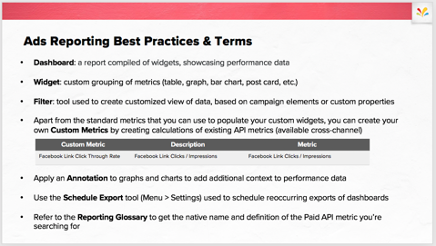  Slide 98 |  | - Dashboard: a report compiled of widgets, showcasing performance data  - Widget: custom grouping of metrics (table, graph, bar chart, post card, etc.)  - Filter: tool used to create customized view of data, based on campaign elements or custom properties  - Apart from the standard metrics that you can use to populate your custom widgets, you can create your own Custom Metrics by creating calculations of existing API metrics (available cross-channel)  - Apply an Annotation to graphs and charts to add additional context to performance data  - Use the Schedule Export tool (Menu > Settings) used to schedule reoccurring exports of dashboards  - Refer to the Reporting Glossary to get the native name and definition of the Paid API metric you’re searching for
 |   Slide 99 | - Let’s make sure that you are confident creating reporting dashboards for your ad campaigns!

 | 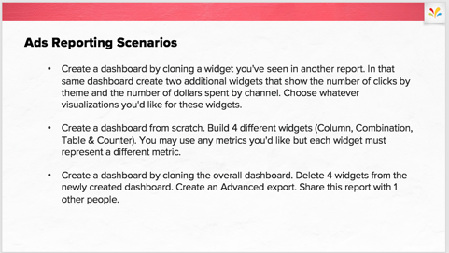  Slide 100 | - You may have experience with Sprinklr Reporting whether its within Advertising, Benchmarking, Listening or Organic/Engagement.  - The good news is the reporting UI is very similar across Sprinklr but there are some Advertising nuances that we’ll make sure to cover.
 | 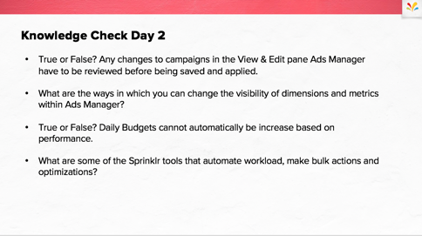  Slide 101 | - True or False? Any changes to campaigns in the View & Edit pane Ads Manager have to be reviewed before being saved and applied. TRUE  - What are the ways in which you can change the visibility of dimensions and metrics within Ads Manager? FILTERS, COLUMN CUSTOMIZATIOS, BOARDS, COLOR TAGS, GROUP BY  - True or False? Daily Budgets cannot automatically be increase based on performance. FALSE  - What are some of the Sprinklr tools that automate workload, make bulk actions and optimizations? MACROS, SIMPLIFIED RULES, RULE ENGINE, BULK IMPORT
- Sprinklr Ads Reporting can help you visualize data, stay informed, and centralize insights. Specifically, you can:
- Customize dashboards to analyze campaign
 |  |  | - Lesson 7 of 7  Wrap-Up & Next Steps

Time
- 15 min

Materials
- Slide 102 - 104

Objective
- To review what’s next and next step to take Advertising Certification exam.

Context
- This closing module ties up loose ends, gathers student feedback, and sets you up to leverage Sprinklr Advertising knowledge to pass certification.

Process
 |   Slide 102 | - Now let’s use what you’ve learned to build an ad campaign by using the Ads Composer workflow.
 | 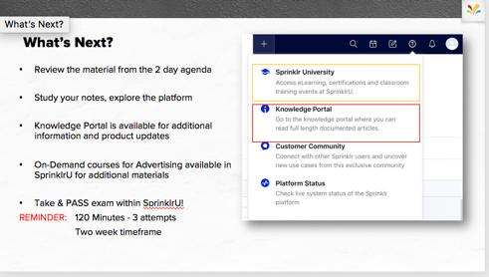  Slide 103 | - Review the material from the 2 day agenda  - Study your notes, explore the platform  - Don’t forget about the resources in SprinklrU and the Knowledge Portal.  - On-Demand courses for Advertising available in SprinklrU for additional materials  - Take & PASS exam within SprinklrU!  - REMINDER: 120 Minutes - 3 attempts  Two week timeframe
 | 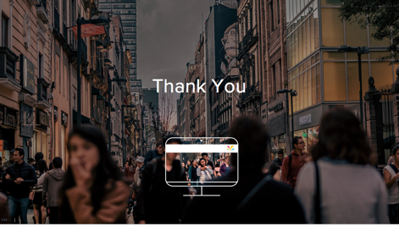  Slide 104 | - Do you have any more questions? Are you sure?  - Thanks for attending!  - I’ll be sending a final exam with with PPT, a guide to access your transcript and survey for course evaluation.

 | Resources
Course survey
To improve our Sprinklr course offerings, click the SprinklrU Learning Services Survey to provide your feedback.
For more information, see these resources:
- About Ads Composer
- Ads Composer
- Create and Use Advertising Naming Convention
- Search and Configure Budget for Ad sets Individually
- Search and Associate Creatives with each Ad set Individually
- Add Placement Variations
- Daypartying in Sprinklr Advertising
- Add and Use a Budget Source
- Add and Use DCM/DFA Account
- Facebook Reach and Frequency in Ads Composer
- Create a Reporting Dashboard
- Dynamic Product Ads
- Ads Campaign Review and Approval
- Ads Manager Overview
- Manage Ads
- Actions in the Ads Manager
- Edit Ads in the Ads Manager
- Cloning Ads in the Ads Manager
- Create or Edit Facebook Ad Creatives in Ads Manager
- Create and Save a macro
- Create and Manage Boards in Ads Manager
- Smart Budget Overview
- Smart Budget FAQ
- Manage Smart Budget Allocations
- Apply Smart Budget Allocation
- Smart Budget Allocation by Channel
- About Ads Reporting
- Paid Media Reporting
- Using Target Metrics
- Reporting Glossary
- Paid Media Reporting Glossary
- Create an Advertising Benchmark
- Manage Advertising Benchmarks
- Using Ads Benchmarking
- Tag Campaigns with Advertising Benchmarks
- Drill Down into Reporting Widgets
- Apply Universal Time Zones in Ads Reporting
- Filter the Ads Reporting Dashboard
- Create a Reporting Dashboard
- Manage Scheduled Exports
- Manage Reporting Widgets
 | Appendices
This section includes references for locating information and performing reporting tasks in Sprinklr:
- Appendix A: Select Ad Account
- Appendix B: Workflow options
- Appendix C: Campaign Setup
- Appendix D: Create a new audience
- Appendix E: Configuring Budget & Schedule
- Appendix F: Placement Variations
- Appendix G: Apply Dayparting
- Appendix H: Selecting existing post
- Appendix I: Placement Asset Customizations
- Appendix J: Creating multiple variations of ads
- Appendix K: Configuring creative for ad sets

Appendix A: Navigate to Ad Composer & Select Ad Account
Dashboards are Sprinklr-designed, prebuilt templates that offer you a leg up on creating reports. They show reporting metrics across most features, summarize ongoing campaigns and social channel performance, and let you copy and configure widgets.
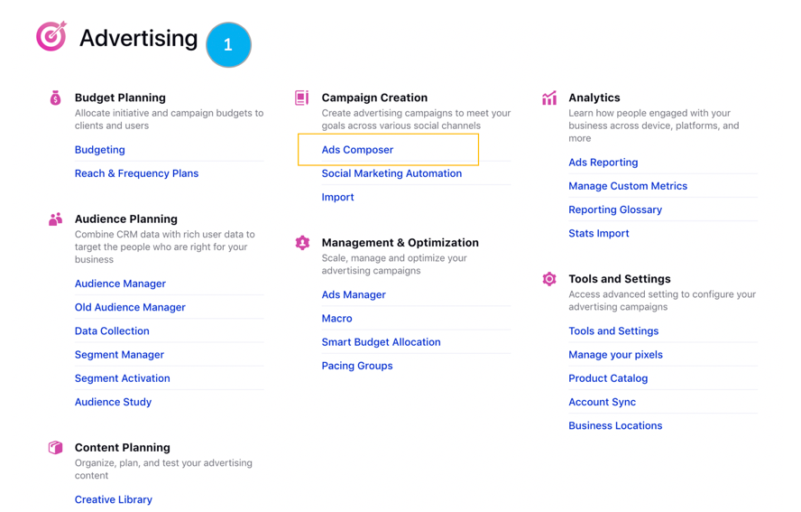

- The Navigation Menu contains all Sprinklr product menus, navigate to Modern Advertising and find Ads Composer within Campaign Creation.
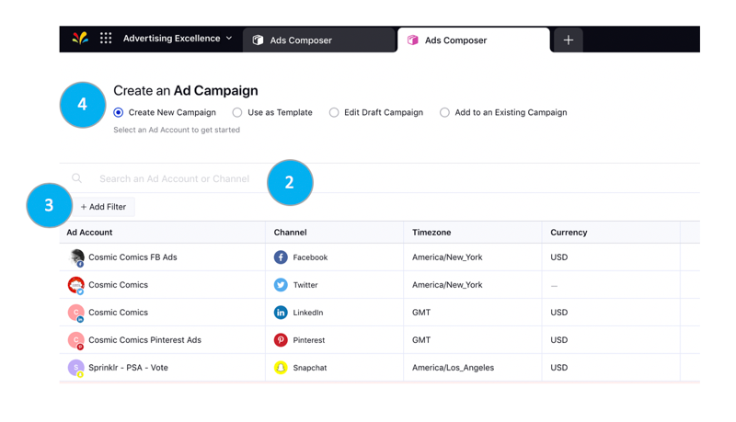
- The Ads Composer will populate all ad accounts you have access to in the list below “Create an Ad Campaign”. You can search an Ad Account or Channel by typing into the search bar. Ad Account, Channel, Time zone and Currency will populate in columns to better identify the account you’re looking for. Click the Ad Account and you will be pushed into the Ads composer step by step workflow.
- Click Add Filter below the search bar to filter the ad accounts of campaigns as needed. You can also sort the columns as desired by clicking the Sort icon alongside each column. Refer to Appendix B for a list of filter and sort options for the different campaign creation types.
- The Create New Campaign option will be your default for Ads Composer. If you would like to select a different workflow, click one of the options before selecting your ad account. Reference Appendix B: Workflow Options for more information.

Appendix B: Ads Composer Workflow Options
Although the most common workflow for Ads Composer is to “Create New Campaign”, Sprinklr also allows you to use a saved campaign as a template and create a new campaign for your social advertising needs, saving you the time and effort of creating it from scratch. The following are the available campaign creation options:
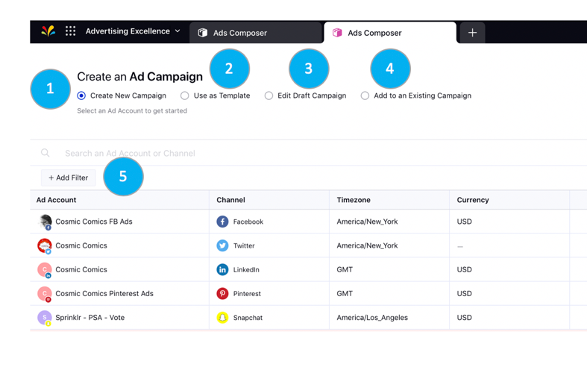
- Create New Campaign: Select an Ad account and create your new campaign.
- Use as Template: Create a new campaign by using the existing or the draft campaign as a campaign template. To create a new campaign, click on any listed ad account, and then you can choose from the following templates within the existing template:
- Use Initial State: Use campaign as it was when originally created and ignore any changes made later to this campaign. Initial State can only be used with those campaign created through Ads Composer.
- Use Current State: Use the current state of the campaign. This is useful if you have, for example, added ad sets or creatives after the campaign was created. Please note that ad set statuses will not be cloned.
- Note: Use Campaign as a Template can be used on all campaigns but not on Deleted or Archived campaigns.
- Edit Draft Campaign: Select from the existing draft campaigns to make changes as required. Note that all the draft campaigns built in Ads Manager via cloning are available for you to select in Ads Composer.
- Add to an Existing Campaign: Select existing campaigns to add new Ad-sets or Ads.
- Filters & Sorting by each campaign creation Type:
- Create New Campaign - Filter by Channel (All channels selected by default). Sort by Channel.
- Use as Template - Filter by Channel (All channels selected by default), Ad Account, Ad Objective, and Status. Sort by Name, Status, and Modified Time.
- Edit Draft Campaign, Add to an Existing Campaign - Filter by Channel (All channels selected by default), Ad Account, and Ad Objective. Sort by Name and Modified Time.

Appendix C: Various campaign Setup Options
Selecting your objective at the first step of Ads Composer, Campaign Details. Picking certain objective will request additional configuration of your campaign.
. 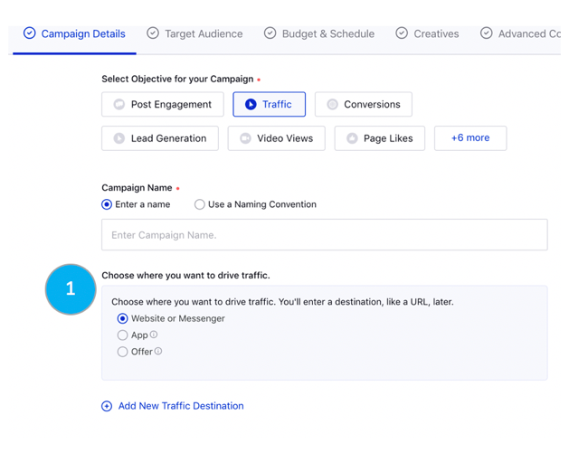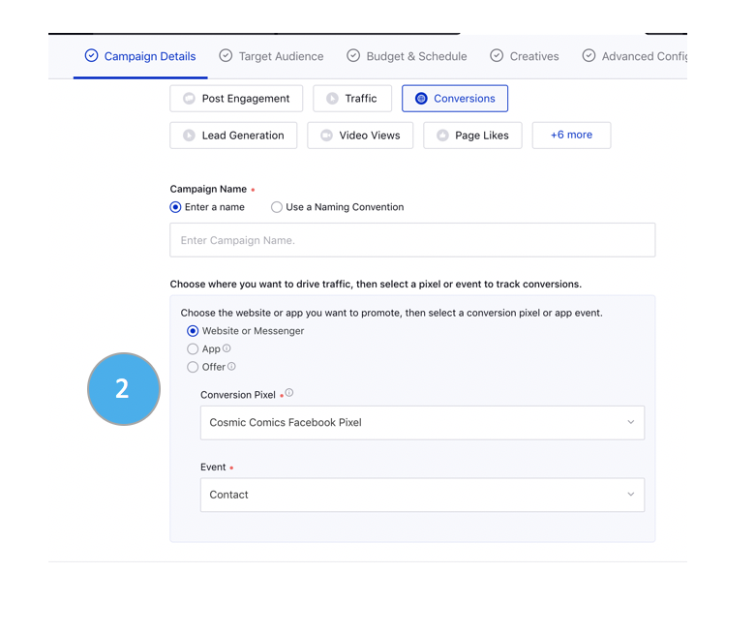
- The Campaign Details tab will populate with different configuration options depending on the objective you select. When selecting the traffic objective for Facebook, it will request that you choose where you want your traffic to drive to.
- If Facebook Conversions is selected as your objective, you’ll need to choose where the traffic will go to and select a pixel or event to track conversions.
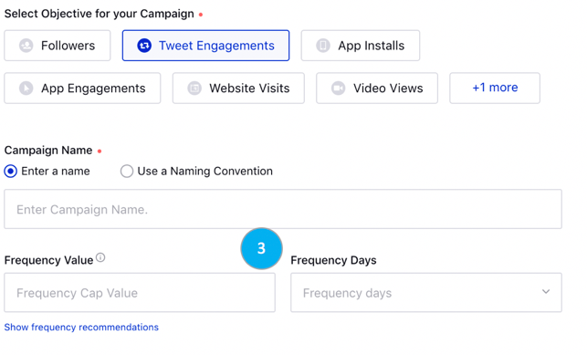
- Twitter Tweet Engagements objective will give you an option to define the frequency value and days for your engagement campaign.
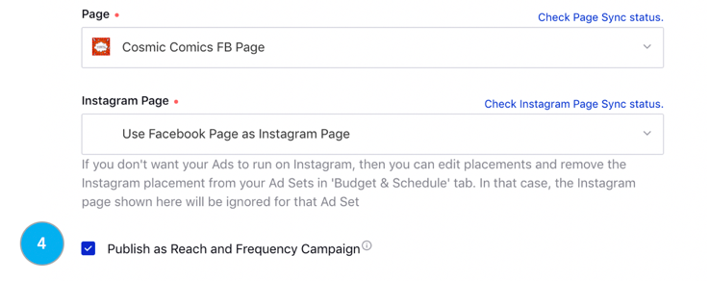
- Depending on which Facebook Objective you select, you may be able to publish your campaign as Reach and Frequency instead of the standard auction based. Click the check marked box next to Publish as Reach and Frequency Campaign and your Ads Composer workflow will change in accordance with reserved buying.

Appendix D: Create a new audience
Enter the target audience details if you need to create a new target audience for your ad campaign.
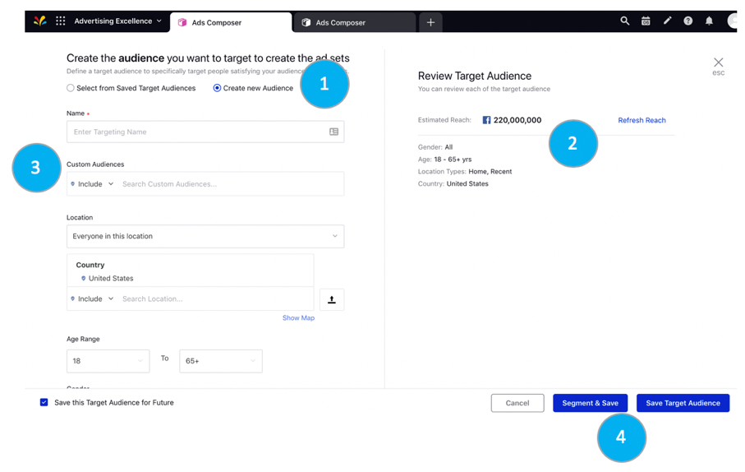
- Select Create new audience and all channel audience targeting options will populate below.
Each channel’s specific targeting aspects to create a Saved Audience will pull through the Ads Composer for section. Some channels offer the option to layer on Custom or Tailored Audiences; however, they cannot be created in the Ads Composer workflow.
- Review Target Audience will populate the estimated reach of the audience selected as well as a review of specifications selected.
- Custom Audiences let you include or exclude your 1st party data that has been previously created within Audience Manager or natively.
- Once all targeting dimensions have been selected, you have the option to Save the Target Audience to apply to your ad campaign or Save & Segment. Any audience that you create here will automatically create a new ad set.
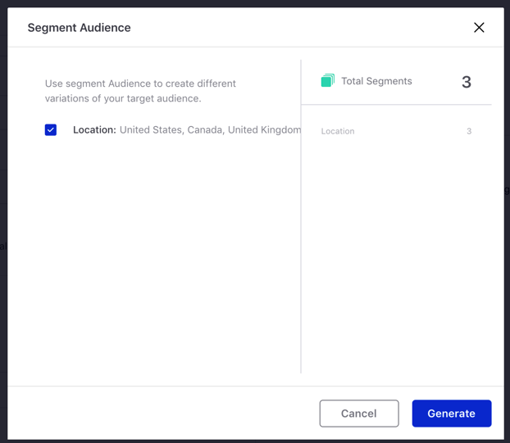
Option to Save & Segment for demographics like location, age and gender to create different ad sets by each breakdown to better optimize between ad sets.

Appendix E: Configuring Budget & Schedule
While composing an Ad, in addition to configuring budget for each ad sets individually within an Ad campaign, Sprinklr allows you to search the ad set based on the keyword associated with each ad set to narrow down on the specific ad sets within an Ad campaign.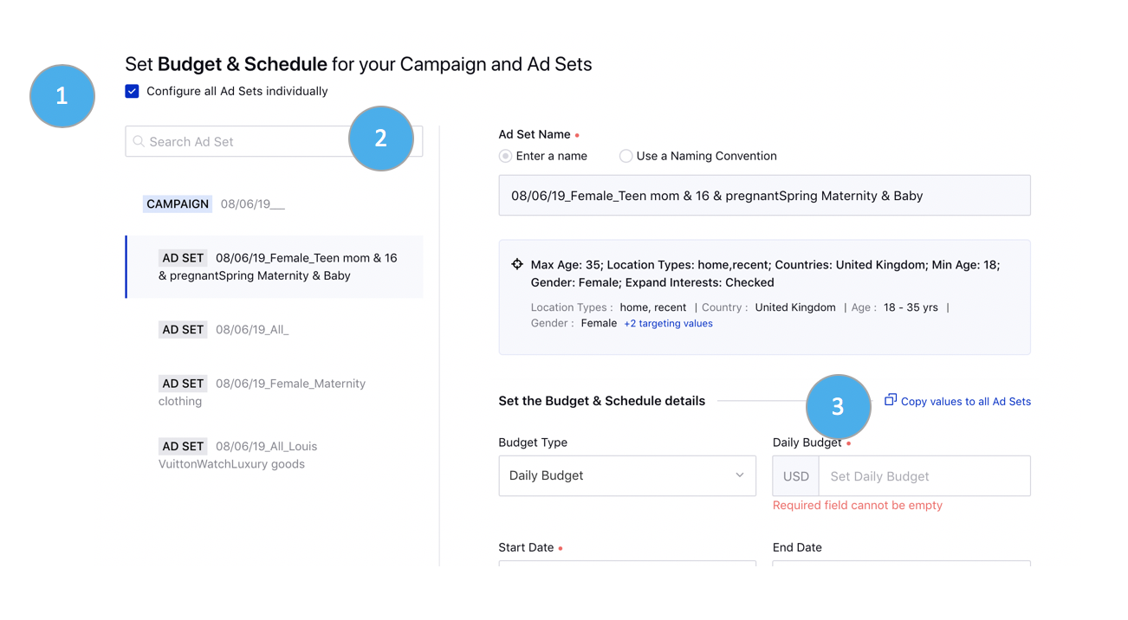
- Under Set Budget & Schedule for your Campaign and Ad sets section, click Configure All Ad sets Individually.
- To further filter the Ad-sets, in the Search Ad Set field, type the keyword that is associated with the Ad-sets. Click the listed Ad-sets and configure budget individually.
- Once you have configured budget for one of the filtered Ad-sets, you can click Copy values to all filtered Ad-sets to apply the budget configuration on all the filtered Ad-sets at once.
- If you are configuring Ad Sets individually but there is one or two details that are consistent across Ad Sets, use the tool Copy values to all Ad Sets to copy those values.

Appendix F: Placement Variations
While composing a campaign, Sprinklr provides you with an option to add multiple placement variations for your target audiences instead of having to add the placement individually. This will create a duplicate of your ad sets for each placement variation.
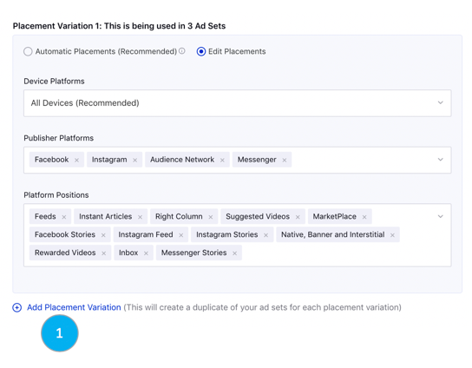
- To add placement variations for all ad sets, click Add Placement Variation under Enter the Placements details for all Ad Sets, within the Budget & Schedule section of Ads Composer.
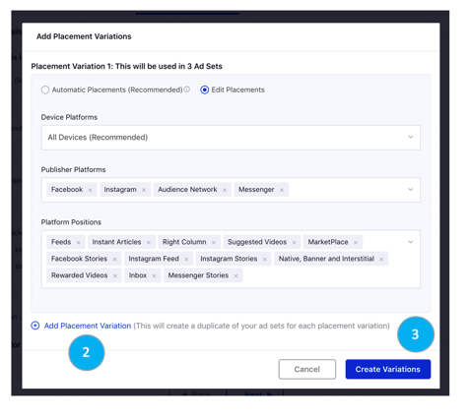
- On the Add Placement Variations pop-up window, click Add Placement Variation to add multiple placement variations for your Ad Sets. You can either select Automatic Placements or Edit Placements for different variations.

- Click Create Variations in the bottom right corner of the pop-up window to create duplicates of your ad sets for each placement variation
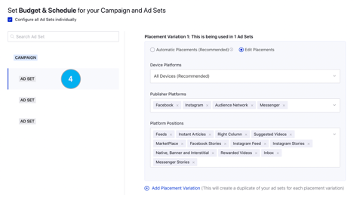
- To Add Placement Variations for Individual Ad Sets, Click on a particular Ad Set to which you want to add placement variations from the left-hand pane.

Appendix G: Apply Dayparting
Advertisements are often viewed more during certain days of the week and certain times of the day over others, depending on different industries and products. So rather than running ads all day and at all times, you can save money and time by targeting your users at times when the chances of conversions are maximum.
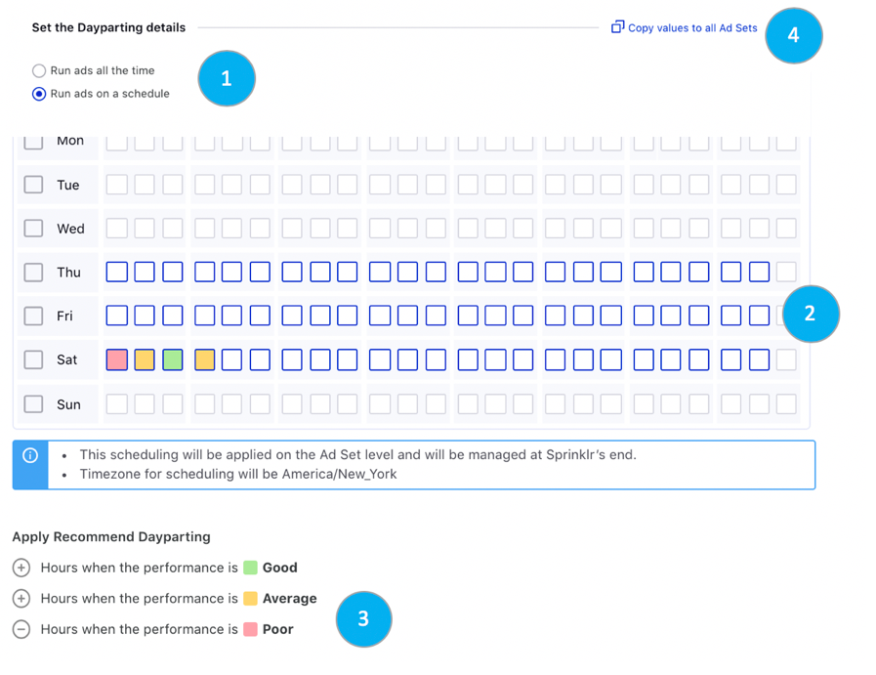
- Within Budget & Schedule step, you have the ability to set your ad sets with Dayparting.
- In the given days and hour boxes, drag along the boxes to select those days and hours you wish to enable your ads on.
- You can unselect the box by clicking on the selected box.
- You can click the + button to schedule your ads based on the historical performance of your ad account:

- Hours when the performance is Good: Click the icon alongside to bulk select the hours when the performance is good.
- Hours when the performance is Average: Click the icon alongside to bulk select the hours when the performance is average.
- Hours when the performance is Poor: Click the icon alongside to un-select the hours in bulk when the performance is poor.

Appendix H: Selecting Existing Creatives
In the Creatives tab, you can search/select from an existing creative for your campaign by clicking on the available creatives.
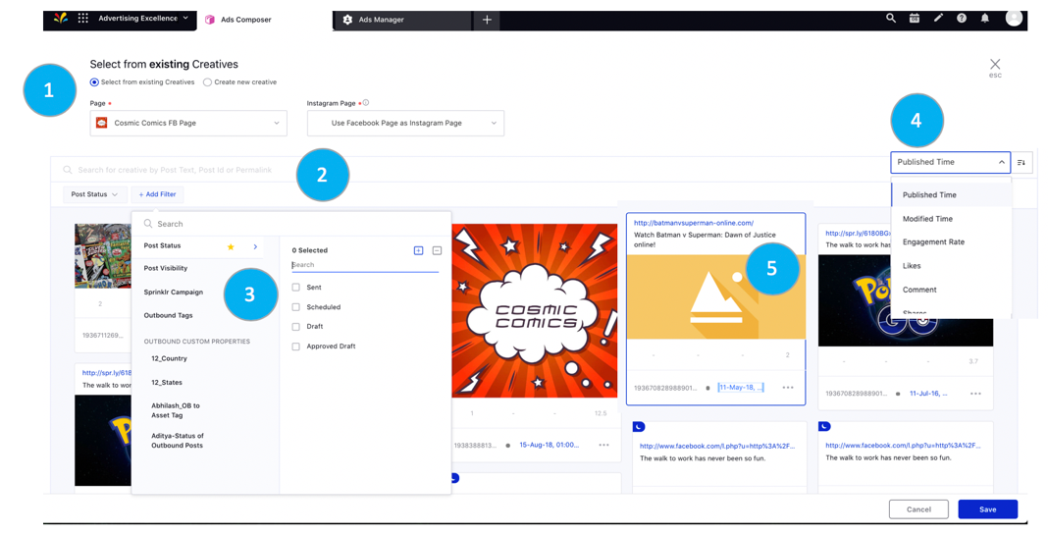
- Select from existing Creative will be the first option once you hit the creative tab. You have the ability to change the organic handle or page you’ll be advertising from (as long as it’s associated with the ad account)
- Search for existing creative by post text, post ID or Permalink.
- Blue moon icon indicates it’s only been published as a dark post, all other posts have bene live on the organic page/handle.
- Option to Add a filter for existing posts by various dimensions in the drop down.
- Sort existing creative by Published Time, Modified Time, Engagement Rate, Likes, etc. Option to sort by ascending or descending order.
- To select an existing post to use as an ad variant, click on the post and it will be outlined in blue.

Appendix I: Placement Asset Customizations
In the Creatives tab, you can search/select from an existing creative for your campaign by clicking on the available creatives.
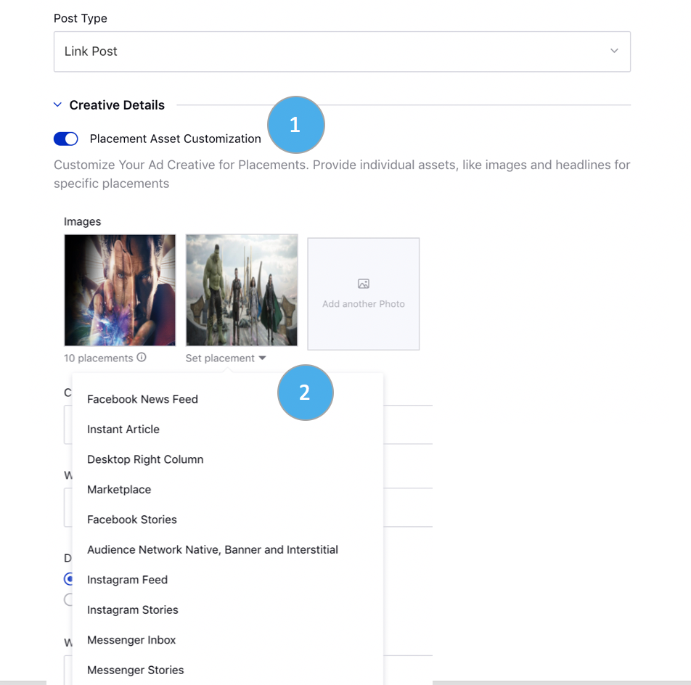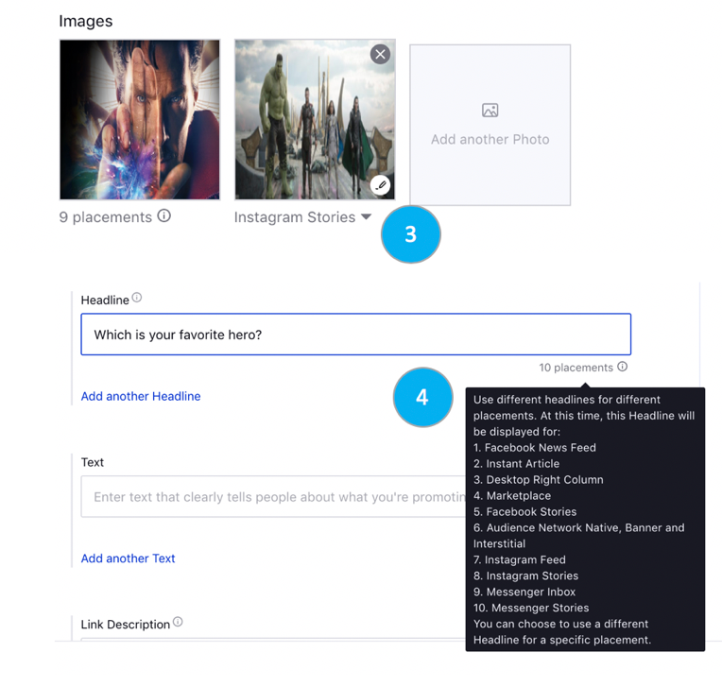
- Select the Post Type for your creative. Placement Asset Customization is only supported for Image, Link, and Video post types. Under Creative Details, slide the Toggle icon alongside Placement Asset Customization to enable customization of your ad creatives.
- As you select multiple assets for your creative, you’ll be able to apply certain placements to specific assets. You can only select a total of nine assets or less for your placement customization
- Under Creative Details, slide the Toggle icon alongside Placement Asset Customization to enable customization of your ad creatives.
- You can only select a total of nine assets or less for your placement customization. Option to Add a filter for existing posts by various dimensions in the drop down.
- Create placement asset customizations for Images, Videos, Headlines and Text.

Appendix J: Creative Variations
In the Creatives tab, you can now add multiple aspects of a Creative in order to quickly create multiple Creative variations. Now, you no longer have to manually add in each variation of a Creative; instead, efficiently create all Creative variations in one seamless workflow.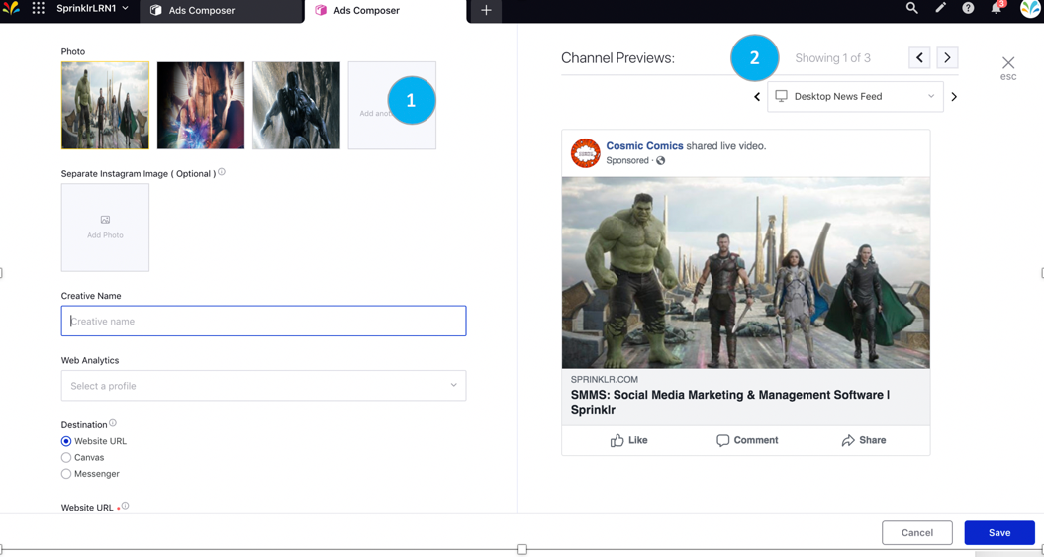

- When creating a new Creative in the New Ads Composer, select Add Another Entry to add in multiple variations of particular headers, texts, photos etc.

- When adding new creative entities, you'll see the number of Creatives built by the number displayed in Channel Previews on the right side of the Creative window.
  - Every Creative that was generated will be put within each Ad Set. Users can toggle between different creative previews.

Appendix K: Configuring creative for ad sets
Sprinklr allows you to search and narrow down on specific ad-sets within an Ad campaign. Once you have filtered the Ad sets based on the Ad set attributes, you can individually apply creatives to the filtered Ad sets.

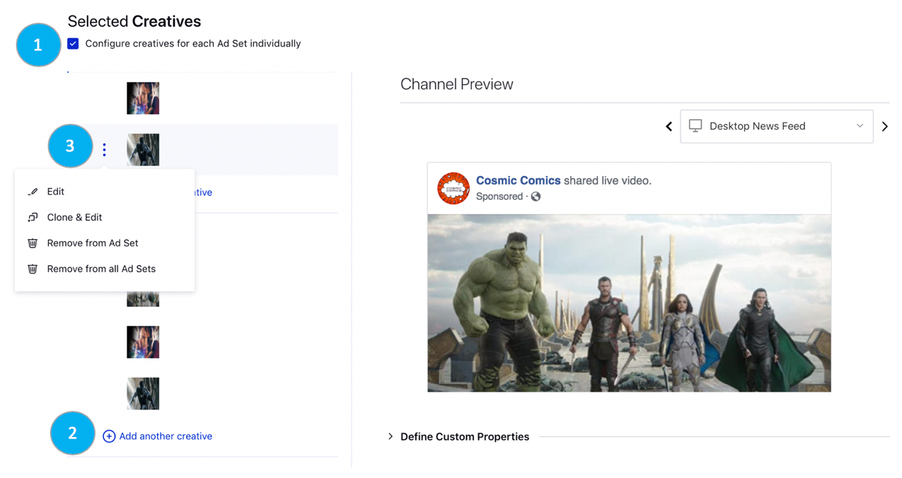
- After you select or create a new creative within the Creatives tab, you’ll be pushed to the Creative Review tab. Under Selected Creatives, click Configure Creatives for each Ad sets individually.

- In the Search ad set field, type the keyword that is associated with the Ad sets. Click Add another creative to apply a unique creative variation to a particular ad sets.
- Hover over the three dot icon to edit, clone & edit, remove from ad set(s).

 | Exercises
This section includes exercises for students to practice what they’ve learned:
- Exercise 1: Create an Ad Campaign

Exercise 1: Create an Ad Campaign

Creating an ad campaign will allow you to reach new and existing audiences to engage with your brand. Ads Composer gives you a consistent workflow across social channels to gain efficiency and apply value-add features. In this exercise, you will create a Facebook traffic campaign.
Log on to Sprinklr and navigate to the Ads Composer screen by clicking Ads Composer, under Campaign Creation, under Modern Advertising.
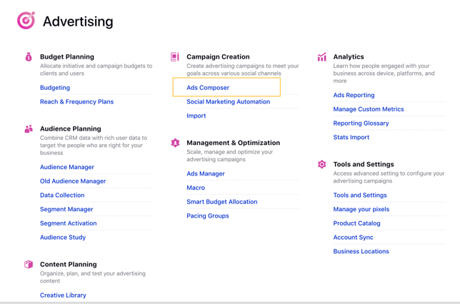

- Navigate to your Facebook Ad Account or search for the name within in search box. This workflow will auto default to Create New Campaign, continue using this option. 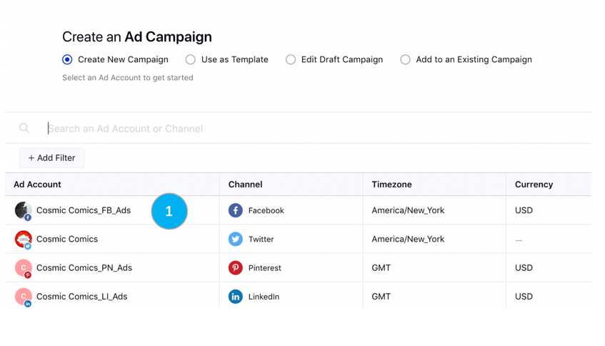
- Continue onto the Campaign Details step and set your campaign’s objective to Traffic. 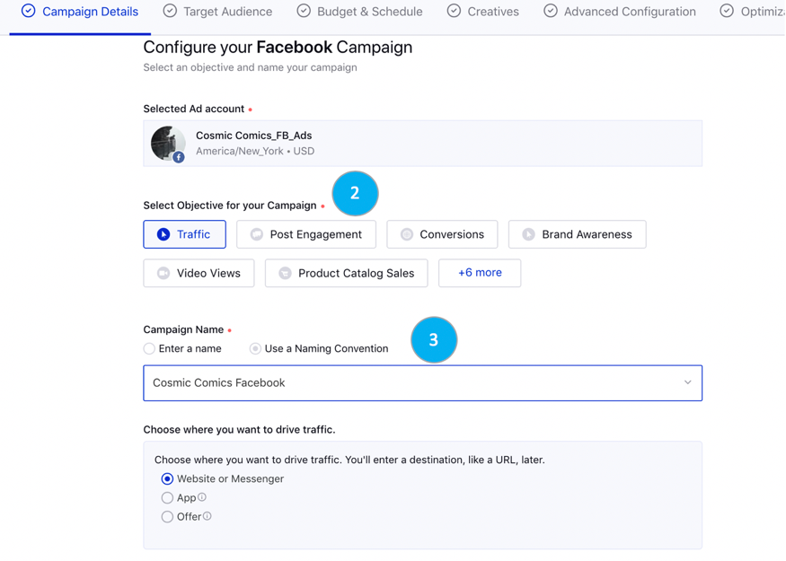
- Next, select the option to Use a Naming Convention and select one from the drop down list.
- Under Define Custom Properties, fill out all campaign custom fields based on what the purpose of the is ad campaign is. All mandatory custom fields will have a red dot next to the name.
- Click Next to move to the Target Audience Tab.
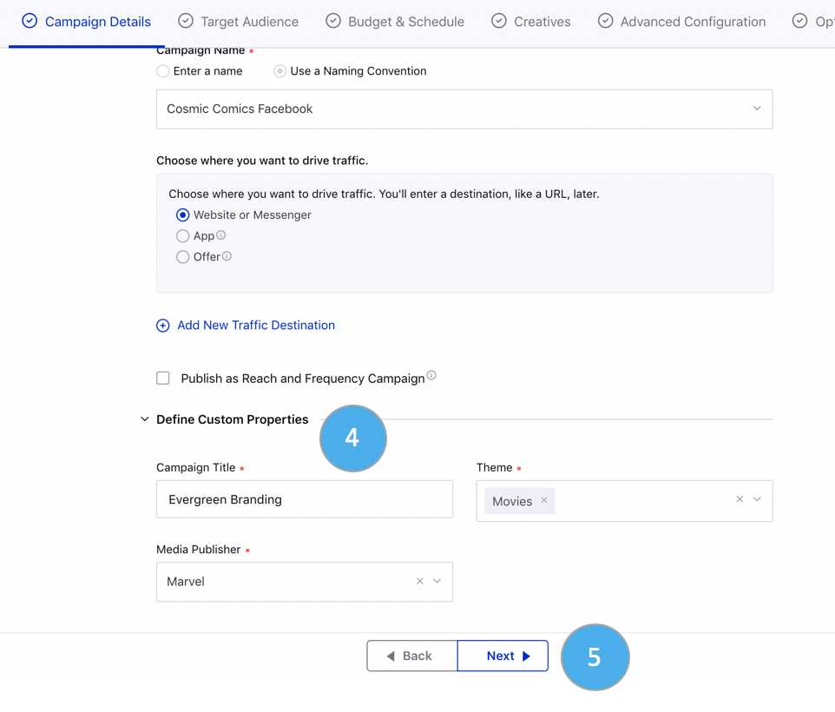
- Select two Saved audiences in the list of audiences available by checking the box next to the name. Option to search for audience by targeting dimensions or name, as well as view details to gain more insight to audience targeting.
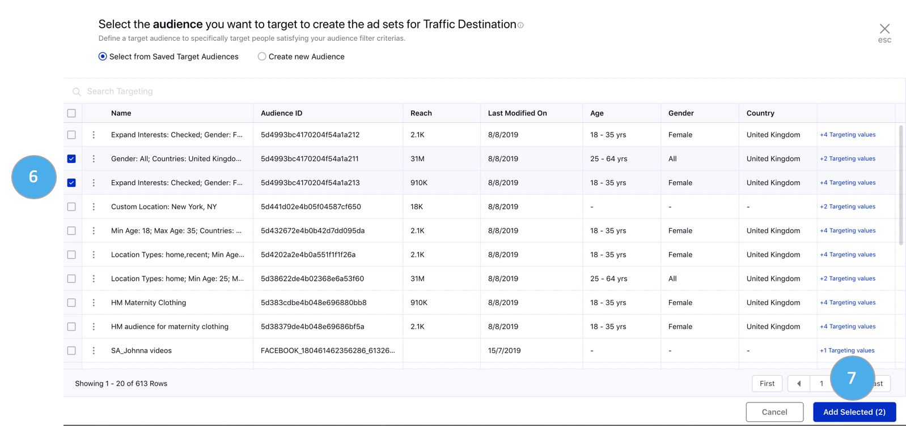
- Click Add Selected (2) to create 2 ad sets within your ad campaign.
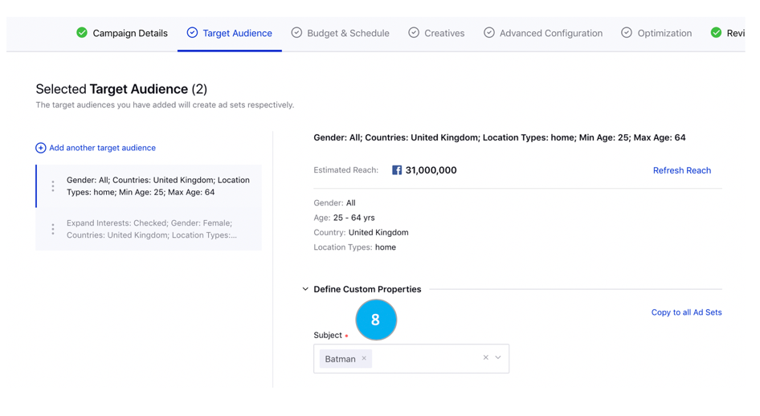
- Review your audiences selected in this tab & reach, then navigate to Define Custom Properties at the ad set level.
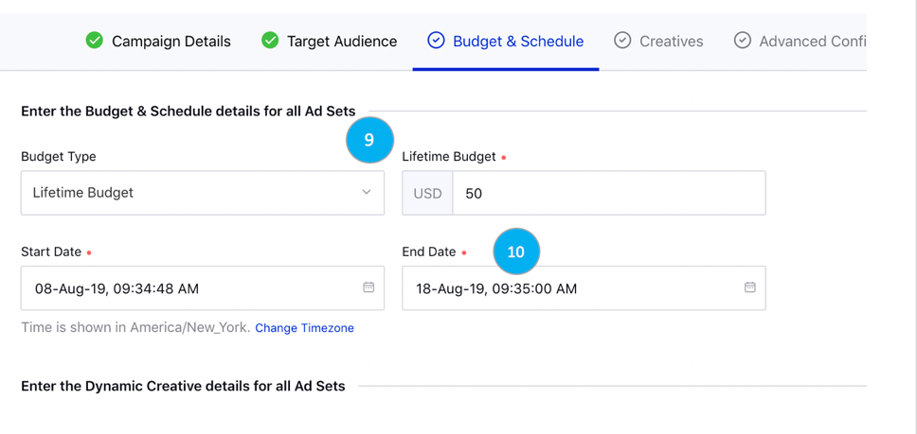
- Within Budget & Schedule tab, change the Budget Type to Lifetime Budget and enter 50 into the budget amount.
- Be sure to add an End Date for Lifetime Budget, select 10 days out of start date for campaign duration.
- Select Edit Placements and change Device Platform to Mobile.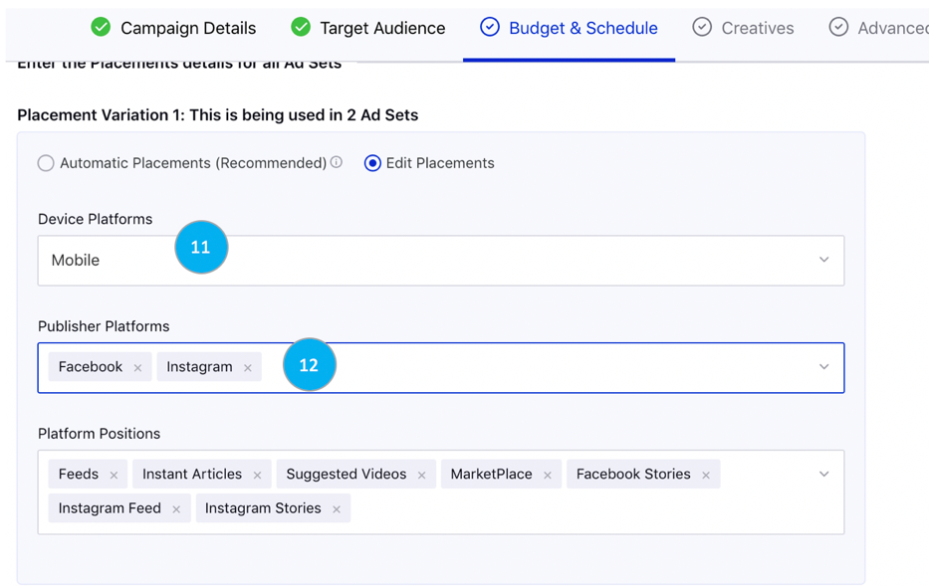
- Under Publisher Platforms, exit out of Audience Network and Messenger. Navigate to the bottom of this page and click Next.
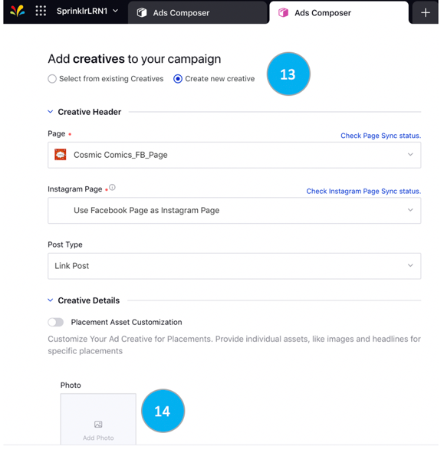

- Select Create new creative within the Creative tab and select the Page your ads will be advertised from. Select the Post Type Link Post.
- In the Creative details section, click on Add Photo and the Media Uploader window will populate.
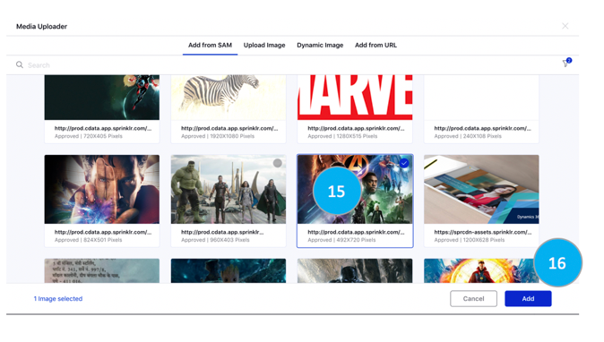
- Click on an image that is available within the SAM and a blue border will populate.
- Click Add.

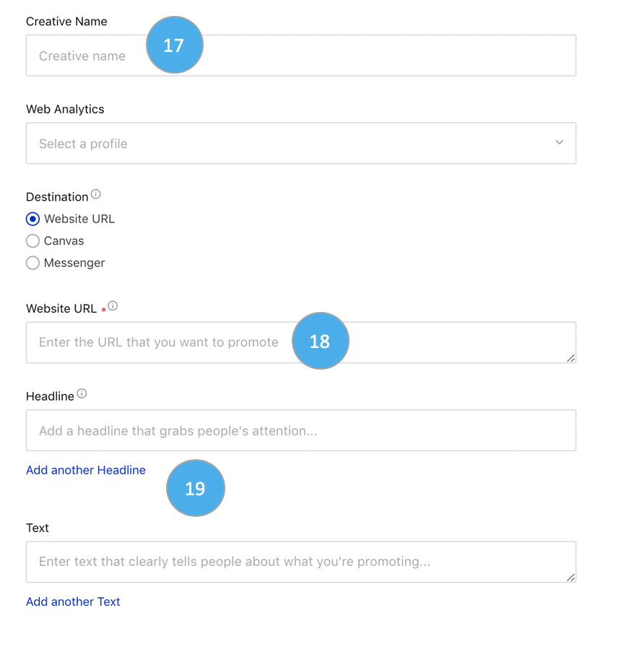
- Enter a Creative Name for the ad.
- Enter a Website URL.
- Type a Headline & Text for the ad. Then click on the hyperlink to add in another Headline or Text to create ad variations.

