Affiliate Promo Kit
The Courage to Call Anyone Challenge
Free 3-Day Live Challenge
April 21–23 at 11:00 AM Pacific
Main Link: https://events.ericlofholm.com/call-anyone-challenge

1. Event Overview (For Affiliates)
Eric Lofholm is hosting a free 3-day live challenge where he will teach entrepreneurs and sales professionals how to confidently prospect anyone—including CEOs, billionaires, and celebrities.
During this challenge, attendees will learn how to:
• Prospect anyone with confidence
• Overcome call reluctance
• Always have a list of 100+ people to contact
This is practical, implementation-focused training designed to help business owners and sales professionals take immediate action and grow their pipeline.

2. Email Swipe Copy

Email #1 – Announcement
Subject Line Options:
• Free Prospecting Training (April 21–23)
• Courage to Call Anyone
• Want More Confidence Making Calls?
Hi [First Name],
If you want to become more confident making calls and reaching out to prospects, you’ll want to attend this.
Eric Lofholm is hosting a free 3-day live challenge on how to confidently prospect anyone.
He will show you how to:
• Prospect anyone with confidence
• Overcome call reluctance
• Build a list of 100+ people to contact
April 21–23
11 AM Pacific
Register here:
[Affiliate Link]
This is practical training you can apply immediately.
See you there,
[Your Name]

Email #2 – Value Angle
Subject: Most people avoid making calls
Most people don’t have a strategy problem…
They have a hesitation problem.
Eric Lofholm is hosting a free 3-day challenge focused on helping you confidently reach out to anyone.
If you are in sales or run a business, this is worth attending.
April 21–23
11 AM Pacific
Save your seat here:
[Affiliate Link]
— [Your Name]

Email #3 – Final Reminder
Subject: Starts Tomorrow
This starts tomorrow.
If becoming more confident in your prospecting matters to you, register now.
Free 3-day Courage to Call Anyone Challenge
April 21–23
11 AM Pacific
Here is the link:
[Affiliate Link]
— [Your Name]

3. Social Media Posts

Post Option #1
Eric Lofholm is hosting a free 3-day live challenge.
The Courage to Call Anyone Challenge
April 21–23 at 11 AM Pacific.
You’re invited to join.
Register here:
[Affiliate Link]

Post Option #2 (Short Version)
You’re invited.
Free 3-day live training
Courage to Call Anyone Challenge
April 21–23
11 AM Pacific
Save your seat:
[Affiliate Link]

4. Text Message Swipes
Eric Lofholm is hosting a free 3-day Courage to Call Anyone Challenge (April 21–23 at 11 AM PST). He will teach how to confidently prospect anyone. Would you like the registration link?
Free 3-day training on how to confidently call anyone (even high-level prospects).
Starts April 21. Save your spot: (Insert Affiliate Link)

5. Graphics
The social media graphics are included below.
To download:
• Right-click the image and select “Save Image As…”
• If that option does not work, copy and paste the image link into your web browser to download.

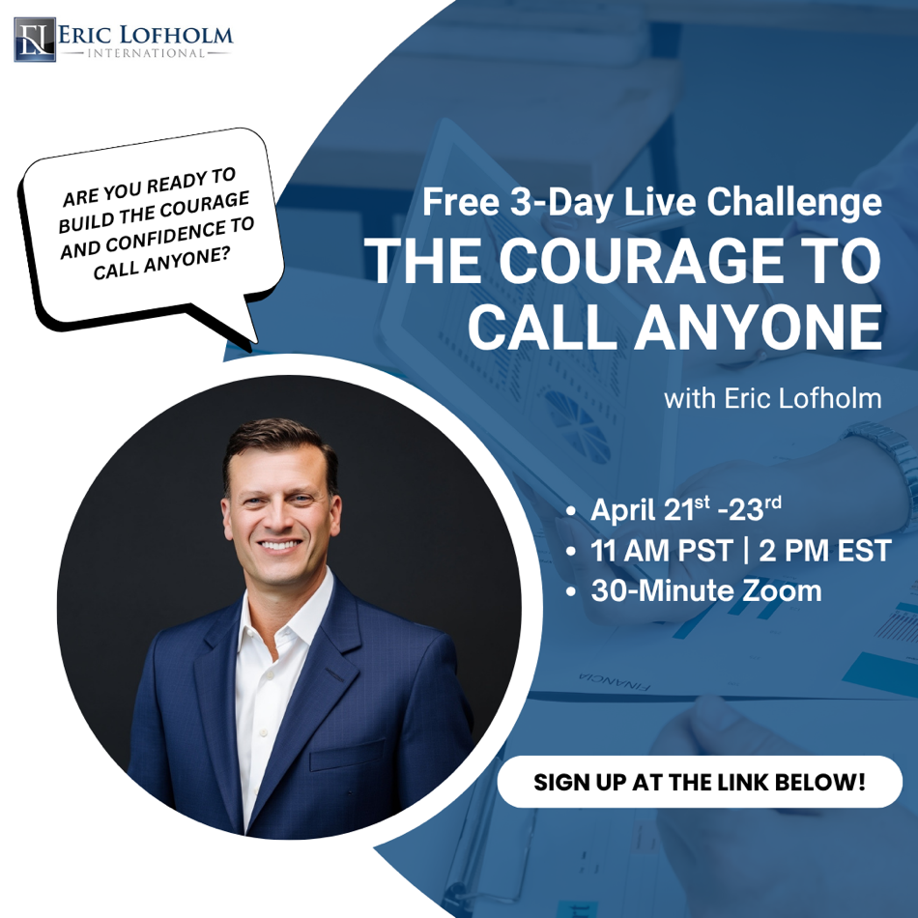
https://assets.cdn.filesafe.space/ofgJiDmoBPPhJj691IhF/media/69d4082b17d86ef0ca1a6b45.png

https://assets.cdn.filesafe.space/ofgJiDmoBPPhJj691IhF/media/69d408303d829c73b27c404a.png
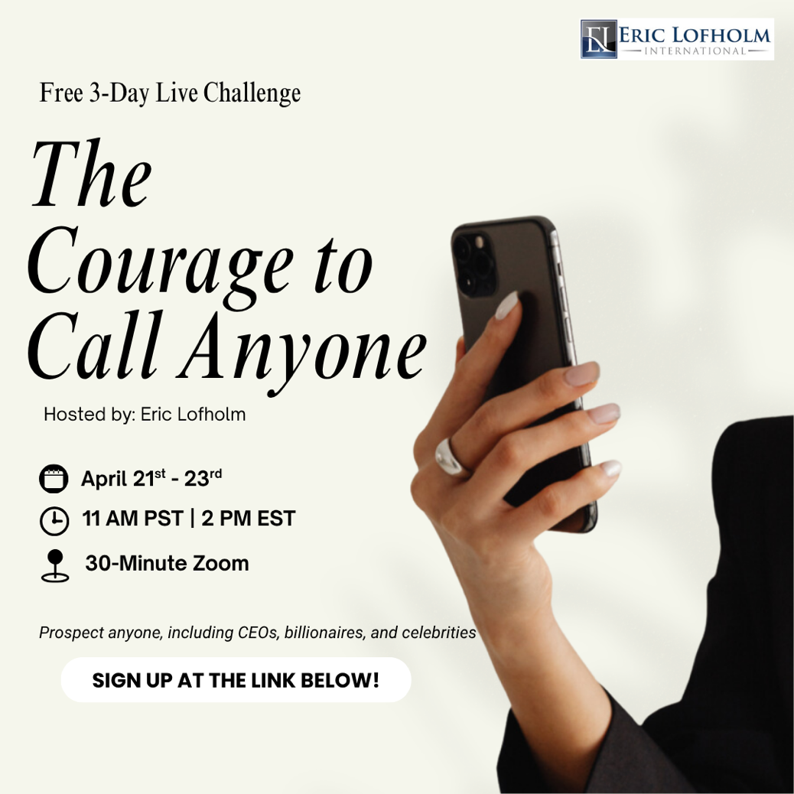
https://assets.cdn.filesafe.space/ofgJiDmoBPPhJj691IhF/media/69d41627bb5ded548ca91ad9.png

