12-Month Dental Email Campaign
Generic Email Platform Version
Soft-sell nurture series | Fun & Quirky Voice | Evergreen Monthly Sequence
SETUP NOTES
• Evergreen — no hard dates. Patients can join at any point in the year.
• Schedule 1 email per month for 12 months in your email platform.
• Replace [FIRST NAME] with your personalization tag.
• Replace [CLINIC NAME] with your practice name.
• Fill in the BTW section each month with your current offer.
• No welcome or final email — rolling magazine-style series.
• Tone is deliberately low-pressure. The offer is a soft afterthought, not a CTA.

EMAIL 1 — JANUARY
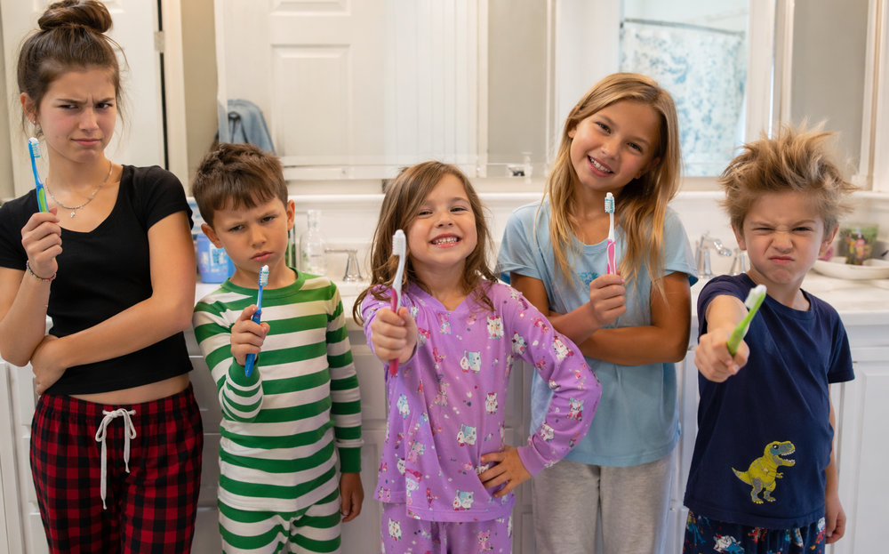
SUBJECT LINE: 🦷 Your Mouth Called. It Has Resolutions.
Happy New Year, {{contact.first_name}}! While everyone else is swearing off carbs and promising to finally learn Portuguese, we thought we'd kick off the year with something a little more… toothy.
January is weirdly motivating. New year, fresh start, the gym is packed, everyone's ambitious. It usually lasts about three weeks — but good dental habits? Those actually stick. Brushing twice, flossing (yes, really), drinking more water — small stuff that quietly makes a big difference.
No pressure, no agenda. Just a friendly nudge from your friends at {{custom_values.clinic_name}} to start the year with your mouth in mind.
Next month we're getting into something that affects nearly half of adults and most people have zero idea. Stay tuned. 👀
⭐ FUN FACT:
The average American spends 38.5 total days brushing their teeth over a lifetime. That sounds like a lot until you realize it's just 2 minutes a day. Totally worth it.
🦷 DID YOU KNOW?
Did you know teeth are the only part of your body that can't heal themselves? Unlike bones, enamel can't regenerate once it's gone. Handle with care.
💬 BTW — one more thing:
[INSERT SPECIAL OFFER DETAILS HERE]
If you want to chat or get scheduled, call/text [CLINIC PHONE NUMBER] or grab a spot at [SPECIAL OFFER PAGE URL]. No pressure either way.
EMAIL 2 — FEBRUARY
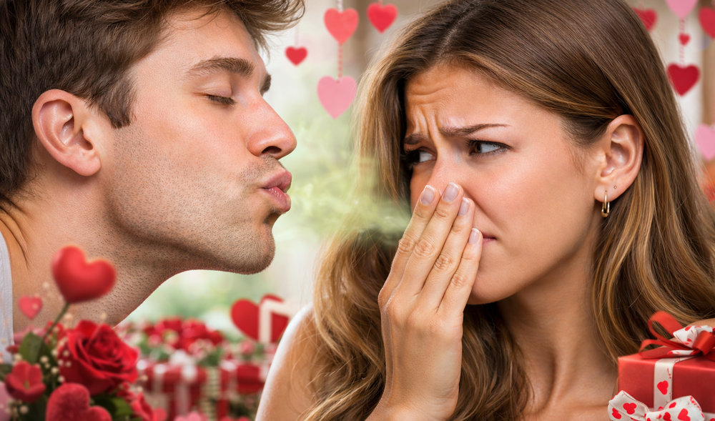
SUBJECT LINE: 💝 Roses Are Red, Your Gums Shouldn't Be
Hey {{contact.first_name}}, February is the month of love — and nothing says 'I care about you' quite like not having mystery breath on Valentine's Day. We're just being honest. That's love too.
Here's the sneaky thing about gum disease: it affects nearly half of adults over 30, and most people have absolutely no idea they have it. No pain. No drama. Just quietly doing its thing in the background.
The earlier it's caught, the simpler the fix. So if it's been a minute since your last visit, this is your (very gentle, very non-pushy) reminder that your gums would like a little attention.
Next month — something to do with St. Patrick's Day and an unexpected teeth connection. We promise it's not green toothpaste.
⭐ FUN FACT:
Kissing transfers up to 80 million bacteria between two people. Most of it is harmless. Most. Happy Valentine's Day! 😘
🦷 DID YOU KNOW?
Did you know gum disease has been linked to heart disease, diabetes, and even pregnancy complications? Your mouth is basically the front door to your whole body's health.
💬 BTW — one more thing:
[INSERT SPECIAL OFFER DETAILS HERE]
If you want to chat or get scheduled, call/text [CLINIC PHONE NUMBER] or grab a spot at [SPECIAL OFFER PAGE URL]. No pressure either way.

EMAIL 3 — MARCH

SUBJECT LINE: ☘️ Luck Has Nothing To Do With It
{{contact.first_name}}, here's a thing nobody mentions: great teeth aren't really about luck. Sorry, leprechauns.
But here's what IS worth celebrating — we live in a time when dentistry is genuinely incredible. People used to make dentures out of hippopotamus ivory. George Washington's famous 'wooden teeth' were actually made from human teeth, cow teeth, and ivory. We've come a very long way.
Good dental health mostly comes down to consistent habits and catching things early. That's it. No magic, no four-leaf clovers — just showing up.
April's email is going to be a good one. Think spring cleaning, but for your whole head. More soon!
⭐ FUN FACT:
George Washington's four sets of dentures were made from human teeth, cow teeth, horse teeth, and hippopotamus ivory. History is absolutely unhinged.
🦷 DID YOU KNOW?
Did you know the average person only brushes for 45–70 seconds, even though dentists recommend 2 full minutes? Set a timer tonight. You'll be genuinely surprised how long two minutes feels.
💬 BTW — one more thing:
[INSERT SPECIAL OFFER DETAILS HERE]
If you want to chat or get scheduled, call/text [CLINIC PHONE NUMBER] or grab a spot at [SPECIAL OFFER PAGE URL]. No pressure either way.

EMAIL 4 — APRIL
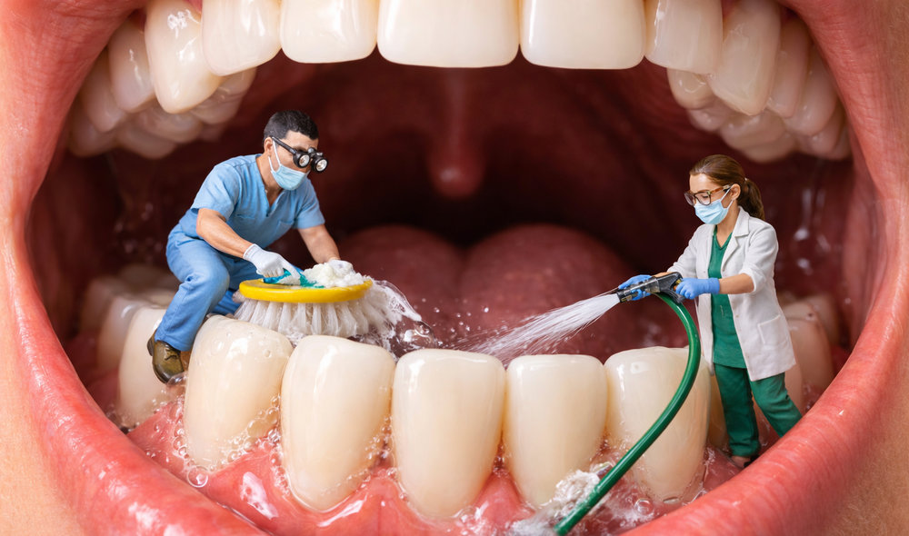
SUBJECT LINE: 🌸 Spring Clean Everything. Including That.
{{contact.first_name}}, you're cleaning the garage, reorganizing the closets, tackling the junk drawer — the one we all have and never talk about. April is just that kind of month.
Here's a fun thing about professional cleanings: they remove the buildup that your toothbrush genuinely cannot reach, no matter how enthusiastic your brushing technique is. It's also when small things get spotted before they become expensive things.
Not a pitch. Just a fact. Small catches now, fewer surprises later. Your future self is a fan of that arrangement.
Next month we're getting into something that sounds a little sci-fi but is completely real — your mouth and your brain are in a secret conversation. May is going to be interesting.
⭐ FUN FACT:
The blue whale has no teeth at all — it uses baleen plates to filter krill. Meanwhile, a snail has up to 25,000 tiny teeth on its tongue. Nature drew some very creative blueprints.
🦷 DID YOU KNOW?
Did you know your tongue print is as unique as your fingerprint? Every mouth really is one of a kind. Including yours, {{contact.first_name}}.
💬 BTW — one more thing:
[INSERT SPECIAL OFFER DETAILS HERE]
If you want to chat or get scheduled, call/text [CLINIC PHONE NUMBER] or grab a spot at [SPECIAL OFFER PAGE URL]. No pressure either way.
EMAIL 5 — MAY
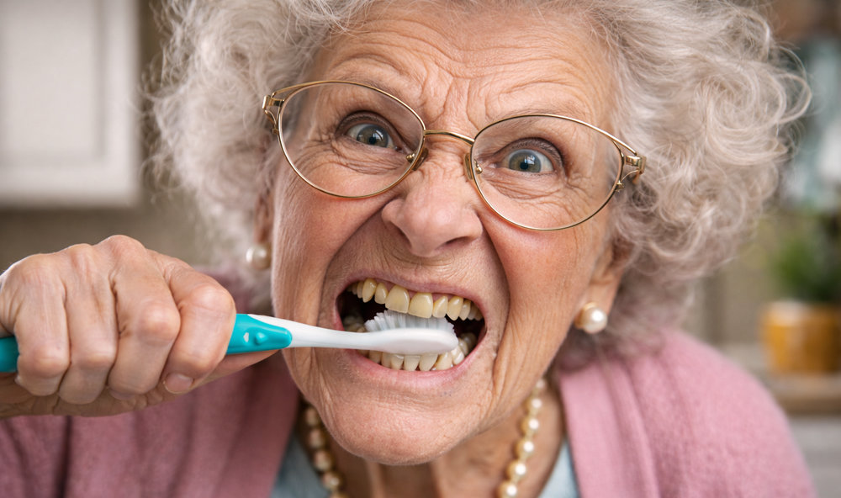
SUBJECT LINE: 🧠 Your Mouth Is Talking to Your Brain (No, Really)
{{contact.first_name}}, okay, this one is genuinely fascinating and we can't stop thinking about it.
Studies have found a link between gum disease and an increased risk of cognitive decline — including Alzheimer's. The bacteria that cause gum disease can travel through the bloodstream and trigger inflammation in other parts of the body, including the brain. Your mouth is not an island.
This isn't meant to alarm anyone. It's just a reminder that taking care of your teeth isn't vanity — it's connected to everything. Brains included.
June's email is much lighter, we promise. Summer's coming and we have strong opinions about poolside drinks and your enamel.
⭐ FUN FACT:
Your mouth contains over 700 species of bacteria. Most of them are helpful. The ones that aren't are extremely committed to their work.
🦷 DID YOU KNOW?
Did you know that stress can cause you to grind your teeth at night without ever realizing it? It's called bruxism, and over time it wears down enamel and causes jaw pain. If you wake up with a sore jaw — that's your clue.
💬 BTW — one more thing:
[INSERT SPECIAL OFFER DETAILS HERE]
If you want to chat or get scheduled, call/text [CLINIC PHONE NUMBER] or grab a spot at [SPECIAL OFFER PAGE URL]. No pressure either way.
EMAIL 6 — JUNE

SUBJECT LINE: ☀️ Hot Take: Some Summer Drinks Are Low-Key Evil
{{contact.first_name}}, summer is here and someone is absolutely about to hand you a lemonade, an iced coffee, or a sports drink. We're not here to stop you. But we do have a note.
Acidic and sugary drinks quietly erode enamel over time — not dramatically, not all at once, just slowly. The sneaky move: drink through a straw, rinse with water after, and don't brush right away (acid temporarily softens enamel, so give it 30 minutes).
That's genuinely all. You can have your lemonade. We just want your enamel to survive the summer too.
July's email involves a holiday, some popcorn, and a cautionary tale. You'll want to open that one.
⭐ FUN FACT:
Sparkling water is slightly acidic but way less harmful than soda. If you're choosing between the two, the bubbles win. Just maybe don't squeeze a lemon into it and call it health food.
🦷 DID YOU KNOW?
Did you know that sipping a sugary drink slowly is actually worse for your teeth than drinking it quickly? Every sip resets the acid attack on your enamel. Sometimes speed is a virtue. 🥤
💬 BTW — one more thing:
[INSERT SPECIAL OFFER DETAILS HERE]
If you want to chat or get scheduled, call/text [CLINIC PHONE NUMBER] or grab a spot at [SPECIAL OFFER PAGE URL]. No pressure either way.

EMAIL 7 — JULY

SUBJECT LINE: 🎆 Freedom Is Great. Cracked Teeth Are Not.
Happy July, {{contact.first_name}}! Fire up the grill, enjoy the fireworks, and please — we're begging you — be careful with the popcorn.
Unpopped kernels crack teeth. This is a thing that happens constantly in July and we feel it is our duty to warn you. Popcorn hulls also love to hide in your gumline and cause low-grade infections. Popcorn is delicious AND a tiny menace and we wish things were different.
Same energy for chewing ice, biting ribs off the bone, and corn on the cob eaten with reckless abandon. July is sneakily rough on teeth. Now you know.
August's email is actually super useful for parents — back to school season has some dental timing moments that are worth knowing about.
⭐ FUN FACT:
Americans eat about 17 billion quarts of popcorn per year. Dentists everywhere have complicated feelings about this statistic.
🦷 DID YOU KNOW?
Did you know chewing ice is one of the most common causes of cracked teeth? Ice is roughly as hard as enamel — something has to give. It's usually the tooth. The ice wins. Put it down. 🧊
💬 BTW — one more thing:
[INSERT SPECIAL OFFER DETAILS HERE]
If you want to chat or get scheduled, call/text [CLINIC PHONE NUMBER] or grab a spot at [SPECIAL OFFER PAGE URL]. No pressure either way.

EMAIL 8 — AUGUST

SUBJECT LINE: 🎒 Back to School Checklist: Lunch. Supplies. Dental Windows.
{{contact.first_name}}, August means new backpacks, school supply runs, and the annual mystery of where all the matching socks went.
Here's a less obvious back-to-school thing: kids' teeth change faster than you think, and there are actual timing windows for orthodontic evaluation that are easy to miss if life gets busy. First molars, permanent teeth, bite patterns — things that are simple to address early and more complicated to address later.
Not urgent, not alarming — just the kind of thing that's nice to know before the year gets chaotic. File it away.
September's email is going to be spooky. Not literally, but Candy Season is coming and we have thoughts.
⭐ FUN FACT:
Children laugh an average of 400 times a day. Adults average about 15. We're not saying dentistry is the answer, but we're not NOT saying it.
🦷 DID YOU KNOW?
Did you know the American Association of Orthodontists recommends kids see an orthodontist by age 7? Not for braces — just to check that jaw and bite development is on track while there's still time to guide it easily.
💬 BTW — one more thing:
[INSERT SPECIAL OFFER DETAILS HERE]
If you want to chat or get scheduled, call/text [CLINIC PHONE NUMBER] or grab a spot at [SPECIAL OFFER PAGE URL]. No pressure either way.
EMAIL 9 — SEPTEMBER
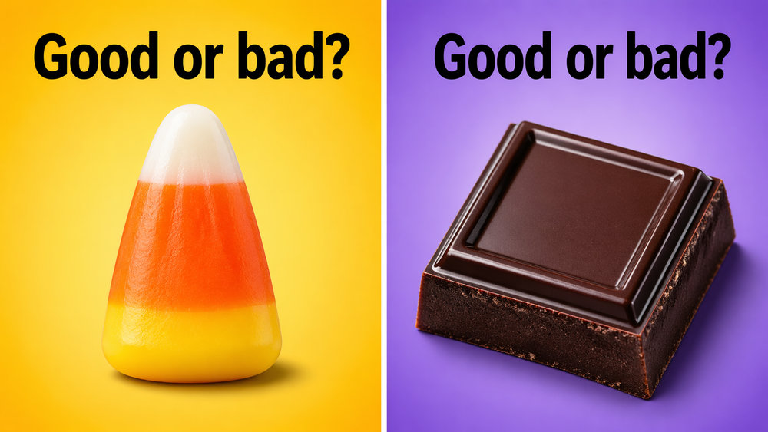
SUBJECT LINE: 🍂 Candy Season Is Upon Us (We're Scared Too)
{{contact.first_name}}, September means pumpkin spice everything, sweater weather, and the quiet beginning of Candy Season — which, if you track these things, runs from Halloween straight through Valentine's Day with very little interruption.
We're not going to tell you to skip the candy. Life is short and caramel exists for a reason. But we will share this: sticky candy (caramels, taffy, gummies) clings to enamel and is nearly impossible to brush off completely. Chocolate, weirdly, is the lesser evil — it melts and rinses away more easily.
You now have a completely legitimate reason to choose chocolate over gummies. You're welcome.
October's email is going to be a real treat. (We're not sorry.)
⭐ FUN FACT:
Candy corn has been around since the 1880s. It's made of sugar, corn syrup, and carnauba wax — which is also used to make car wax. Snack thoughtfully.
🦷 DID YOU KNOW?
Did you know dark chocolate contains tannins that can actually inhibit bacteria from sticking to your teeth? It's not a dental treatment. But it is a great excuse.
💬 BTW — one more thing:
[INSERT SPECIAL OFFER DETAILS HERE]
If you want to chat or get scheduled, call/text [CLINIC PHONE NUMBER] or grab a spot at [SPECIAL OFFER PAGE URL]. No pressure either way.

EMAIL 10 — OCTOBER
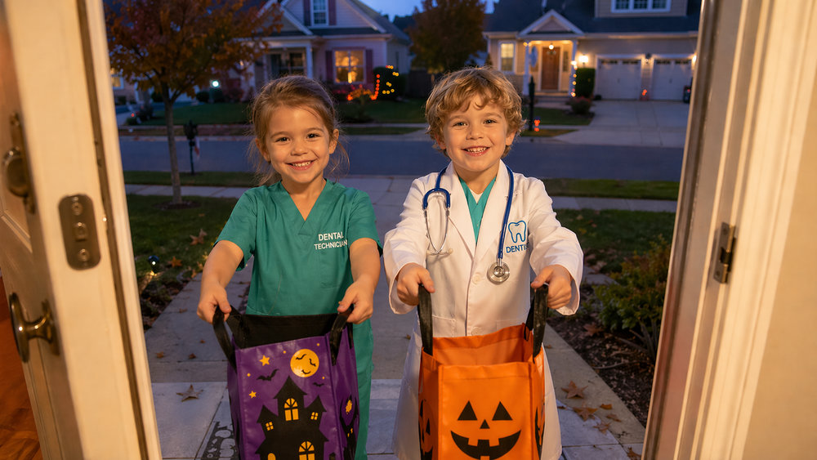
SUBJECT LINE: 🎃 The Only Scary Thing This Month Is Ignoring Your Teeth
{{contact.first_name}}, October is the month of costumes, haunted houses, and enough sugar to power a small city. We deeply respect it.
Here's a thing worth knowing: it's not just the sugar that causes damage — it's the frequency. Every time you eat something sugary, your mouth goes through an acid cycle that lasts about 20 minutes. Snacking on candy all afternoon is basically a 12-hour acid rave. The move is to eat it in one sitting (with a meal is even better), then brush. One exposure instead of twenty.
This is genuinely useful information and not just a setup to recommend a cleaning. Although cleanings are great. Okay moving on.
November is coming and we've got something unexpectedly wholesome — gratitude, turkey, and a dental connection you probably haven't thought about.
⭐ FUN FACT:
Americans spend over $3 billion on Halloween candy every year. Dentists collectively experience a very complicated range of emotions every October 31st.
🦷 DID YOU KNOW?
Did you know some dentists buy back Halloween candy from kids at $1 per pound and donate it to troops overseas? Clever, wholesome, and mildly sneaky — much like dentistry itself.
💬 BTW — one more thing:
[INSERT SPECIAL OFFER DETAILS HERE]
If you want to chat or get scheduled, call/text [CLINIC PHONE NUMBER] or grab a spot at [SPECIAL OFFER PAGE URL]. No pressure either way.
EMAIL 11 — NOVEMBER
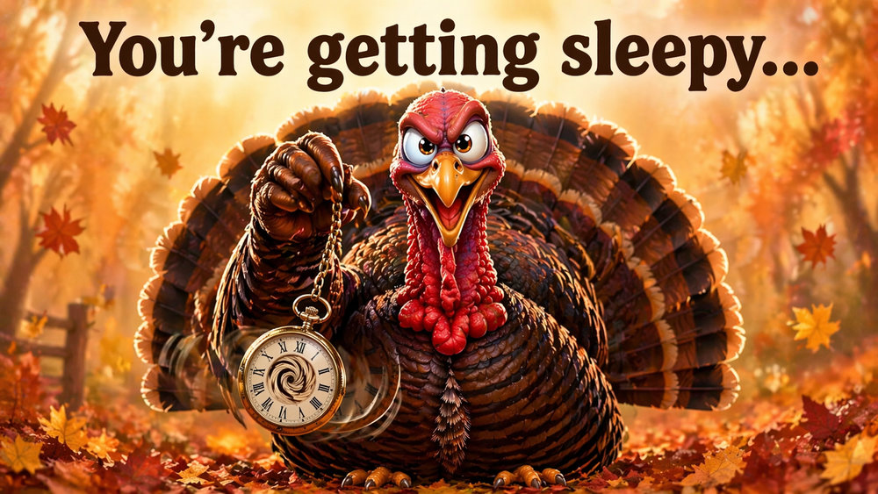
SUBJECT LINE: 🦃 Genuinely Grateful for Your Teeth (Hear Us Out)
{{contact.first_name}}, November is the month of gratitude lists — and we want to make the case that your teeth deserve a spot on yours. Right between 'family' and 'reliable Wi-Fi.'
Think about it: your teeth let you eat the entire Thanksgiving spread, laugh at the family stories you've heard eleven times, and smile in every photo that's about to get texted around for years. That's a lot of quiet, thankless work.
They don't ask for much. Just a little brushing, some flossing, and a visit every now and then. Small investment. Enormous return.
December's email is coming in hot with something genuinely helpful about end-of-year timing. Don't sleep on it.
⭐ FUN FACT:
Turkey contains tryptophan, which your body converts to serotonin. So your post-Thanksgiving nap isn't laziness — it's biochemistry. You earned it.
🦷 DID YOU KNOW?
Did you know most dental insurance benefits reset on January 1st? Unused benefits don't roll over — they just disappear. If you've been putting something off, the end of the year is genuinely a good time.
💬 BTW — one more thing:
[INSERT SPECIAL OFFER DETAILS HERE]
If you want to chat or get scheduled, call/text [CLINIC PHONE NUMBER] or grab a spot at [SPECIAL OFFER PAGE URL]. No pressure either way.

EMAIL 12 — DECEMBER
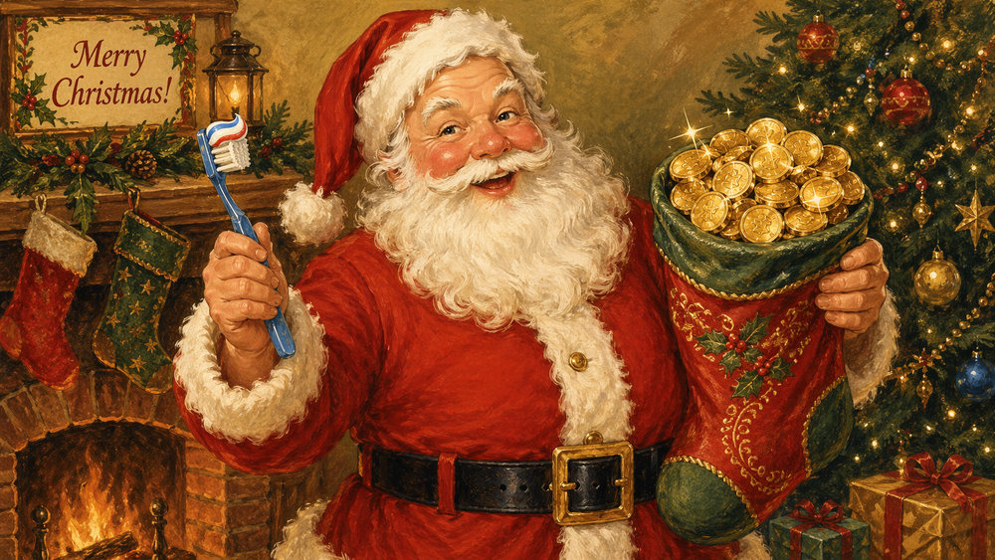
SUBJECT LINE: 🎄 Before the Year Disappears, A Quick Heads Up
{{contact.first_name}}, December is here — twinkling lights, holiday parties, and the office cookie tray that you absolutely did not plan on visiting four times. No judgment.
Just a heads up: dental benefits reset January 1st. If you have unused benefits sitting there, they don't carry over — they expire. It's genuinely one of those 'use it or lose it' situations and we'd hate for you to lose it.
We're not trying to be pushy about it. We just think you should know. Do with that information what you will.
Happy holidays from everyone at {{custom_values.clinic_name}}. See you in the new year — we'll be here, same time, same place, with more weird dental facts and zero pressure. 🦷
⭐ FUN FACT:
The tradition of hanging stockings by the fireplace comes from a legend about gold coins tossed down a chimney that landed in stockings hung to dry. Dental benefits work differently, but the 'use them before they vanish' energy is the same.
🦷 DID YOU KNOW?
Did you know cold weather can make sensitive teeth hurt more? Thermal changes cause enamel to contract slightly and can trigger sensitivity. If winter bites back, it's very fixable — just mention it at your next visit.
💬 BTW — one more thing:
[INSERT SPECIAL OFFER DETAILS HERE]
If you want to chat or get scheduled, call/text [CLINIC PHONE NUMBER] or grab a spot at [SPECIAL OFFER PAGE URL]. No pressure either way.

