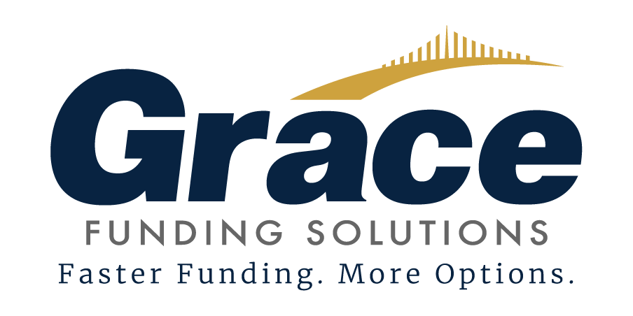 | FINDER & FINANCIAL AGREEMENT  Page 1 of 5 Initial: ________

FINDER & FINANCIAL AGREEMENT
This Finder & Financial Agreement is made and entered into this ______ day of ________________, ________, by and between
Client / Issuer Name: ____________________________________________________________
Issuer Address: ____________________________________________________________
(the \u201cIssuer\u201d), and Grace Funding Solutions, whose address is 240 S Wolcott Street Ste. 10B, Casper, Wyoming 82601 (the \u201cFinder\u201d), collectively referred to as the \u201cParties.\u201d

1. THE AGREEMENT
1.1 Issuer is to be part of any loan, equity investment, lease, asset-based line of credit, credit facility, debt restructure or payoff, joint venture, merger or acquisition, strategic alliance, or real estate/asset sale (the “Transaction”). The Transaction shall be on terms and conditions satisfactory to the Issuer. As a result of the introduction made through Finder to an Investor (either a single investor, several investors, institutions, banks, advisory firms, venture capitalists, or fund managers referred to herein as “Investor”) or any related entity under Investor control, should all or any part of the Transaction be placed with investors, the Issuer shall owe Finder the fees described herein. Should the Issuer close on any introduced transactions under this Agreement, that shall serve as proof that the Transaction met the terms and conditions that were satisfactory to the Issuer.
1.2 The Issuer acknowledges that the Finder has acted solely as a finder and not in any other capacity. Finder has not advised Issuer in any manner regarding the merits of this or any other financing arrangement. Issuer has consulted its counsel on all aspects of this Transaction and has done its due diligence to its satisfaction. Finder has not made any representations to Issuer to induce it into this Agreement.
1.3 Issuer shall be under no obligation to pay Finder where the introduced source has offered to purchase all or part of the Transaction unless accepted by Issuer. For purposes of this Agreement, the total amount due to the Finder shall be due and payable on the closing date. The Issuer shall be under no obligation to consummate any transaction except upon such terms as shall be acceptable to the Issuer at its sole discretion.
Grace Funding Solutions | 240 S Wolcott Street Ste. 10B, Casper, Wyoming 82601 | +1 (307) 275-3232 | info@gracefundingsolutions.com

FINDER & FINANCIAL AGREEMENT
Page 2 of 5 Initial: ________

1.4 The undersigned parties, as a result of this agreement, irrevocably agree not to circumvent, avoid, bypass, or obviate each other, directly or indirectly, to avoid payment of fees or commissions in any transaction with any institution, fund, corporation, partnership, or individuals revealed by either party to the other (excluding those previously known to the other party, defined with aged documentation), in conjunction with any Transaction (including the purchase and sale of any real estate or asset) or currency exchange, or any loans, or collateral, or funding(s), or addition, renewal, extension, rollover, amendment, renegotiation, new contracts, parallel contracts, agreements, or third-party assignments thereof. The Issuer agrees and covenants that he or she will not directly, indirectly, or in conjunction with any other person, company, partnership, or corporation, apply to the investors to whom Finder has submitted a loan application, except through Finder, for
12 months; otherwise the Issuer shall be liable to Finder for the Fee described in [2.1] of this Agreement whether or not Issuer receives capital from any introduced investors from Finder.
1.5 This Agreement between Issuer and Finder will expire Twelve (12) months from the date first above. At that time, neither party will have any obligations towards the other party unless introduced Investors are negotiating with the Issuer at the expiration time or after. In that case, this Agreement will survive until the active dealings are terminated or a transaction is closed.

2. THE FEE
The fee from the Issuer for retaining Finder to introduce various financial and investment sources will be 3% due upon closing.
The fee for successful introductions by Finder to Issuer in the event of a financial introduction either for loan, equity, lease, asset-based line of credit, credit facility, debt restructure or payoff, joint venture, merger or acquisition, strategic alliance, or real estate/asset sale is outlined in item [2.1] below. It is to be paid by the Issuer under this Agreement in the sum distributed and computed as follows:
The cash fee due from the Issuer shall be payable to Finder through closing escrow or by Issuer at the discretion of Finder for the successful introduction of any loan, equity, lease, asset-based line of credit, credit facility, debt restructure or payoff, joint venture, merger or acquisition, strategic alliance, or real estate/asset sale. The term “successful introduction” is defined as any lender or investor that Finder introduced to Issuer, where Issuer receives capital in the form of a loan, lease, equity, debt restructure or payoff, merger or acquisition, strategic alliance, or real estate/asset sale. The escrow agent or Issuer shall release the fee to the Finder via wire transfer while the balance of investor funds is released to the Issuer.
2.1 – A Three Percent (3%) fee of the total amount invested by the Investor.
The fee distribution is defined in the cash formula.
Grace Funding Solutions | 240 S Wolcott Street Ste. 10B, Casper, Wyoming 82601 | +1 (307) 275-3232 | info@gracefundingsolutions.com

FINDER & FINANCIAL AGREEMENT
Page 3 of 5 Initial: ________

3. OTHER
3.1 Any arrangements made by the Issuer with any broker or other people with whom the Issuer is or may be involved are the total responsibility of the Issuer. Upon payment made by Issuer to Finder of Finder's fee, Finder will hold Issuer free and harmless from any and all claims, liabilities, commissions, fees, or expenses in connection with the transaction from any party who alleges a relationship with or through Finder and the Investors.
3.2 This Agreement contains the entire agreement between Finder and Issuer concerning the introduction of Investors to Issuer and correctly sets forth the rights and duties of each of the parties to each other on this matter. Any other agreement concerning the subject matter herein entered into after the date of this Agreement is null and void unless otherwise agreed to in writing by the Issuer and the Finder.
3.3 The laws of the State of Wyoming shall govern this Agreement. Any dispute, action, or claim under this Agreement shall be resolved, excluding all other forums, in the appropriate court of Natrona County, State of Wyoming.
3.4 Issuer's disclosure and obligation to make a true statement of facts to Finder and Investor(s) are outlined in the Investor(s) application. The Issuer shall provide Finder and Investor(s) with all material facts about this application. The Issuer agrees to save and hold Finder harmless from all claims, disputes, litigations, and/or judgments arising from incorrect information supplied by the Issuer or from any material fact known by the Issuer that the Issuer fails to disclose.
3.5 Issuer understands that an Investor(s) may require a cash deposit before issuing and accepting a loan commitment. Any such deposits will be collected and retained by the Investor(s), subject to the Investor(s) policies and procedures.
3.6 Issuer warrants that he or she has the authority to execute this Agreement. The Issuer and Finder further intend that this Agreement constitutes the complete and exclusive statement of its terms and that no extrinsic evidence whatsoever may be introduced in any judicial or arbitration proceeding involving this Agreement.
Grace Funding Solutions | 240 S Wolcott Street Ste. 10B, Casper, Wyoming 82601 | +1 (307) 275-3232 | info@gracefundingsolutions.com

FINDER & FINANCIAL AGREEMENT
Page 4 of 5 Initial: ________

3.7 If required, the Issuer agrees to provide and pay travel expenses for the Finder and Investor, including round trip airfare, hotel expenses, and any related transportation from and to the site visit destination. Travel time and dates will be subject to and agreed upon with an Exhibit “A” attached to and made part of this agreement.
3.8 Finder is not registered with the SEC as a broker/dealer or investment advisor. As a consequence, Finder will not provide any investment services that require registration as a broker/dealer or investment advisor. The Finder shall act as an introducing party only. Finder will not advise any person or entity on the merits of lending money to, purchasing an equity interest in, or purchasing assets from the Issuer. Finder will not advise the Issuer about the terms and conditions of a transaction with any person or entity introduced by Finder to the Issuer.
3.9 A facsimile or electronic copy of this document shall be deemed and considered an original, binding, and enforceable document.
Grace Funding Solutions | 240 S Wolcott Street Ste. 10B, Casper, Wyoming 82601 | +1 (307) 275-3232 | info@gracefundingsolutions.com

FINDER & FINANCIAL AGREEMENT
Page 5 of 5 Initial: ________

IN WITNESS WHEREOF
The within Agreement has been executed by a duly authorized officer and representative of each party who has signed it after all due corporate authority has been granted to each signatory on the date indicated below, and shall be binding upon and inure to the benefit of each party's respective successors and assigns.

Grace Funding Solutions (\u201cFinder\u201d)  Signature: _________________________  Name & Title: ______________________  Date: _____________________________ | ____________________________ (\u201cIssuer\u201d)  Signature: _________________________  Title: _____________________________  Date: _____________________________

Grace Funding Solutions — Faster Funding. More Options.
Grace Funding Solutions | 240 S Wolcott Street Ste. 10B, Casper, Wyoming 82601 | +1 (307) 275-3232 | info@gracefundingsolutions.com

