

Office Of The
Deputy for the Orient of
Georgia




Request for a Certificate

Honorary Loyal Lady Ruler

Commander-N-Chief

President – COR
State Grand Loyal Lady Ruler
Past Commander-N-Chief

Past President COR
Past State Grand Loyal Lady Ruler

Loyal Lady Ruler

President-PSCOR

Honorary Past State Grand Loyal Lady Ruler

Past Loyal Lady Ruler

Past President-PSCOR

Please submit the following information and requiremants”

- (Name)…………………………………………………
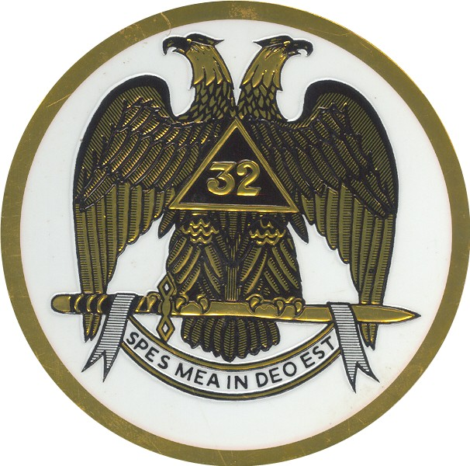

- Address (Street /Post Office Box)……………………..

- City, St & Zip………………………………………….

- Telephone (Home/Cell)………………………………..

- Consistory/COR/Assembly & No………………………

- Valley Location (i.e., Rome)…………………………..

- Date Elected to Position’………………………………………………..

- Period Served (from when to When)…………………………………….

- Degree (32ᵒ/33º)…………………………………………………………………………..

- (X) the box above to indicate type of Certificate(s)

- Make checks and/or money orders for $15.00 (payable to Georgia Council of Deliberation) and submit same with a colored Masonic attired (Passport type) photograph to: Ill. William V. Rogers, Sr., 202 Mill Creek Road, Woodstock, GA 30188

- For Information regarding the purchasing & printing of Commanders of the Rite dues cards for local chapters, please contact Ill Rogers

For additional information or concerns, please contact Ill Rogers (wvrogerssr@att.net or Cell 678-859-3177); or Ill Primis T. James (pjamestimber@comcast.net or Cell 404 42305850)Form

