Address and Contact Information
Address: 257 Aguinaldo Ave. Titusville, FL 32780
Phone: (321) 268-3365
Fax: (321) 268-3397
Website: www.lakefernmontessori.com
E-Mail: LFMA@cfl.rr.com

About Lake Fern
Lake Fern Montessori Academy was established in 1981. We have grown from a preschool program with seven students housed in a rented church wing to preschool through eighth grade programs with 150+ students in our own 9300 square foot facility on two- and one-half acres of land. We offer a teaching staff which holds various Bachelor and Master educational degrees, as well as specializations including the Montessori methodology of teaching, counseling, and special education.
Utilizing the Montessori Method of teaching we have developed proven educational programs for children which set the foundation for educational experiences throughout life. The true value of the Montessori Method comes when the child is able to use the tools and skills learned in earlier years and in turn, to share them with others.
LFMA is licensed by the Brevard County Environmental Health Services under the direction of the State of Florida Health Department of Children and Families (DCF) and we hold an occupational license issued by the City of Titusville. Our participation in the Florida Tax Credit scholarship (FTC), Family Empowerment Scholarship for Education Opportunities (FES-EO), the Family Empowerment Scholarship for Unique Abilities (FES-UA) and Voluntary Pre-K programs also require we demonstrate and adhere to standards set forth by the Department of Education and the Early Learning Coalition. We are subject to regular inspection by the City Fire Inspector, DCF and Consumer Health
“Education is not something which a teacher does, it is a process which develops spontaneously…”
Montessori
Services. We are also required to comply with Child Day Care Standards, Florida Administrative Code 62C-22 which sets forth a number of regulations relating to our daily operations, facility, records and includes among other items, background checks conducted by the Florida Department of Law Enforcement for the school staff and owners. Many of the policies and procedures set forth in this handbook are direct results of our compliance with one or more of the above licensing agency regulations.

Admission is open to all qualified individuals without regard to race, color, sex or national origin.

In the Beginning
The primary focus of Lake Fern Montessori Academy is to provide a quality educational environment in which your child can experience developmental excellence. Lake Fern has attempted to limit the "grade level" syndrome. LFMA is made up of multi-level classrooms, whose scholastics overlap somewhat to allow placement of each student according to ability rather than chronological age. Each environment is designed to challenge the student to his or her fullest potential, by allowing the child to excel beyond “grade level" in her area of interest while giving the child the materials necessary to progress steadily in other areas.
The Montessori philosophy was introduced by Dr. Maria Montessori in the early 1900's.
Dr. Montessori was the first woman to be granted a medical degree from an Italian University. With the help of Itard and Sequin she developed special teaching techniques and materials. In 1907 she opened her famous "Casa Dei Bambini" (or “Children’s House”). The children who attended her school were from Italy's slums.
Dr. Montessori found through her extensive study of the techniques and avenues by which children learn that the child learns most efficiently when driven by the desire for knowledge. Dr. Montessori also noted that to satisfy this intense desire for knowledge, a child must have the freedom to work independently... a freedom that is born out of order and self-discipline. A great musician is free to compose and perform anything he wishes, but only after he has taken command of his basic physical skills. Self-discipline is required to master those skills for personal achievement.
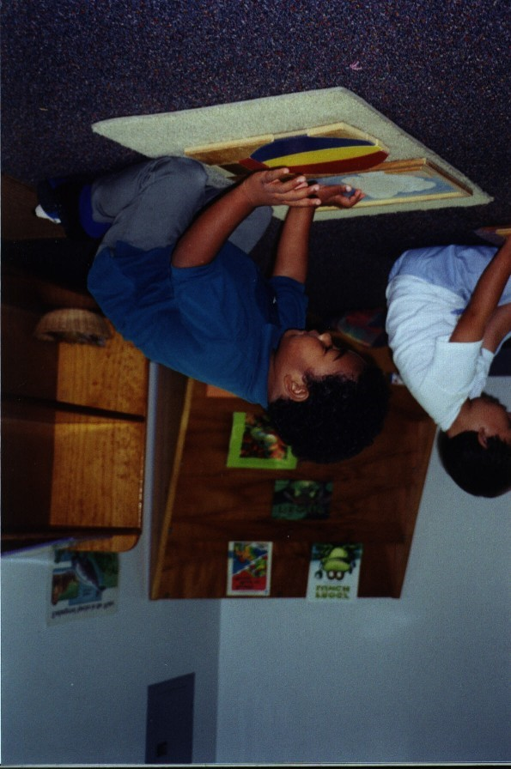
Since the results of Dr. Montessori's program have become better known, schools all around the world have begun incorporating the Montessori methods. The Montessori philosophy cannot only be found in the private sector but increasingly in public schools also.
Within the Montessori classroom each environment is under the direction of one or more instructors. The classroom and its unique materials is in itself the source of the child's knowledge for the most part; the instructors serve as guides to the academic material and a resource of information. Through her observations, Dr. Montessori found that with these techniques and materials the children could literally teach themselves.
Education is an independent activity but not a solitary
endeavor. It is the result of a cooperative effort of all within the environment for the maximum benefit of the individual. Lake Fern is committed to promoting effective family-school partnerships that strengthen our community as a whole and provide a safe, tight-knit environment for each child to thrive.

Both school and family recognize that effective partnerships are characterized by mutual respect, open lines of communication, a shared commitment to collaboration, clearly defined responsibilities, and a common vision of the goals to be reached.

● Recognizes that its effectiveness in helping the child to develop her fullest potential is a function of its effectiveness in helping the family do the same.  ● Fully presents to parents during the admission process, its philosophy, program and practices and encourages dialogue that assists parents in clarifying their expectations and goals for the child.  ● Keeps parents well informed through published policies, systematic reports, conferences, publications, and informal conversations.  ● Ensures that teachers and administrators are accessible to parents, model candid and open dialogue and seek and value the parents’ perspective on the child.  ● Offers and supports a variety of parent education opportunities, including the development of parent networks and suggestion of effective ways for parents to support the educational process.  ● Defines clearly how it involves parents when considering major decisions that affect the school community.  ● Actively seeks the knowledge it needs to work effectively with a diverse parent body. |  | ● Acknowledges the opportunity that participation in the school creates for collaboration with an extended community in rearing the child.  ● Selects a school by seeking an optimal match for the child’s needs, parental expectations and the school’s philosophy, program, and services.  ● Supports the school’s policies and procedures and stays involved in the life of the school.  ● Values the school’s perspective on the child. When concerns arise, the parent seeks information directly and consults with those best able to address the concerns.  ● Provides a home environment that supports the development of positive self-esteem, learning attitudes and habits, and social and intellectual competence.  ● Supports the stability and continuation of the school by fulfillment of such responsibilities as timely arrival and departure, payment, and promotion of enrollment.  ● Shares with the school any religious, cultural, medical, or personal information that the school may need to serve the child and the family best.
The School: The Family:

Attendance
A student attending irregularly will miss out on learning opportunities. The weekly topics are expanded upon all week. The child missing days needlessly may not be able to mesh easily with the daily activities. Elementary students may only have 18 unexcused absences in a school year, the standard set by the State of Florida. Unexcused absences in excess of this number can lead to the possibility of the student failing the school year due to absences.

Recording Arrivals and Departures: Signing in and Out
Your child may arrive ten minutes before a session begins and depart ten minutes after a session ends before day care fees will be charged. LFMA opens at 6:30 A.M. and closes at 6:00 P.M. By this time in the afternoon, we are sure that each child has a strong need to be taken home, fed a delicious hot meal, offered a warm bath and a bit of love before bed! A fee of $1.00 per minute may be assessed for any child not picked up by 6:00 PM. We are required to maintain a record of arrivals and departures. Children must be signed in and out each day in the ProCare system. Students will be dropped off/ picked up in the car loop during their class assigned drop off/ pick up times. Students attending before/ after school care will be dropped off/ picked up at the front door of the main building during before/ after school care hours.

Discipline
Pursuant to HRS rules, each parent will be provided with a copy of the school discipline policies, which comply with the guidelines in Florida Administrative Code 10M-12.
“We call an individual disciplined when he is master of himself, and can, therefore, regulate his own conduct when it shall be necessary to follow some rule of life. Therefore, the child is being prepared for life."
Montessori
Parents must read and sign this form and it will be retained in the student’s file. Recurring discipline problems will be discussed with the parents for a collaborative solution.

Conduct
Positive development is only possible when students and staff agree on a code of conduct. As Dr. Montessori stated:
"...when work becomes a habit, the intelligence level rises rapidly, and good order causes good conduct to become a habit."
The following guidelines are designed to promote positive conduct.
● Children are expected to show respect for others and their property at all times.
● Children will remain in their classrooms unless authorized by the instructor to leave the room.
● Profanity, verbal or physical abuse will not be tolerated.
Recurring misconduct is a discipline problem and will be handled in conjunction with the family. In consideration of the other children in the school, the school reserves the right to impose suspension or expulsion in extreme cases.

Clothing and Dress Codes
Uniforms must be worn Monday through Thursday for all classes. Fridays are considered “dress down days” and students are not required to dress in uniform on Fridays. Characters, slogans, or objectionable material (skulls, drug paraphernalia, etc.) are not allowed. Also, even on dress down days the rest of the dress code policies must still be observed (length of clothing, appropriate shoes, etc.) Please remind students to adhere to the dress code. Students who do not adhere to the dress code will be required to change. If the student does not have a uniform to change into, a parent will be called to bring one.
Uniform Colors:
Shirt: any solid colored shirt (polo, t-shirt, or blouse.) ow cut- strapless or spaghetti strapped shirts are not allowed. Shirts are not allowed to be see-through and bra straps may not show. Shirts must be long enough so that if a student’s arms are lifted above her head the stomach does not show. NOTE: If a sweatshirt is worn over the uniform shirt, it must be solid color also.
Shorts/ Pants: any solid color. Shorts must be at least fingertip in length when arms are held straight down at the student’s side. Rips are not allowed. Leggings/ skintight pants are not allowed unless worn beneath a skirt/ dress.
Dresses/ Skirts: any solid color. Dresses/ skirts must be at least knee-length and shorts or leggings must be worn beneath them.
Shoes: Shoes must be closed toed and have a back. Sneakers are preferred as students are playing on the playground with mulch, basketball court. Etc. Crocks, slides, and high heels are NOT allowed.
Hair—Hair color must be student’s natural color or if hair is dyed it must be a natural color.
Make-up: If student wears make up, it must be natural-looking/ neutrally colored. No bright colors or heavily applied makeup (including heavy eyeliner, bright lipstick, heavy mascara, etc. will be allowed.)
Jewelry: Piercings are not allowed except for ear lobes. Only small earrings may be worn—no long or large earrings allowed. Long hanging jewelry, especially in the younger classes, could pose a safety hazard and should not be worn. A short necklace or bracelet is fine if it does not become a distraction.
● When the weather gets cooler, we will still go outside for fresh air and exercise. During the winter, please dress your child appropriately with mittens, hats, and coats. At no time will a child be allowed to stay inside the classroom while others are on the playground. If your child is too ill to be outside, he should not be in school that day. Temperatures can soar during the warmer months in Florida and heat exhaustion/ stroke is a very serious problem. Students will not be allowed to wear sweat shirts/ jackets outside during hot weather.
Severe Weather Procedures
As citizens of Florida, we all know that severe weather is something we need to live with and be prepared for. Each classroom always has a weather alert radio on that will inform us of any severe weather in the area that pops up with little notice. We have procedures in place to deal with severe thunderstorms and tornado alerts.
Hurricanes and tropical storms are another unwelcome feature of Florida living. As conditions warrant, we will close the school for the safety of our students and staff and to allow us to prepare the property. We generally have plenty of notice as to when we will close the school. We will reopen when the weather, facility and infrastructure conditions allow. That has typically been the second day after a storm passes, which allows us time to prepare the facility. If utilities are affected, or we have other damage, it may be longer. We ask each family to stay tuned to Class Dojo for important updates relative to storm situations. We have potential makeup days built in to the yearly schedule to ensure we have the required number of in-session days for the upper level, should we be forced to close for weather.

Field Trips
We believe that experiential learning is important for the education of our students. Pre-K to eighth grade students attend field trips regularly throughout the year. Sometimes there are fees associated with these trips. Parents are responsible for the admission fees and a parent/ guardian is required to attend. Plenty of advance notice will be given. These trips are always announced on Class Dojo and permission forms are sent out well in advance of the trip.

Personal Property
● Each child is assigned a cubby space in which to keep textbooks, supplies, lunch, sweater or jacket and personal belongings.
● Articles from home brought in for the purpose of sharing are permitted with the understanding that the share must teach or demonstrate something academic in nature. Toys, Ninja turtles, guns, swords and the like are not considered "good shares". Share items may be brought only on the designated share day and are related to the topics being studied.
● Each pre-primary child must have a change of clothing in his cubby as he will periodically be working with water and may need a dry change of clothing. It is advisable for upper-level students to keep a change of clothes at school as well. Be certain to label all your child’s belongings: lunch box, thermos and lid, slippers, extra clothing, shares, etc. Nappers must have their own nap mat which will need to be taken home and laundered weekly.
● Upper-level students should bring a backpack and lunchbox each day. They should also be prepared with their daily folders, homework, and any books taken home for study.

Food for Thought
Everyone attending the morning or full day session must bring a packed lunch. Please make sure hot foods are placed in a thermos to keep them warm. We are unable to heat food.
“..all our handling of him will bear fruit, not only at the moment but in the man he is destined to become.”
Montessori
There are some items which we prefer you not to pack such as cakes, chips, and high energy granola bars. These foods are high in sugar content and have little if any food value. We have found that the more basic a lunch is the better a child likes it. Sip-ups are expensive, and many times are wasted because the children do not finish them. A thermos is a better value, and the contents can be saved if not finished. Lunchables are attractive to the parents because of their convenience. However they are not good value because most of the food is discarded by the child.
Each class has a break for snack time. Please provide fruit or vegetable snacks for your child’s lunch. The pre-primary class and full day VPK/ kindergarten have a morning and afternoon snack time. Please include enough snacks for both breaks if your child is in the pre-primary or VPK/ kindergarten classes. If your upper level child will remain in the after school program, an additional snack is recommended as well.

A healthy, balanced lunch should include protein, fresh fruit, vegetables and a drink.
Your child will stay healthier and have more energy if you feed him the proper foods. Here are a few suggestions for items to pack in your child’s lunch:
Proteins: Hard boiled eggs, yogurt, cottage cheese, cheese and crackers, peanut butter and crackers, mixed nuts, cream cheese and dates, sandwiches of meat and cheese or soups in a wide mouth thermos.
Crunchies: Vegetable sticks such as celery, carrots, peppers, sliced cucumbers or pickles. Served with dip, they are a big hit with the children. Try packing fresh veggies each day instead of chips.
Fruits: Fresh fruits of all sorts provide needed energy. Please include fresh fruit each day in your child’s lunch box.
Candy, gum or soda are NOT allowed at any time in school. It will be taken away if found. Remember that "Variety is the spice of life!" Children, just like adults, get tired of the same old thing in their lunches. Experiment a little with new and different foods.

Health Guidelines
Consistent attendance is essential for the best academic progress, but if your child should become ill it is in his best interest to stay home. Your child cannot progress when ill and will recover much more slowly without proper rest and care. Being at home for a day or two is much more desirable than struggling along for several days making little progress.
The school realizes that in many cases, both parents are working, and that keeping a child home means missing work. Lake Fern strongly believes that by keeping your child home at the onset of an illness, the child will fight off the infection much more quickly and completely, returning to class with more energy and a better chance to ward off any subsequent infections.
If your child has a communicable disease, please notify the school immediately. Do NOT send your child to school if he/she has had a fever within the past 24 hours. This is how colds and other infections get passed from child to child and eventually to the teachers (and then their spouses). It is difficult for the child to work efficiently when feeling poorly. This is reinforced. You will be asked to take your child home if necessary.
If your child runs a fever, has more than one loose stool, or begins vomiting repeatedly, the school will call you to come pick up your child. When evidence of an infection becomes apparent, it is necessary to isolate the child to avoid spreading the infection to others.
If your child contracts head lice, he must be removed from the school until total treatment has been completed and the child is found to be free of all lice and their nits. As you may well know, bugs are one of the solid fixtures of life in the State of Florida and head lice is a problem for all schools public and private. It is in no way a reflection of the cleanliness of your home or the school. The best way of combating the problem is quick and effective treatment of the child and her surroundings. We have worked closely with Environmental Health Services in this area and we can provide the details of treatment to you if it should become necessary.

Medications
Students are prohibited to carry any form of medication on their person. This includes both prescription and non-prescription drugs, including seemingly innocuous items such as cough drops and vitamins. If your child is on medication and needs dosage during the day, we will be glad to administer it. You must provide instructions and sign an Authorization for Medication form 50B as required DCF. If the medication must be given through the course of many days, please make sure the date is changed daily on the form. These forms are available from any staff member. NEVER leave medicine of any kind in your child's lunch box or cubby. Make sure it is given to a member of the staff with the proper form. Violations of this policy may result in disciplinary actions up to and including suspension or expulsion.

Special Occasions
Birthdays are very special events in a child’s life. If you would like to celebrate it with us at school, please discuss the date and your plans with the child’s teacher. You may choose to send a special snack to share. All snacks must be in store-bought, individual pre-packaged containers. We are not permitted to give homemade treats to the students.
A timeline of your child’s life is very nice to show during the birthday circle. Pictures of the birth and special events that the child has experienced are interesting to talk about.

Our Rich Environment
Animals and plants are favorites of children and offer many learning opportunities. We occasionally plant a garden area that the children often help with. We have had several different types of animal visitors over the years from fish and hermit crabs to turtles and rabbits. We once had an iguana and a rooster!

Computer Use
Computers/tablets will be used extensively at various times during the course of the school year in the upper level classrooms. Ethics and sound judgment are expected in the use of these machines. There is a heavy emphasis placed on computer use and proficiency. To guard our students from the less desirable corners of the Internet, we have a content filter appliance installed which blocks objectionable websites, spam and viruses from entering our network.
There is zero tolerance for any instance where computers are used to humiliate, intimidate, harass, or acquire the personal information of others. Any instance will result in a mandatory meeting between the students involved, their parents, and school officials. All students will be required to sign a Computer/Internet User Agreement.

Other Electronics
Other electronic devices (cell phones, MP3 players, video games, etc.) are prohibited. Any device found on a student’s person or in their possessions will be confiscated by the teacher and not returned until it is claimed by the student’s parent.

Financial Arrangements and Hours
Lake Fern is open at 6:30 A.M. and closes at 6:00 P.M. The actual school hours are 8:30 A.M. to 11:30 A.M. for the preschool half-day session and 8:30 A.M. to 3:00 P.M. for the full day preschool, elementary, and middle school sessions. The half day VPK session is from 12:00-3:00.
Any time before or after school hours are considered day care and will be charged at $3.50 per hour over and above the monthly tuition charge. As previously mentioned, LFMA closes promptly at 6:00 P.M. If a situation outside of the ordinary prevents you from picking up your child before then, we expect you to make other arrangements. LFMA reserves the right to charge a fee of $1.00 per minute for departures after 6:00 P.M.
As with any other private school, a school year fee or tuition is charged for the regular sessions and has been detailed in the Registration Form and Parent Contract. For your convenience we have broken these fees down into monthly payments. A full monthly tuition payment is due even if your child does not attend for a portion of the month. For example, if you go on vacation or your child is ill for a few days, credit on the monthly tuition charge is not issued. Tuition payments are normally due 10 days after the monthly invoices are distributed. LFMA reserves the right to apply late fees detailed in the Parent Contract.
Monthly invoices will be sent through the ProCare platform. You may pay with credit card on the Pro Care site or bring a check/ cash for payment to the school. Students that receive a scholarship will not receive invoices through ProCare unless they have before/ after care charges. Instead, an invoice will be submitted to the scholarship agency. Parents will then receive an email with a request to approve payment. Requests are expected to be approved within a week of receiving the email.
If your account is not paid in full, unpaid invoices will continue to list on the statement. It is our policy to apply payments received to the oldest invoices in order. LFMA reserves the right to apply the provisions of the Parent Contract to delinquent accounts. Keep the invoice and the statement for your records. These are especially helpful if you are eligible for child-care tax credits. At the end of the calendar year, you may download a report from ProCare with total amounts paid for your convenience in filing your tax return.
In the event you dispute an amount on your bill, you must bring it to our attention as soon as possible. While we research the problem, no late fees will be applied. We may ask you for supporting information such as a copy of a cancelled check. We, like everyone, occasionally make mistakes and we will correct them if we do, or we will provide you a detailed explanation if we think the billing is correct. In any event it is our intention to reach a mutually agreeable solution.
Florida State law makes it a misdemeanor and, in some cases, a third degree felony to pass bad checks and the school reserves the right to collect a service fee for any bad checks received as allowed by law. Generally, your bank will notify you of a returned check before our bank returns it to us, and we fully expect you to notify us as soon as possible if this should happen. If you have a problem from time to time meeting your obligation, please talk with us for special arrangements as we are willing to work with you, but PLEASE communicate with us. If you do not, we can only assume your account is intentionally delinquent and act accordingly.
If you are going to withdraw your child for any reason, we expect at least one month notice, otherwise we reserve the right to charge you for time your child did not attend when a child waiting for space to admit may have attended.
In fairness to those who meet their obligations on time, it is the policy of LFMA to vigorously collect delinquent accounts. Families with delinquent accounts will not be permitted to attend school. LFMA reports to the Experian Credit Bureau. We will reflect the amounts due on the parent’s credit record(s) in accordance with the Fair Credit Reporting Act. We will file for judgement in Brevard County Court. We will collect the judgement and any attorney and court costs by attaching to real estate, wages or other property including costs associated with these actions.

Communicating
"Keeping in touch" is one of the primary goals of the staff at Lake Fern. There are various ways of doing this throughout the school year.
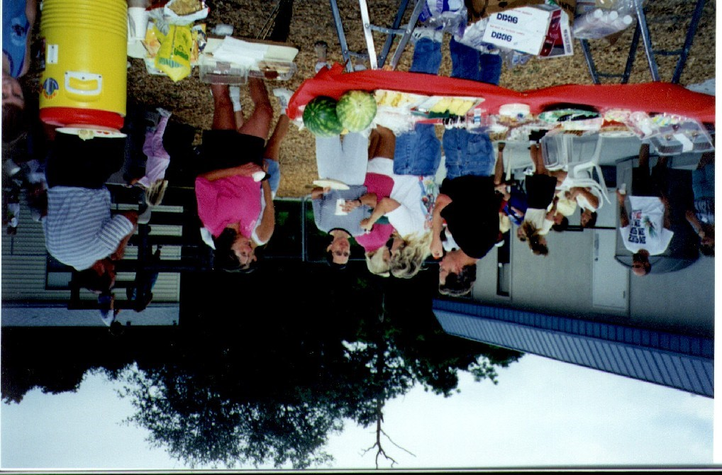
Mini-Conferences: Feel free at any time to talk with us about the progress of your child, or any problems you may want to discuss. Sometimes, however, if you approach a teacher during the day and request a conference, it may be unintentionally forgotten due to the business of the moment. Please follow up with a note in your child’s folder or on Class Dojo requesting a conference. This way we can assure you that you will receive the information you requested.
To assist us in keeping in touch, we use the Class Dojo platform. Important information can be shared by private messaging individual parents, class stories, or school-wide stories. Please stay active engaged with Class Dojo, as this is our primary way of communicating with our parents.
LFMA also maintains a site on the World-Wide-Web at www.lakefernmontessori.com. General information about the school, the newsletter, calendar, circle schedule, notice of upcoming events and an e-mail link are but a few of the items available.

Conferences and Progress Reports
For the pre-primary and VPK students, written progress reports will be distributed three times per year. For the kindergarten, elementary, and middle school level students written progress reports will be distributed four times per year. Twice a year the school will schedule formal Parent/Teacher conferences. The conferences will coincide with progress report releases. At anytime you need to talk with a teacher, please message on Class Dojo and we can set up a time to talk in between formal conferences.

