Transportation Information for Mumineen
Closest Airports:

- LAX - Los Angeles International Airport (Closest international Airport)

Airport Arrival Tips
- Free airport Wi-Fi is available throughout the terminals
- Download Uber, Lyft, and Offline Google Maps before arrival
- Consider purchasing a local SIM card or eSIM for navigation and rideshare apps.
- ALL transportation services will require a credit card for payment.

Travel Time Expectations
Typical travel times from LAX to Woodland Hills (Masjid Area): 35 – 100 minutes
Transportation Options

Option 1: Uber / Lyft (Most Convenient)
Please note that Uber, Lyft, and other rideshare drivers are not permitted to pick up passengers directly at the terminal.
If you plan to use a rideshare service, you will need to follow LAX airport procedures and proceed to LAX-IT. For more information regarding LAX-IT please click on the link: https://www.discoverlosangeles.com/sites/default/files/2024-03/LAXit-doc.pdf
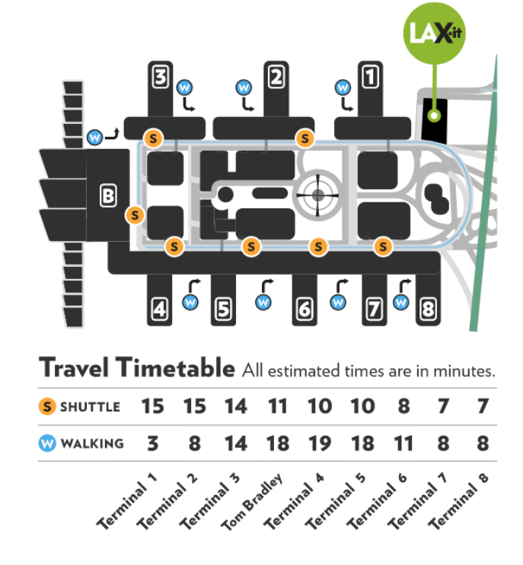

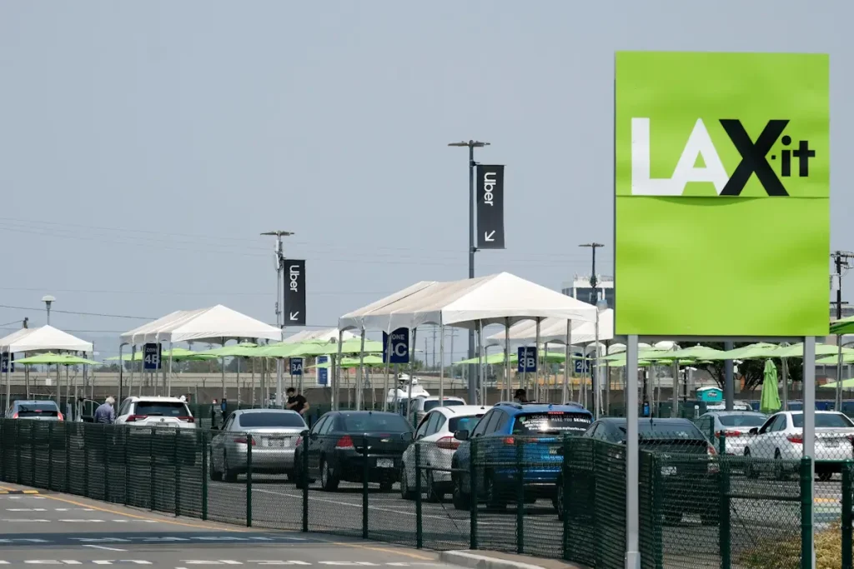

For families, Buzurgo, or those traveling with luggage, rideshare services (e.g. Uber/Lyft) are often the most convenient option.

Estimated Fares from LAX to Woodland Hills
- UberX / Lyft Standard: $60–$100
- UberXL / Lyft XL (recommended for families of 4+ with luggage): $75–$140
Pricing varies based on traffic, demand, and time of day.

Subscription Savings
If you plan to use Lyft or Uber frequently during your time in the US, please consider subscribing to their monthly subscription service (e.g. Uber One or Lyft Pink) for savings and convenience:

Option 2: Rental Car (Most Convenient)

For those attending Ashara Mubarak for several days, a rental car may provide the greatest flexibility. Consider Renting a Car directly from the airport as they have the most competitive pricing. Visit www.autoslash.com for available rental cars and prices.

Estimated Rental Rates (June 11–25)
Vehicle Type | Average Daily Rate
Economy Car | $35–$55/day
Midsize Sedan | $45–$70/day
Standard SUV | $65–$110/day
Minivan (7–8 passengers) | $90–$150/day

LAX Rental Car Information
LAX utilizes a centralized rental car facility which requires a shuttle to get to. We recommend using these major international car rental brands from LAX:
- Enterprise
- National
- Alamo
- Hertz
- Avis
- Budget
- Dollar
- Thrifty
- Sixt

Other car rental agencies, although much more economical, may require 1-2 additional shuttles to reach and have stricter rental policies.

Requirements for Renting a Car
Most rental agencies will require:
- A valid driver's license (in English)
- A major credit card in the driver's name - Debit cards are often not accepted
- Minimum age requirements (typically 25 years old depending on the company)
- Proof of insurance, if applicable
- Applicable car seats for children under the age of 8
International visitors should:
- Bring a valid driver's license from their home country
- Carry a passport
- Although your local drivers license may be accepted in the US during your stay here, please also consider getting an international drivers permit (IDP)

Option 3: Van Nuys FlyAway + Rideshare (Most Economical)
The Van Nuys FlyAway bus provides a cost-effective alternative to taking an Uber/Lyft directly from LAX if not renting a car. The shuttle picks up passengers from terminal curbside in large buses with undercarriage luggage capacity and drops off at the Van Nuys Bus Terminal which is closer to the Masjid Area. From there, arriving Mumineen can request and Uber/Lyft for a much lower price to the Masjid Area. Tickets can be pre-purchased through their app or purchased on board via TAP.
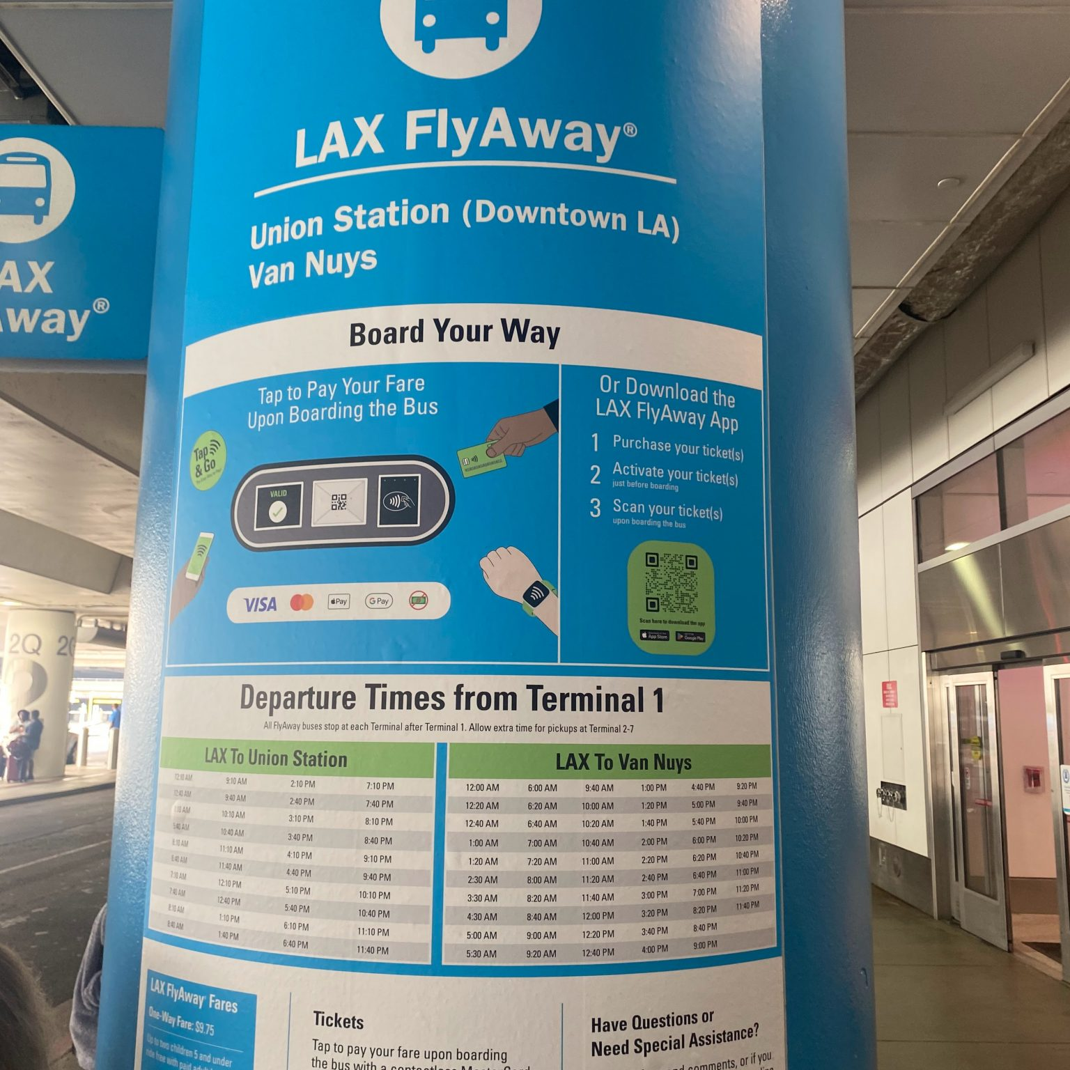

FlyAway to Van Nuys (Recommended) - Current one-way fare: $12.75 per person
- Board the FlyAway Bus at LAX.
- Travel directly to Van Nuys.
- Take an Uber or Lyft from Van Nuys to Woodland Hills.

Van Nuys FlyAway Terminal
- 7610 Woodley Ave. Van Nuys, CA 91406

Travel Time
- LAX → Van Nuys: approximately 40–60 minutes depending on traffic.

Approximate Cost Comparison (Family of 4)
Transportation Option | Estimated Total Cost
UberXL Direct from LAX | $75–$140
FlyAway + UberXL from Van Nuys | $55–$90

Option 4: Taxi Service (Least Recommended)
Traditional taxis are available from LAX-IT and select terminals and typically cost:
- $110–$150 to Woodland Hills

Ashara Mubarak Parking Information
Details on parking arrangements at Al Masjid al Ezzi masjid will be posted here closer to the Ashara Mubaraka. Khidmat Guzaars will be on hand to guide vehicles during peak hours

