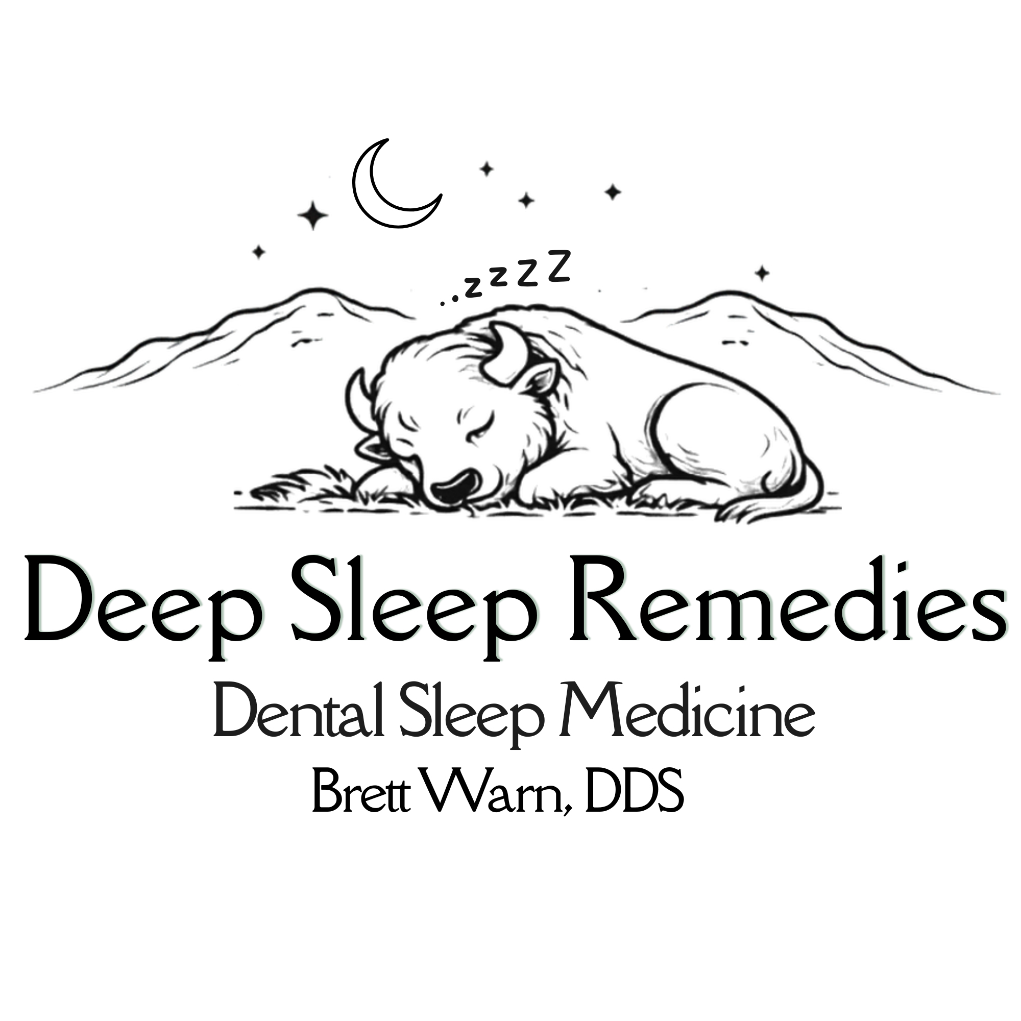
DEEP SLEEP REMEDIES
Brett Warn, DDS
5103 NW Cache Rd
Lawton, OK 73505
(580) 725-2011

Email: Info@BrettWarnDDS.com

LETTER OF MEDICAL NECESSITY (LOMN) & Rx
Re: Obstructive Sleep Apnea and Mandibular Advancement Device Rx and Statement of Medical Necessity
I
NPI:
Date:

Prescribing Physician (PRINT): ______________________________________
Prescribing Physician's Signature: ___________________________________
Physician Address: _______________________________________________
Phone: __________________ Fax: _____________________

